Women’s Right to Vote
Who is the greatest hero of the Suffrage Movement?

SS.7.C.3.7 Analyze the impact of the 13th, 14th, 15th, 19th, 24th, and 26th amendments on participation of minority groups in the American political process.

For this decision-making lesson, students will continue their study of the Women’s Suffrage Movement based on information provided by articles, videos, and their classroom texts to determine the most influential woman of the Movement. Using this information, students will rank their choices and explain how they reached their decisions.

Problem
Who is the most influential woman of the Women’s Suffrage Movement?

Alternatives
Susan B. Anthony, Elizabeth Cady Stanton, Alice Paul, Lucy Stone, Ida B. Wells

Criteria
Role in fighting for voting rights for women, role in fighting for other rights for women, role in fighting for rights for other groups

Decision
Which woman did you choose? How did you make that decision?

Read the letter from Women of the 21st Century and discuss the decision that the students need to make (which woman should be named the most influential woman of the Women’s Suffrage Movement). Discuss the criteria that the class included regarding how to choose the woman (role in fighting for voting rights for women, role in fighting for other rights for women, role in fighting for rights for other groups).
- What was the Suffrage Movement? Refer to the classroom texts to review the specifics of this time period and rights of women, African-Americans, and children.
  - To review the history of voting rights, use this link to The Library of Congress: https://www.loc.gov/teachers/classroommaterials/presentationsandactivities/presentations/elections/founders-and-the-vote.html
- Use the links below to connect the national Suffrage Movement to events in Florida. Discuss how Florida did not formally recognize the 19th Amendment until 1969 even though women were allowed to vote before that.
  - https://www.floridamemory.com/learn/exhibits/in-her-own-words/
  - http://articles.orlandosentinel.com/1996-09-01/news/9608291707_1_women-suffrage-suffrage-movement-suffrage-association
- Show the pictures of five leaders of the Women’s Suffrage Movement located at the bottom of this lesson plan. Provide students with the matrix and/or note-taking tool. Review the alternatives and criteria. Explain that they will research each of these women and determine which one was the most influential helping women get the right to vote.
- Use the following link to read about important women in the Suffrage Movement:
  - http://www.history.com/topics/womens-history/women-who-fought-for-the-vote
- Use the following links to research each woman:
- Susan B. Anthony https://www.youtube.com/watch?v=jiK6GI-lj2Y
- Alice Paul https://www.youtube.com/watch?v=5GDe4DkZN2A
- Elizabeth Cady Stanton https://www.youtube.com/watch?v=bE38EpqCtUk
- Lucy Stone https://www.youtube.com/watch?v=2hcIDGAKCjE
- Ida B. Wells https://www.youtube.com/watch?v=9DgsA3B4oVA
- After all information has been gathered, use the matrix to start a discussion on Susan B. Anthony. What notes were made related to each of the criteria? Does Susan B. Anthony meet all of the criteria? If yes, how? If not, what is missing?
  - How did she go beyond basic civic and political responsibilities to improve government and society?
  - What risks did she take?
- Repeat this process for the other women.
- In teams the students will work together to evaluate the completed matrix and make a decision regarding the woman that should be named as The Most Influential Woman of the Women’s Suffrage Movement. Students will then rank each woman from first to last.
- Students will then present their findings to the class, giving the reasons why ranked the choices as they did and the procedure of how they got to that decision. What is the opportunity cost (the next-best choice for the Most Influential Woman of the Women’s Suffrage Movement)?
  - Encourage students to discuss each step in their processes for making their choices. What did they do first? After that?
- Students write a letter to Women of the 21st Century and explain:
- how they ranked each woman
- the process they used for making their choices and
- why the woman they chose is the best choice.
A frame can also be used:
Date:
Dear Women of the 21st Century,
Our team has reviewed information on the five women that you provided and are suggesting the following for the Most Influential Woman of the Women’s Suffrage Movement. We have ranked them in order beginning with our top choice.
Top Choice:
Alternate Choice #1:
Alternate Choice #2:
Alternate Choice #3:
Alternate Choice #4 ________________________________
Alternate Choice #5 ________________________________
Our step-by-step procedure for ranking the choices in this way was:
Thank you for the opportunity to assist you with this project!
Sincerely,
Five Fearless Females:

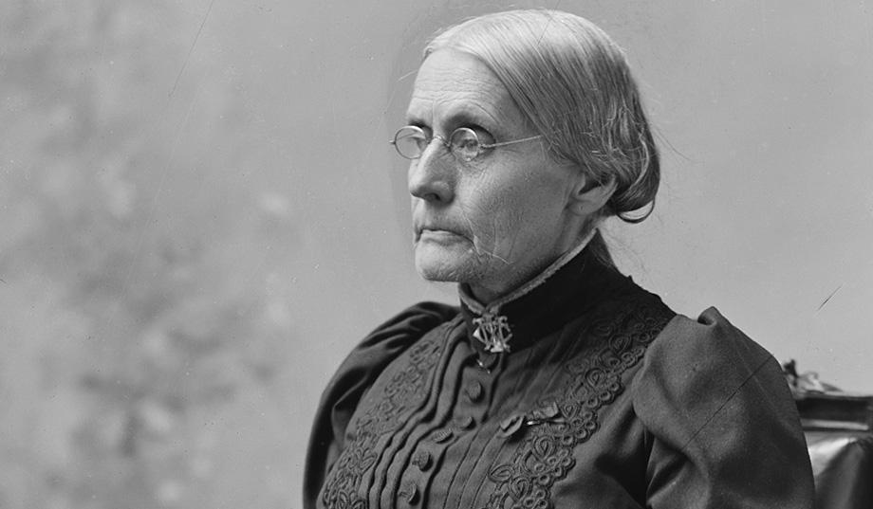 Susan B. Anthony

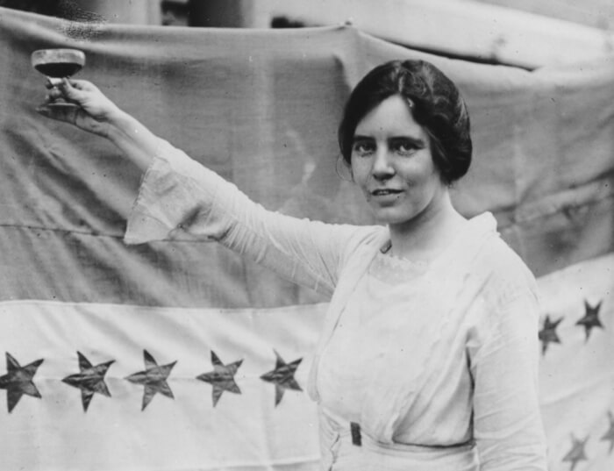 Alice Paul

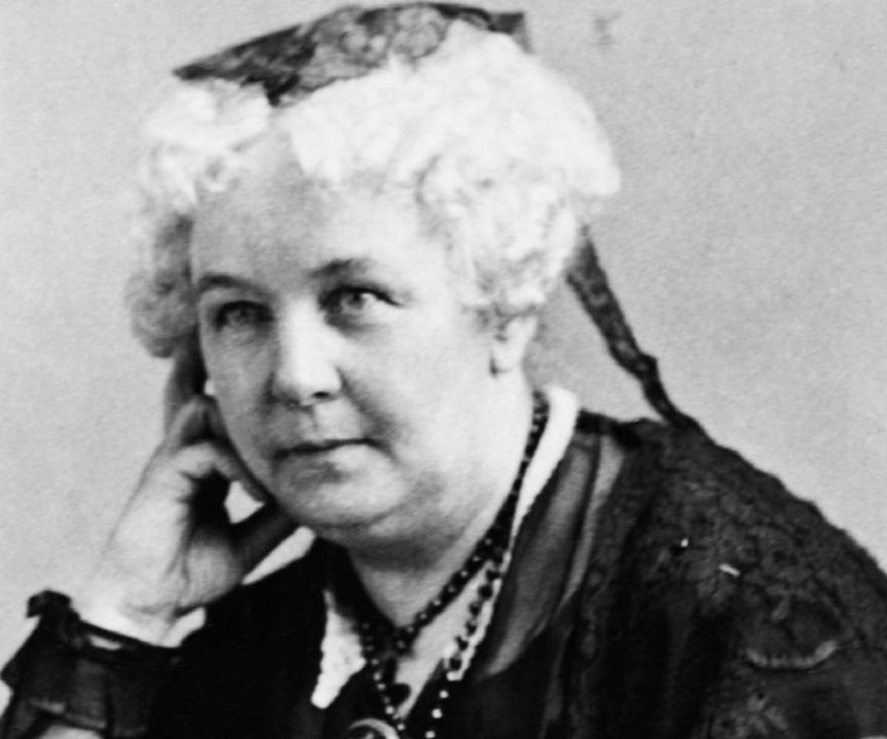 Elizabeth Cady Stanton

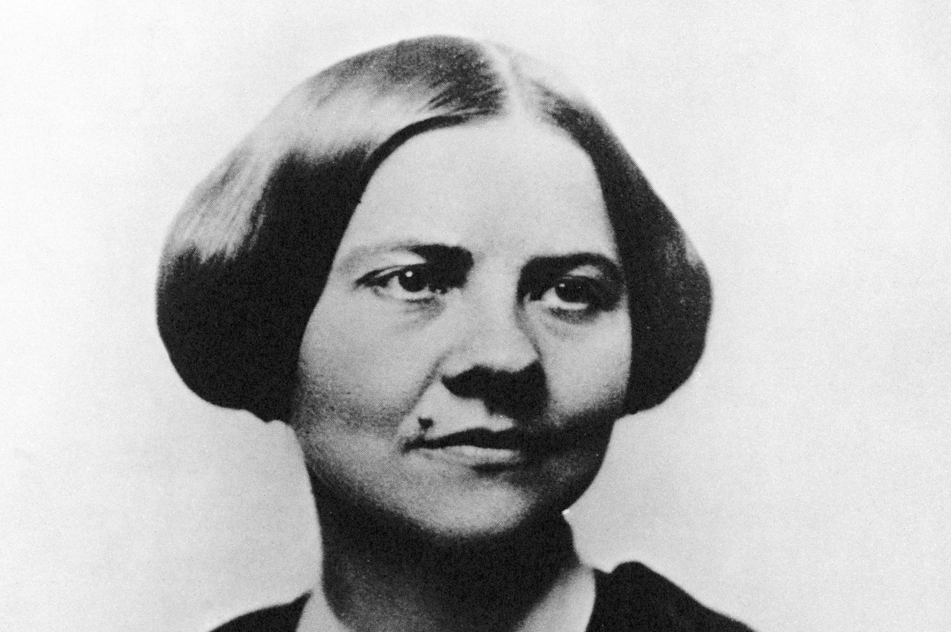 Lucy Stone

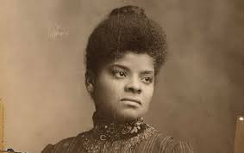 Ida B. Wells

Extension/ideas:
- Create a presentation for the Women of the 21 Century that outlines the woman chosen for the award.
- Have students role play the women and stage a television interview with the women as a panel of experts on suffrage.
- For more creative ideas, check out: 19 ways to teach the 19th Amendment
- Read more about the Suffrage and Civil Rights at:
  - Library of Congress Scrapbooks of Elizabeth Smith Miller and Anne Fitzhugh Miller
  - National Archives Educator Resources Woman Suffrage
  - Khan Academy Nineteenth Amendment Reading

Differentiation:
- Reduce alternatives and/or criteria.
  - Create a new letter from Women of the 21 Century asking students to reconsider their choices based on different alternatives/criteria
- Increase alternatives and/or criteria.
  - Same as above
- Provide note-taking tools with some of the information from textbooks, videos, and/or web articles already filled in.

