Alternatives: | role in fighting for voting rights for women | role in fighting for other rights for women | role in fighting for rights for other groups
Susan B. Anthony
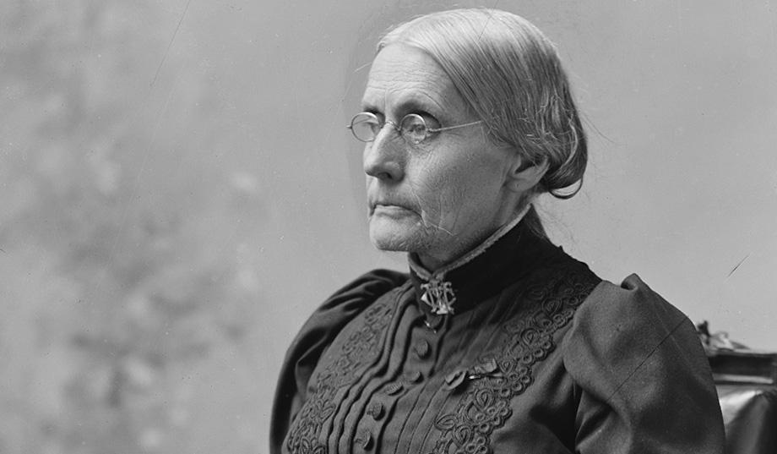
Elizabeth Cady Stanton
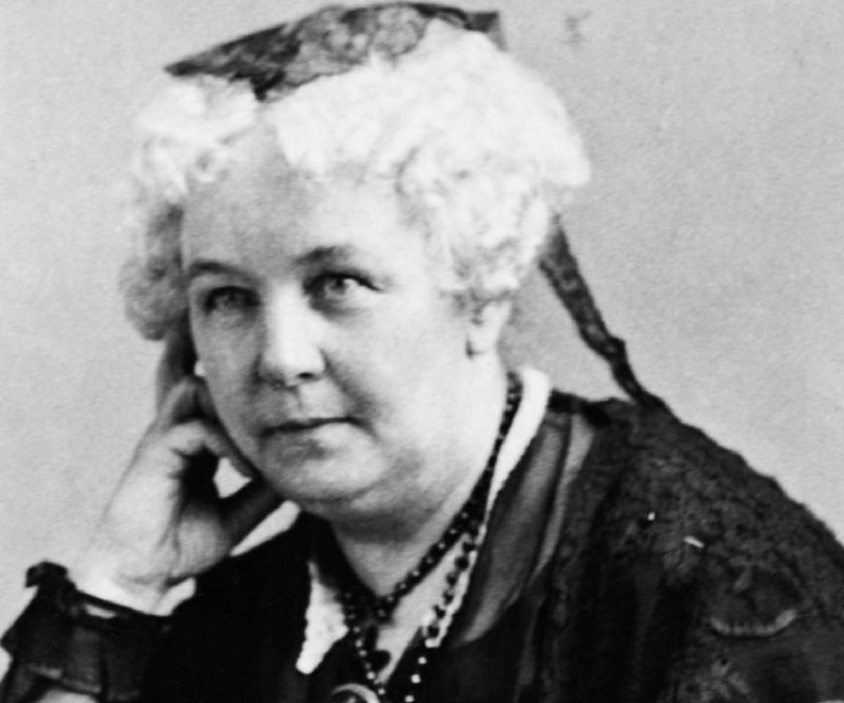
Alice Paul
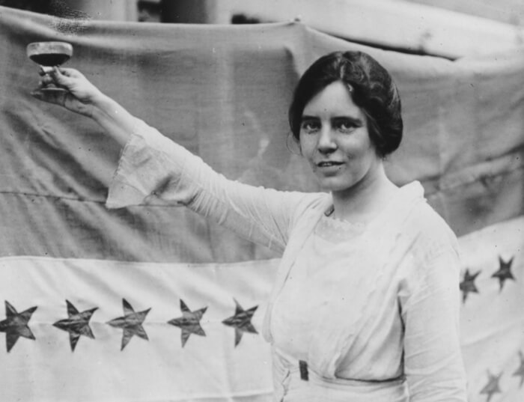
Lucy Stone
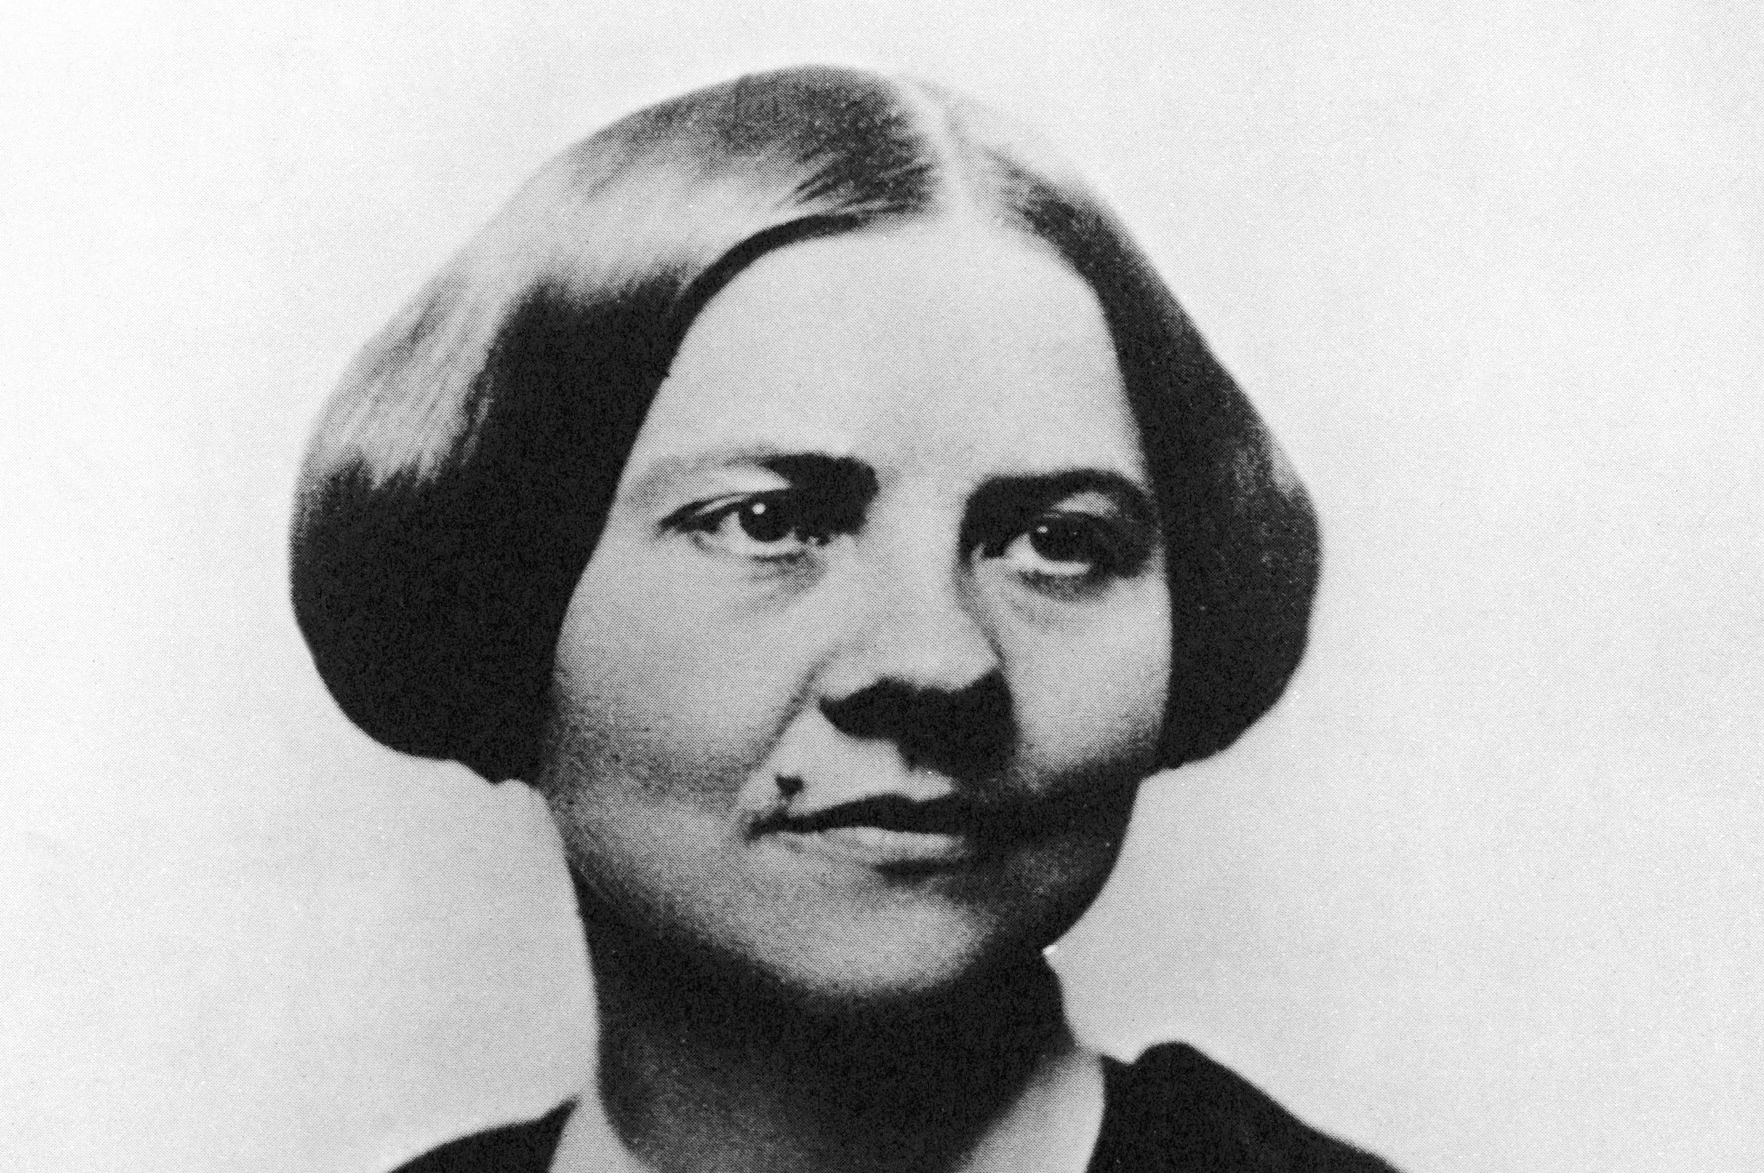
Ida B. Wells
