Decisionomics Lesson
Social Studies: Standalone Subjects or Interdisciplinary
Lesson Idea contributed by: Dr. Sherry Moser

The elementary schools in your area are trying to make a decision about how to teach social studies in K-5 classrooms. The Elementary Social Studies Supervisor found some research on Social Studies.org that listed some of the concerns by elementary educators (see Table 3) and some of their suggestions on how to better teach social studies in K-5 classrooms (see Table 4).

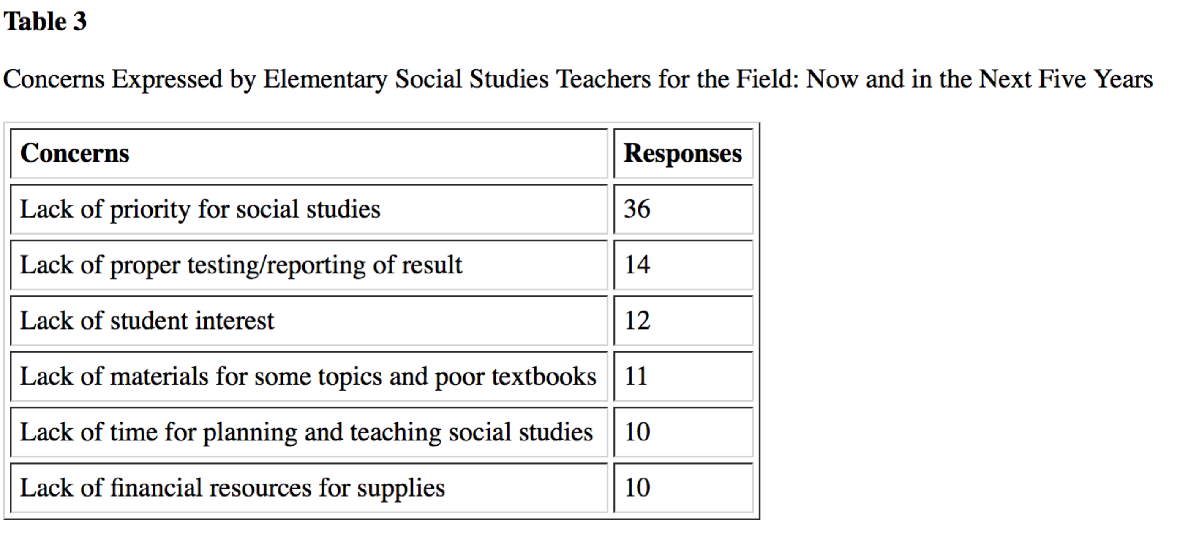
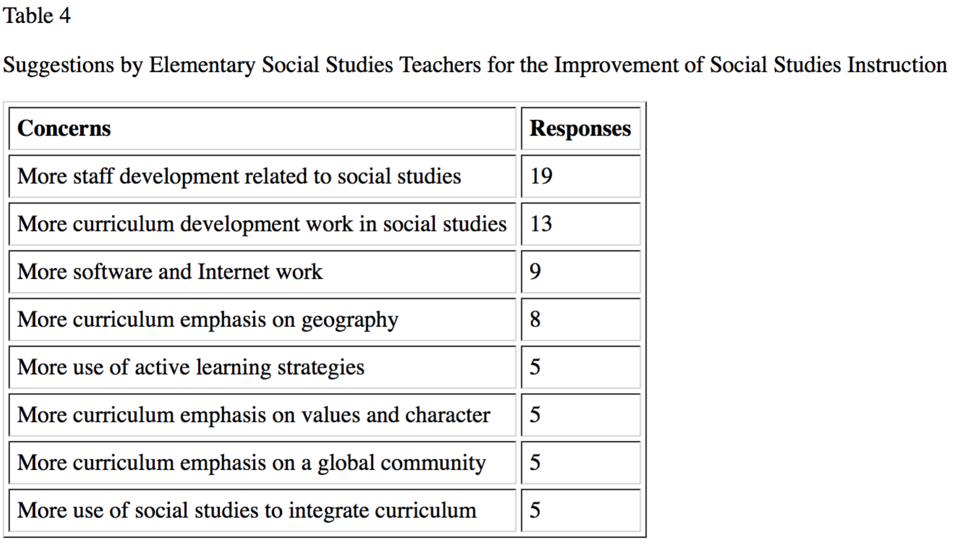
Retrieved April 22, 2016 from: http://www.socialstudies.org/system/files/publications/se/6502/650208.html

Now your school district is considering moving from teaching social studies in individual content areas–history, economics, geography, and civics–toward a more interdisciplinary approach.

Definition of Interdisciplinary Studies at Dictionary.com http://www.dictionary.com/browse/interdisciplinary
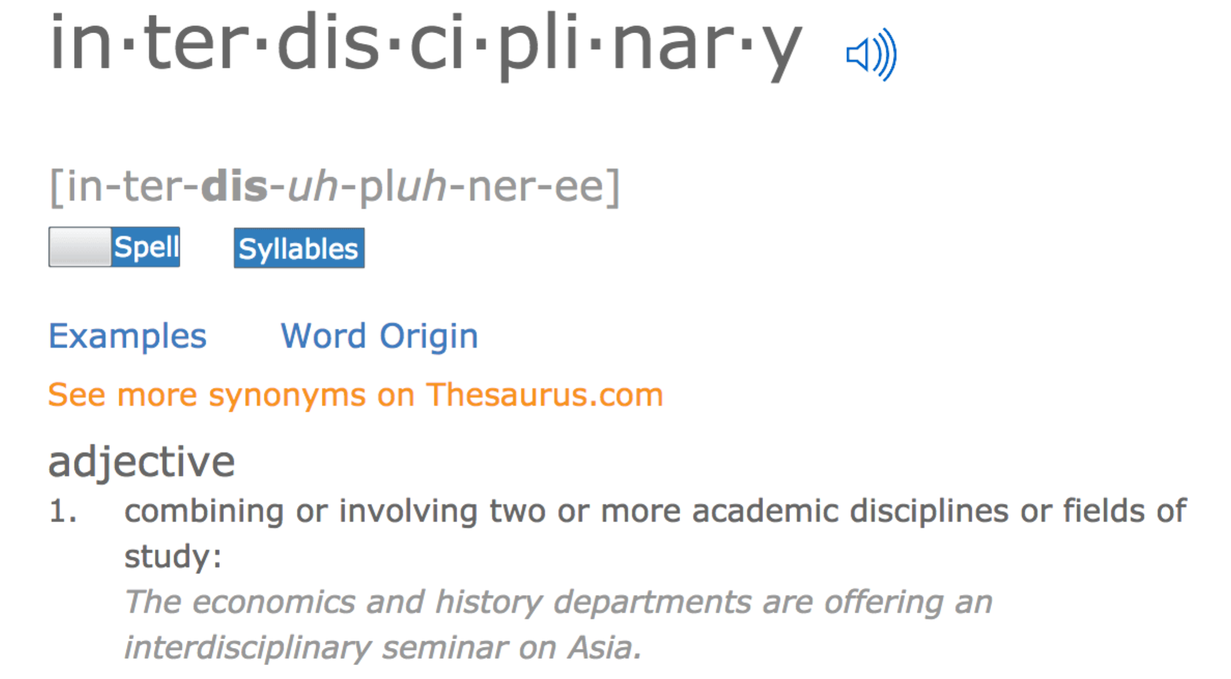
The Elementary Social Studies Supervisor wants to ensure that all students are learning the content of social studies in addition to being motivated and engaged in learning. Engagement and motivation are the most important criteria to helping students develop an interest for the subjects as they proceed toward secondary subjects in grades 6-12. After examining the data in Table 3 And Table 4, do you think it would be a good decision to consider an interdisciplinary approach to teaching social studies?
- Problem:
  - What are some of the problems the elementary teachers face?
  - If you were writing a blog about these problems, what would you say?
  - What are some suggestions the elementary teachers made?
  - In your blog post, after examining the teacher suggestions, combined with your own social studies education thus far, which side of the argument would you make? Why?
2. There are a variety of experts who think that an interdisciplinary approach is better. Read what these experts say and record the opinions and evidence they give in support of their argument for an interdisciplinary approach.
Article by Edutopia http://www.edutopia.org/integrated-studies-experts
Integrated Studies: What Experts Say
Great things can happen when teachers break out of their silos and collaborate across subjects. Here's what researchers, educators, and curriculum writers have to say about the benefits of integrated studies.
DECEMBER 6, 2011
- Elena Aguilar, Oakland Unified School District
- Veronica Boix Mansilla, Project Zero, Harvard
- Heidi Hayes Jacobs, Curriculum Mapping Institute
- Dayna Laur and Katlyn Wolfgang, Central York High School
- Bob Lenz, Envision Schools
- Susan McCray, Casco Bay High School
Organizations and Resources that Support and Promote Integrated Studies

Elena Aguilar
A former humanities teacher and instructional coach, Elena Aguilar is now a transformational leadership coach in the Oakland Unified School District.
"To be able to plan an interdisciplinary unit, you need to know what’s expected of your students in other subject areas. So I would need to have the standards for math, science, history, everything, spread out all over around me. And I would be constantly referring to them, going back and forth -- these are my goals, where are the standards in other areas that fit in and support them? Or, how can I modify my goals so I can actually pull in that sixth grade math standard and support their learning in this unit? I would be talking to other teachers to find out, what is it in 6th grade math that would be helpful for students to have reinforced in my class? Or which are standards that are not addressed enough? Then I would go back to my plans and see whether they work."

"I think one of the keys to success in designing an interdisciplinary unit is doing a lot of research; on the internet, in books, and then asking everybody you know. I’m doing this, do you have any ideas for anything I could read, play for my students, can you come and talk to the class? If not, can you forward this email to somebody else who can? I’m a firm believer in asking for what you want from everybody, even though you may not even know them. Keep looking, keep asking -- there are tons of resources out there."

Watch the full Edutopia.org interview with Elena Aguilar or read her professional development blog on Edutopia.org.

Veronica Boix Mansilla
Veronica Boix Mansilla is the principal investigator at the Interdisciplinary Studies Project at the Harvard Graduate School of Education’s Project Zero.
"While empirical research is scarce, learning theorists have associated interdisciplinary learning with higher levels of mental complexity, perspective taking, beliefs about knowledge and inquiry, and complex collaboration. Yet the promise of interdisciplinary learning extends beyond the important skills here described. In quality interdisciplinary classrooms, students can examine relevant contemporary topics in their full complexity. From globalization to climate change, from the ethics of global health to the digital revolution, the world of today and tomorrow becomes the source of problems for study, and helping students make sense of such problems becomes our goal. In such classrooms, interdisciplinary learning is not an aim in itself but a rigorous tool to help students gain practice in the work of their generation."

Heidi Hayes Jacobs
Heidi Hayes Jacobs is president and founder of Curriculum Designers and Curriculum 21. Her books include Interdisciplinary Curriculum: Design and Implementation, Mapping the Big Picture: Integrating Curriculum and Assessment K-12, and most recently Curriculum 21: Essential Education for a Changing World.
"We need to modernize the curriculum if we are going to have 21st-century scientists and social scientists and mathematicians and writers. There’s not going to be one problem in the real world, especially in this century, that is not inherently interdisciplinary. There is no such thing as a strictly science problem or a simple math problem. If you go to solve a problem in the real world, you have to deal with legal issues, money issues, ethical issues, resources, applications. Whether it’s addressing the BP oil spill or new job creation in the global economy, our students need to be able to apply a range of skills in viable ways to real interdisciplinary problems."
"How do we build those bridges and connections to pull it all together? We have to focus on what to cut, what to keep, and what to create. We’re seeing more work now on integrating language literacy, digital literacy, and global literacy that cuts across all subjects. I don’t see a debate anymore about whether to integrate. It’s more strategically, where and when do we have those opportunities?"

Dayna Laur and Katlyn Wolfgang
AP government teacher Dayna Laur and art teacher Katlyn Wolfgang collaborated to create a joint project between their classes at Central York High School in York, Pennsylvania.
Katlyn Wolfgang: "Make sure that you structure your lessons with final goals and supporting tasks. However, don't forget to let the students experience the learning; sometimes the best experiences occur unplanned or unscripted."
"When working with another class, make sure you have daily updates with the other educator(s) concerning your students' progress on specific tasks. Do your best to keep up with deadlines but embrace the fact that not all learning can be, or should be, restricted to a time line. With that in mind, always have an activity on the back burner in the event that tasks do not align with the predetermined time line. Finally, be flexible and embrace the collaborative experience."
Dayna Laur: "Integrated studies projects create a connectedness between disciplines that otherwise might seem unrelated to many students. Deliberately searching for ways in which you can mingle standards and content is imperative if you want to create truly authentic experiences because, in the world outside of the classroom, content is not stand-alone. Teachers need to identify areas in which social studies, math, science, reading, writing, art, music, and even physical education cross paths. Once the content and standards have been decided, the planning part falls into place. However, in order to have a truly successful project, it needs to be one that meets all of the elements of project-based learning and not turn into just another project. Teachers also need to leverage the opportunities presented to them by collaborative technology tools and not be dissuaded if the two classes involved do not meet during the same class period."
Read the blog "Integrating Art and Politics to Improve High School Student Engagement", where Katlyn and Dayna share their strategies for creating a successful integrated studies project. It includes a video, and you can also find free resources and downloads from from Central York High School.

Bob Lenz
Bob Lenz is chief executive officer and cofounder of Envision Schools and is a nationally recognized leader in redesigning high schools.
"At Envision Schools, students are motivated to master difficult subjects by interacting with peers in an interdisciplinary environment and tackling real-world issues. For example, while students are learning an important standard in world history, they study this topic in three classes: history, English, and digital media. Each student must individually write a historical analysis of this topic; read a book on the subject in English class; and work in a team to create a Ken Burns-style, multimedia documentary in Digital Media. An integrated approach to learning provides the relevance and context to help students not only master academic content but also acquire the critical-thinking and problem-solving skills necessary for success in college and career."
Read Bob Lenz's blog on Edutopia.org for practical advice from the trenches of the charter school movement.
Susan McCray
Susan McCray teaches humanities at Casco Bay High School, an Expeditionary Learning school in Portland, Maine. Her inspired teaching was featured in Edutopia’s Schools That Work package on project-based learning.
"It’s hard to tease apart the elements of a cohesive education. Our students engage with the work when they can tell it’s real, when it’s for an authentic purpose. They can smell if it’s fake. If subjects are isolated, then learning feels disjointed. Why should students be expected to think one way in math and then, when the bell rings, think another way in science? That’s not how the world works. But when the subjects are integrated, students can go deeply into something and construct their own meaning. There’s no point in integrating unless you have that objective."
"We work on real-world problems, such as how to reduce our dependency on fossil fuels. Students move through their day seeing different angles and perspectives on this problem -- in chemistry, in math, and in social studies. It all feels connected. Students have a sense of urgency. They know they have a chance to effect real change and that their work will have a real audience. Their day has meaning."
"Students also see their teachers working together. We introduce the project as a team, and there’s a sense that we’re all in it together. That builds community. For teachers, collaboration is so powerful. We share ideas, share resources, share students. You need space and time to work this way. But in the end, you get curriculum that’s meaningful and rich, and students produce things that matter."
Watch the full Edutopia.org interview with Susan McCray or see a video about the interdisciplinary project her high school juniors did.

Organizations and Resources that Support and Promote Integrated Studies
- Interdisciplinary Studies Project at the Harvard Graduate School of Education’s Project Zero
- Curriculum21
- The Curriculum Integration Website at North Carolina State University
Association for Interdisciplinary Studies

Overview http://www.edutopia.org/integrated-studies-research

Problem and Decision
What is the Elementary Social Studies Supervisor trying to do?

What problem do the teachers have?

What decision do they have to make?
Alternatives
What alternatives are they considering?

Criteria
What criteria does the supervisor want to meet?
Evaluation
Examine the data.

List the steps you followed to make your decision.

What other research would you like to conduct online before making a final recommendation?

Decision
What decision did you make? List reasons (evidence) for your decision.

