Decisionomics: Service Learning
How can we raise the financial resources to finance the non-profit organization?
Based on idea by: Dick Dearoff

http://www.sidewalkangelsfoundation.org
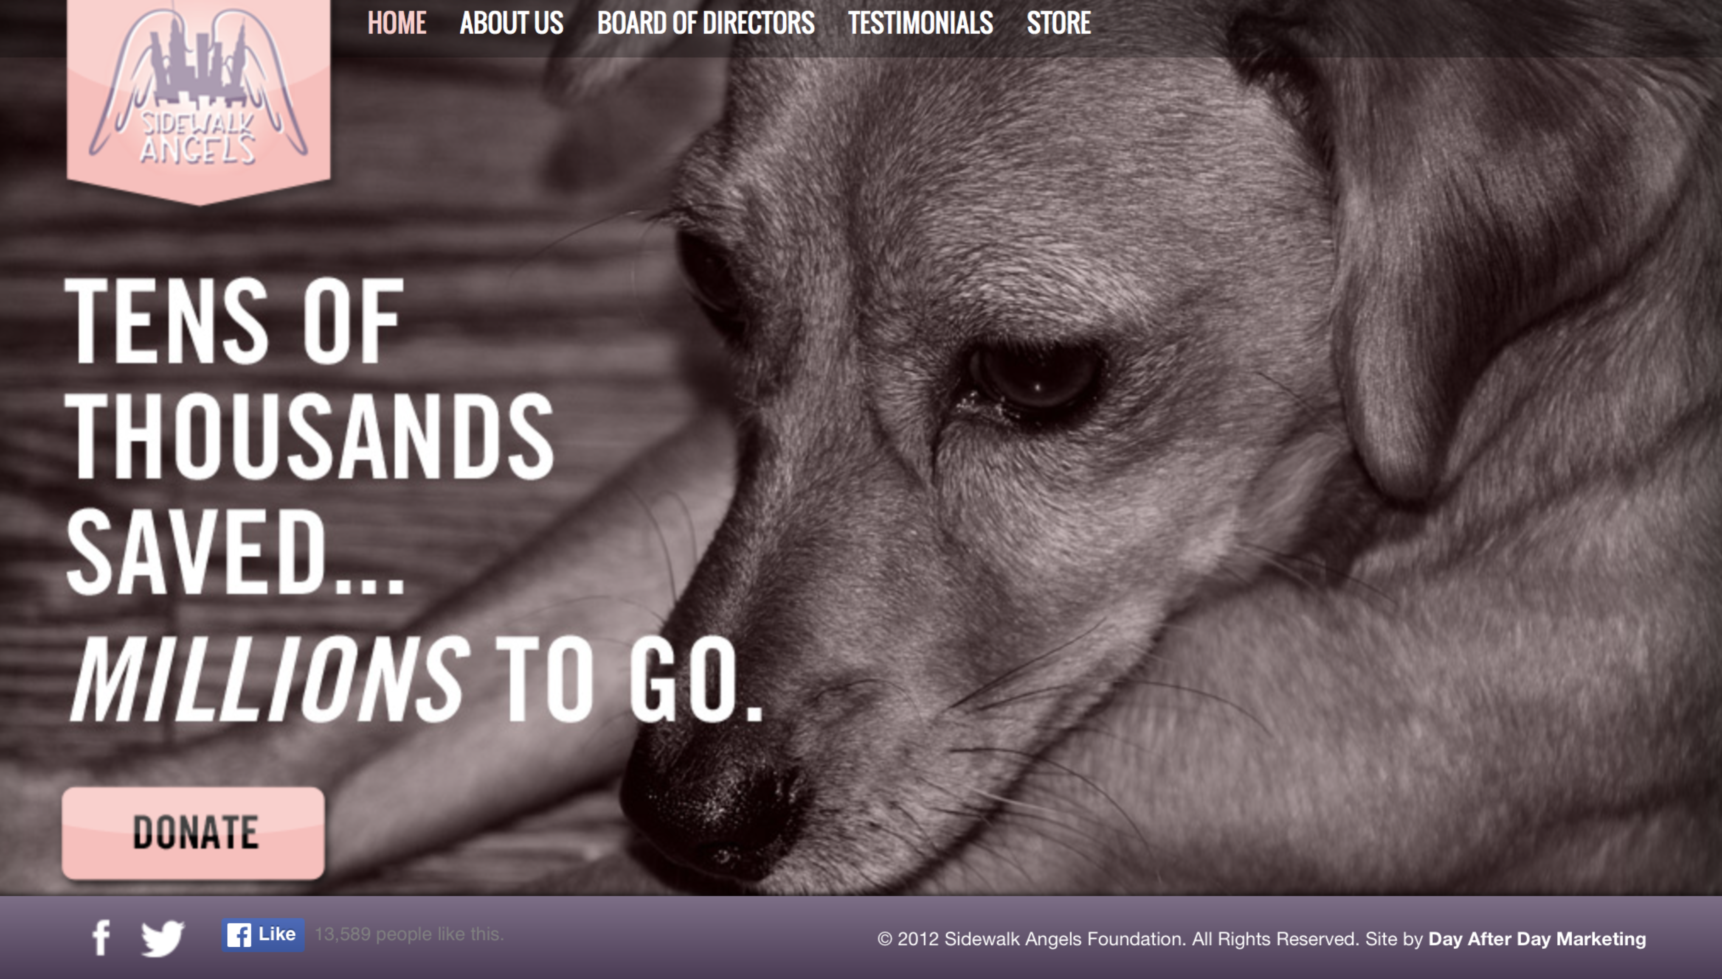
Problem
Your favorite rock star has a foundation to save stray animals.
http://www.entrepreneur.com/article/171296
https://www.501c3.org/4-simple-steps-to-raising-all-the-money-your-nonprofit-needs/ shorter
Third party http://www.huffingtonpost.com/auren-kaplan/a-powerful-method_b_4138690.html
Crowd source funding pages http://www.thefundraisingauthority.com/internet-fundraising/crowd-funding-your-non-profit/
Go fund me https://www.gofundme.com/fundraising-ideas-for-nonprofits/
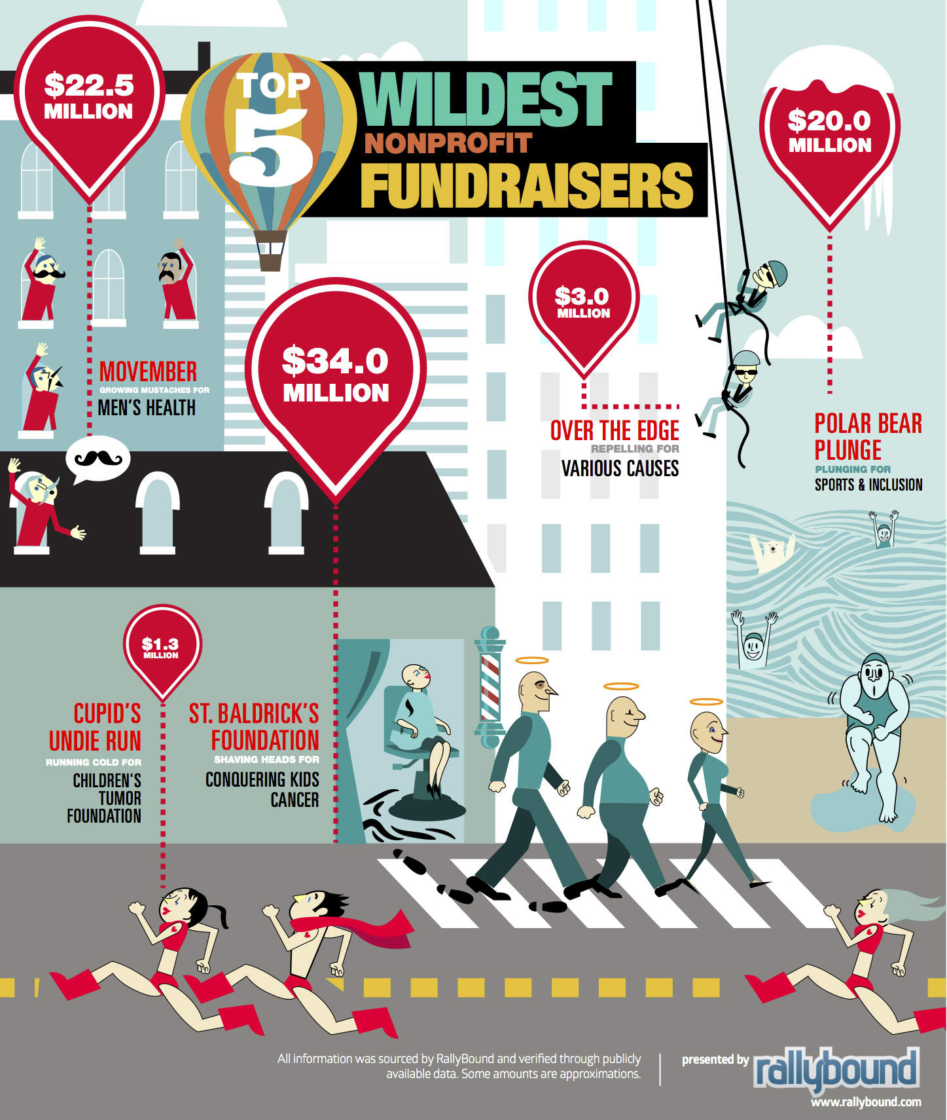
http://nonprofithub.org/infographics/top-5-wildest-nonprofit-fundraisers-infographic/

https://www.capitalbusiness.net/resources/tracking-the-top-tech-trends-in-fundraising/

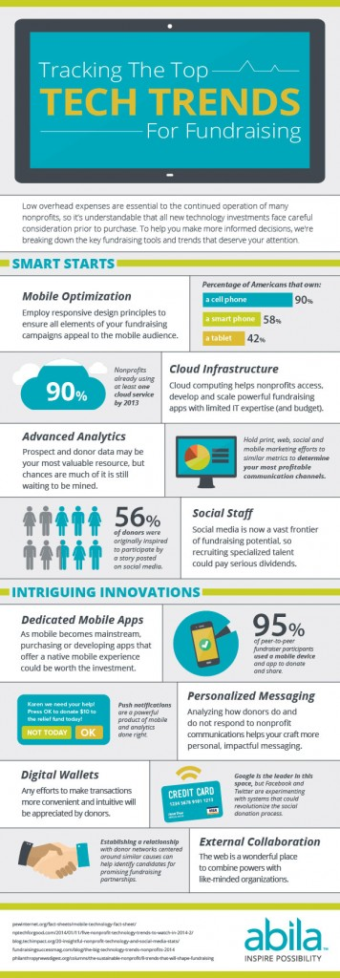
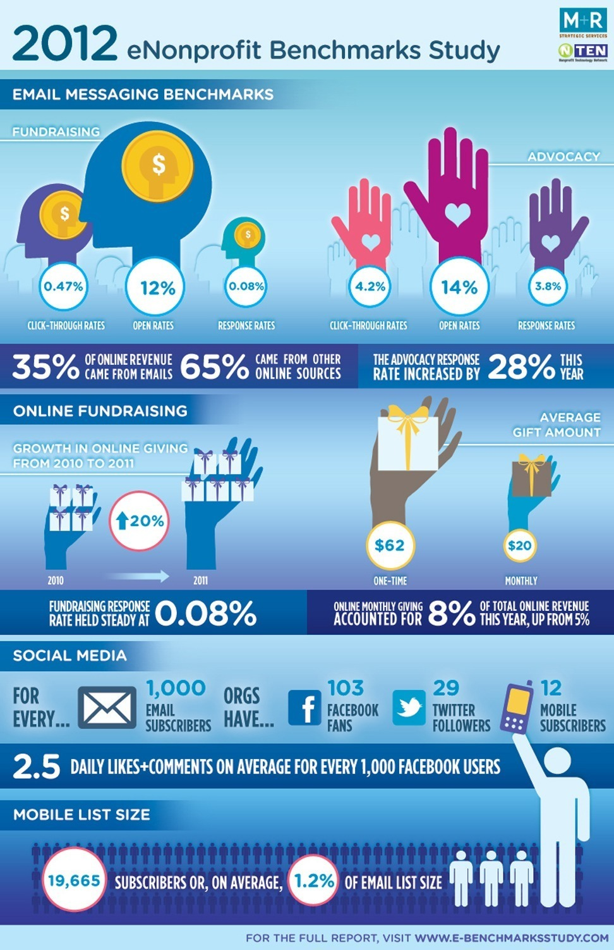http://mashable.com/2012/03/21/non-profits-digital-infographic/#dtSPbmfPmgqC (above)

http://blog.rallybound.com/post/114164100750/4-ways-to-enhance-your-2015-fundraising#.VvHzBtCyM2w

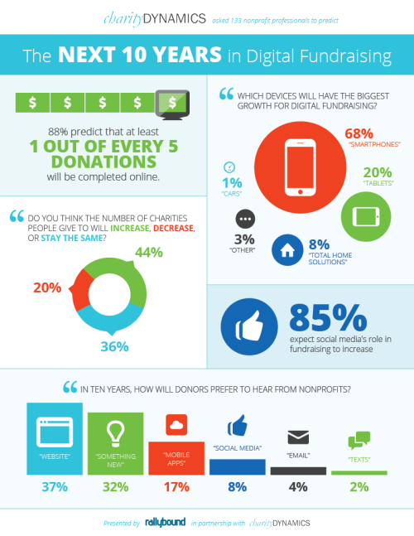

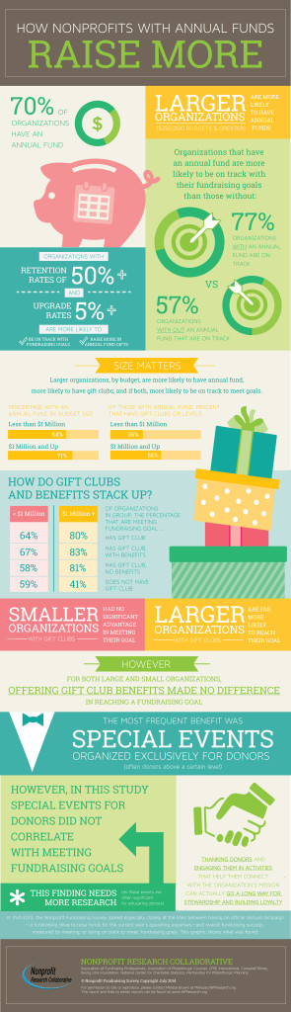
After conducting some research, the ants came up with some data about budget and costs, transportation, teacher pay. Also, the grasshoppers were very concerned about vacation and family time. They even mentioned the ants, who had teenagers that liked to get summer jobs. The ants also mentioned the impact on student learning. Do you think students would do better if they went to school all summer? Or should they have holiday weeks

Should the ants maintain the traditional school year? Should ?

Problem
What roof should

Alternatives
What alternatives does she have?

Images of the different alternatives:
Asphalt shingles
Wood shingles

Criteria
What criteria are mentioned.

Criteria: What is important for the roof?
Alternatives | Color | Flavors | Price
Tablets
Powder
Liquid 1
Liquid 2

