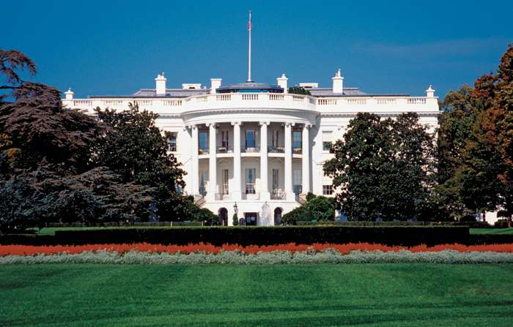

Future Presidents of the United States:
A Vision for the Future

Dear Students,
Our organization is setting ground-breaking ideas about qualifications for being the President of the United States and how to broaden the perspective of the nomination process. While Article I of the Constitution is clear about some specific requirements in becoming a president, there are many other ideas to consider.
Use your classroom texts along with resources we are sending to you to decide the most important character traits a person should have to be a president. Then research of the candidates of your choice and decide which one should be considered as viable in our next election.
Please write us back let us know the following: 1) The most important character traits a president needs, and 2) which candidate you chose for president. Please explain how you made your decision for president and show us how you ranked each candidate.
Thank you so much for your help! We look forward to hearing the winner of this presidential election.
Sincerely,
Future Presidents of the United States

