Decisionomics Lesson: New Schools Rule?
Should your district build a new school?

Lesson Idea contributed by: Arthur Noriega

Your school is overcrowded, with 500 additional students. The county has received many complaints from parents. In addition, concerned students have started a blog, noting some of their concerns. The school is too crowded. The hallways get too congested during class changeovers, making many students late for class. In addition, students are unable to sign up for some of the classes they want to take due to lack of space. Should the county build a second school site, add portables, or bus students to surrounding schools?

Here is an article recently published about the issue:

Thousands of residents in your school district voted Tuesday on the $75 million proposal to build a new high school.

ELECTION RESULTS:
YES – 4,524 (63%) – WINNER
NO – 2,667 (37%)

The plan would increase taxes on homes valued at $100k by $40, at least $6 on cars, and $60 on businesses valued at $100k.
The referendum resolution to build a new Secondary School was unanimously approved by the school board in January and now it’s up to you to approve it or vote against it next week.

“This isn’t about a tax increase this is about providing schools for our children and doing the things we need to do in this school district to make it an attractive viable place to live,” says John Brown, a parent in favor of the plan.

State representative Alex Barron agreed, “If you own a home in this school district I can’t see how you wouldn’t support this initiative because this new school is going to make our county a more attractive place to live.”

But not everyone is in favor of the tax increase “I could see once this debt has been paid off then undertaking 75 million as another debt for the county is one thing but we’ve still got many years of debt to pay off,” says Betty Longmire, against the proposal.

District Leader Dr. Russell Booker says, for the most part, the public has been supportive of the plan. “It’s been overwhelmingly positive from my perspective. I know there are concerns out there about the tax increase I met with the group today that support our schools but they are concerned about additional taxes. The high school is almost 60 years old and it’s a worn-out building. The cost to renovate that school to accommodate the extra students is going to exceed 50 million and that would require a referendum also and we don’t think that’s a proven use of taxpayer dollars when there’s so much more that we can give to your environment.”

If the proposal is approved, your school district’s new high school would open in the fall 2019. If the proposal is not approved, the district will need to add 30 portables at a yearly rental price of $2500.00 based on the proposed increase in this high-growth area.

District 7 (your district) residents will be able to vote on March 15th. You must be a district 7 resident in order to voice your opinion.

WHAT WOULD YOU DO?

Problem and Decision
What is the organization trying to do?

What problem do they have?

What decision do they have to make?

Alternatives
What alternatives are they considering?

Criteria
What criteria do they need to meet?

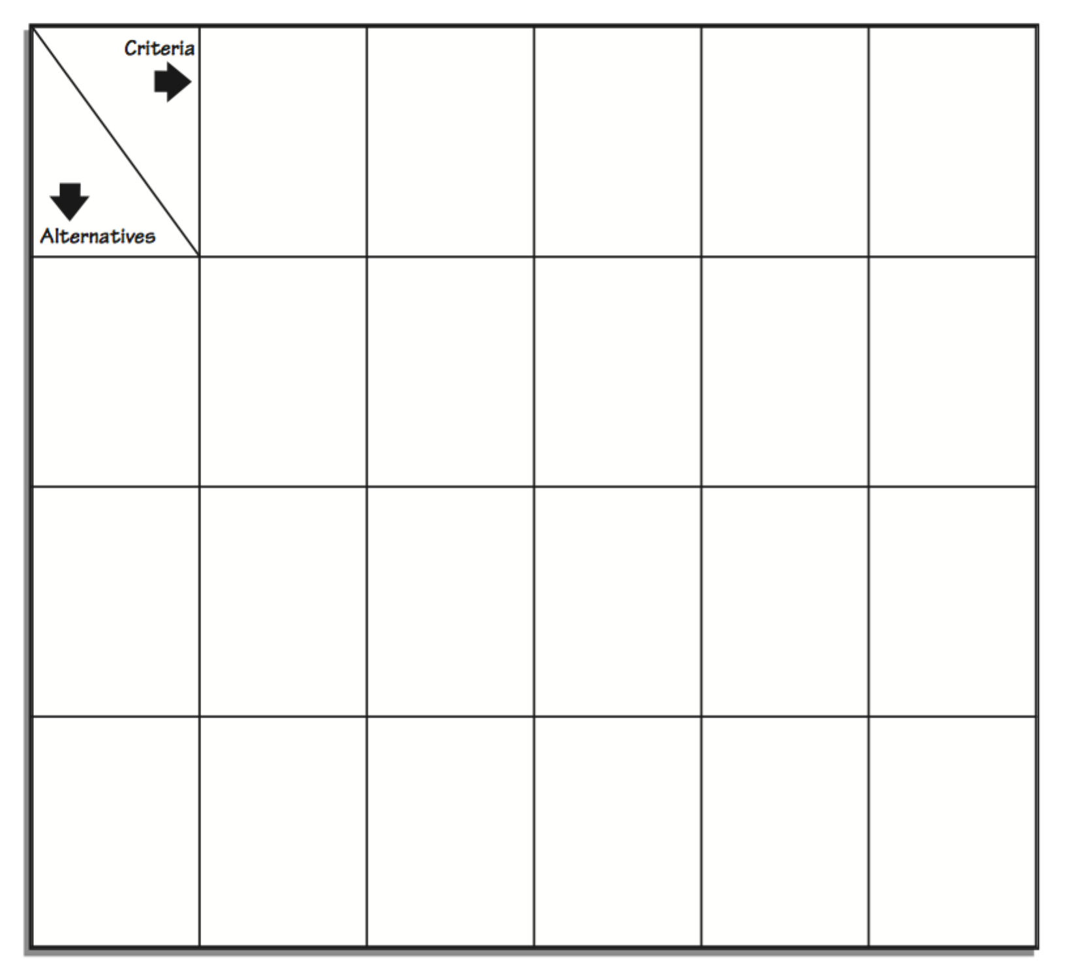
Evaluation
Examine the data.

List the steps you followed to make your decision.

What other data would you like to have before you make a final decision?

Decision
What decision did you make AND WHY? List reasons (evidence) for your decision.

New Schools Rule STANDARDS:
SS.912.FL.2.5: Discuss ways people incur costs and realize benefits when searching for information related to their purchases of goods and services and describe how the amount of information people should gather depends on the benefits and costs of the information.
SS.912.FL.5.10:Explain that people vary in their willingness to take risks because the willingness to take risks depends on factors such as personality, income, and family situation.
SS.912.E.1.2: Analyze production possibilities curves to explain choice, scarcity, and opportunity costs.
LAFS.1112.WHST.3.9 Draw evidence from informational texts to support analysis, reflection, and research.

