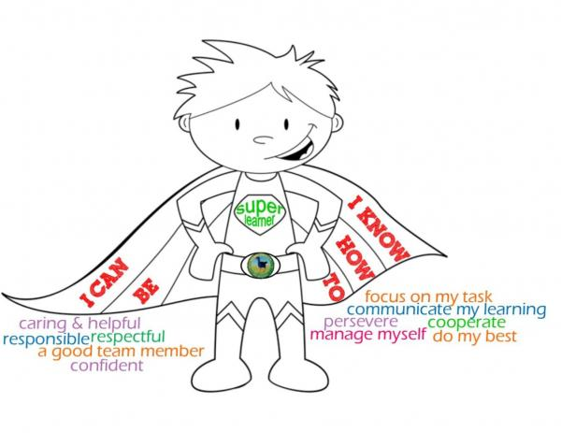
Super Learner Elementary School
Where Kids Learn Every Day

Hello Kindergarten Students!!

Greetings from Mr. Piper’s Kindergarten Class at Super Learner Elementary School! We just found out that we are going to get a new pet for our classroom, and we need some help in deciding which one to choose.

Our top 4 choices are:
- A parrot
- A ferret
- A gecko
- A miniature pig

We would like for you to help us make this decision. There are three important qualities in a pet that we want you to consider in making your choice:
- The pet must be easy to take care of
- The pet must be kid-friendly
- The pet must be a healthy type of animal

Please do some research on these pets and decide which would be best for our new classroom. Be sure to write back to us! Tell us which pet you chose and how you made the decision.

Thank you so much!

Mr. Piper’s Class

