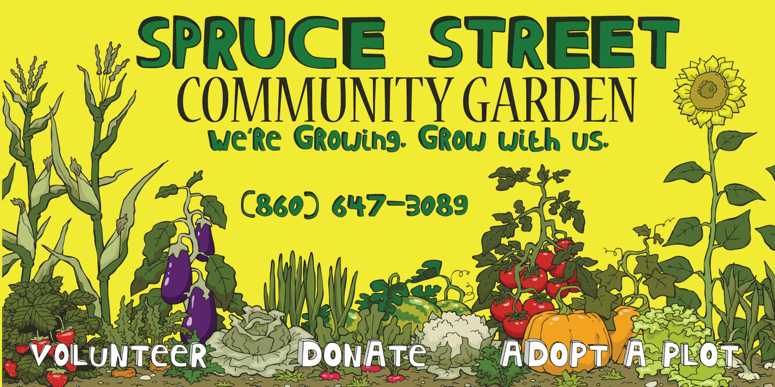

Hello Kindergarten Students!!

Spruce Street Community Garden is a place where people in the neighborhood come together to prepare plots, plant gardens, grow flowers and food, and work together to make our community great. We are excited to have a brand new plot of land ready for planting, but we cannot decide on whether we should grow vegetables, flowers, or herbs.

We would like for you to help us make this decisions. There are three important ideas that we want you to consider in making your choice:
- We want a beautiful garden.
- We want a garden that will help keep people healthy.
- We want a garden that is easy to grow.

Please do some research on these three types of gardens and decide which would be best for our new plot. Be sure to write back to us! Tell us which type of garden you chose and how you made the decision.

Gardens Are Great!!

Spruce Street Community Garden

