Alternatives: Classroom Rules | Safety | Organization | Good manners
Keep hands, feet and objects to yourself.
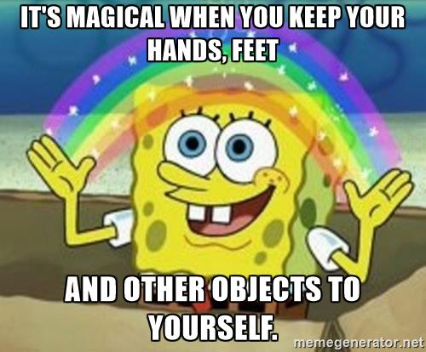
Follow directions the first time they are given.
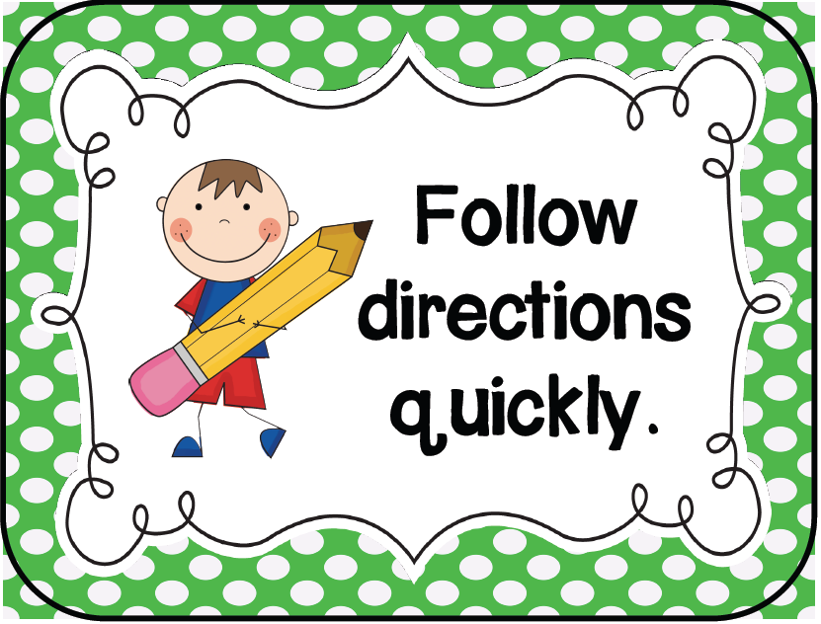
Treat each other with respect.
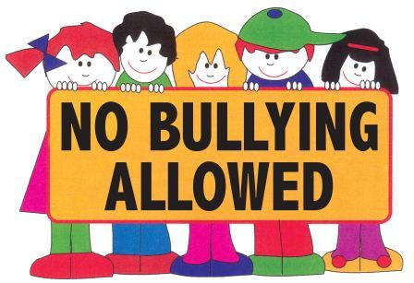
Keep your desk clean.
