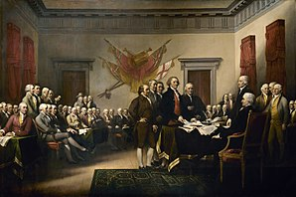
Our Founding Fathers Association

Our Founding Fathers Association received a request from the Federal Reserve to nominate a founding father to be represented on new United States currency. Many well-known founding fathers have had their pictures on U. S. currency in the past, so the Association would like to choose a man who has not yet received this honor.

The four candidates are:
- Oliver Ellsworth
- John Dickinson
- George Mason
- Charles Cotesworth Pinkney

The Federal Reserve would like for each candidate to be considered based on the following criteria:
- Education and Career Choices
- Role in the formation of the United States,
- Impact of Federalist or Antifederalist viewpoints
- Service to the United States after the Constitutional Convention
After completing your research, decide which founding father should be depicted on new U. S. currency. Once you have made your decision, please email us and explain how you ranked each man from first to fourth. Also explain the process you used to make each ranking.
Thank you for your assistance in this historic effort,

Our Founding Fathers Association
foundingfathers@msn.com

