Alternatives: Founding Fathers | Education and Career Choices | Role in the Formation of The United States | Impact of Federalist or Antifederalist Views | Service to the United States After the Constitutional Convention
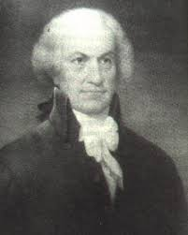
Oliver Ellsworth
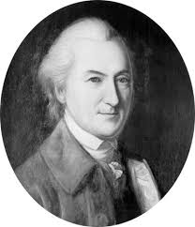
John Dickinson
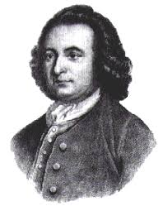
George Mason
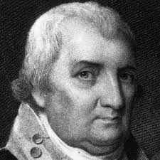
Charles Cotesworth Pinkney

