 | Criteria:
Alternatives: Founding Fathers | Education and career choices | Role in the formation of the United States | Impact of Federalist or Anti-Federalist Views | Service to the United States after the Constitutional Convention
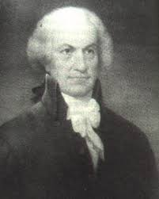
Oliver Ellsworth
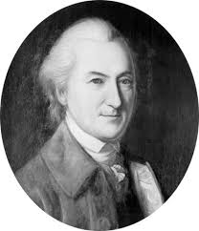
John Dickinson
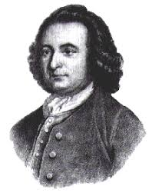
George Mason
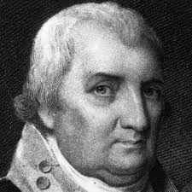
Charles Cotesworth Pinkney

