Decisionomics Lesson
Should The School District Place Advertising on Driver Education Vehicles?
Lesson Idea contributed by: Dr. Dennis Holt
The school district has a busy Driver Education program. Recently money has been cut out of their budget so they are trying to raise more funds to continue to operate the program. One of the teachers heard that people get paid for driving around with car wraps. A student said he read on the Internet that people make up to $3,000 per year by advertising this way. Another student pulled out his cell phone and googled “car wraps for money” and found some companies that claimed to help with “carvertising” and “getting paid to drive.” Should the school district place advertising on their Driver Education vehicles? If so, should they contact one of these carvertising companies?
What do you think? Is there enough information to make a decision? Let’s work through this problem.
- Google the following terms and record what you discover:
  - “car wraps for money”
  - “carvertise”
  - “get paid to drive

- Did you find any information about scams yet? If not, google “car wrap advertising scam.” What did you find out?

- You can’t trust all websites. If you discover anything about Internet scams, you should check out two sources: the Better Business Bureau and the IC3-Internet Crime Complaint Center. Read what these sources posted about the car wrap advertising scams on the articles on the next two pages. Then advise your school district on whether they should:
  - Go ahead with their plan to make money with car wraps,
  - Forget about the plan
  - Conduct more research
- Why did you make this decision?

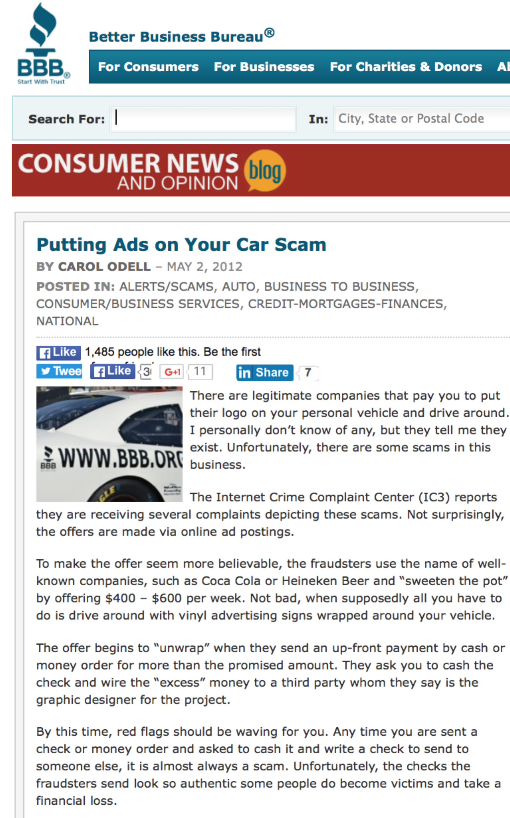 http://www.bbb.org/blog/2012/05/putting-ads-on-your-car-scam-says-carol/
https://www.ic3.gov/media/2012/120420.aspx
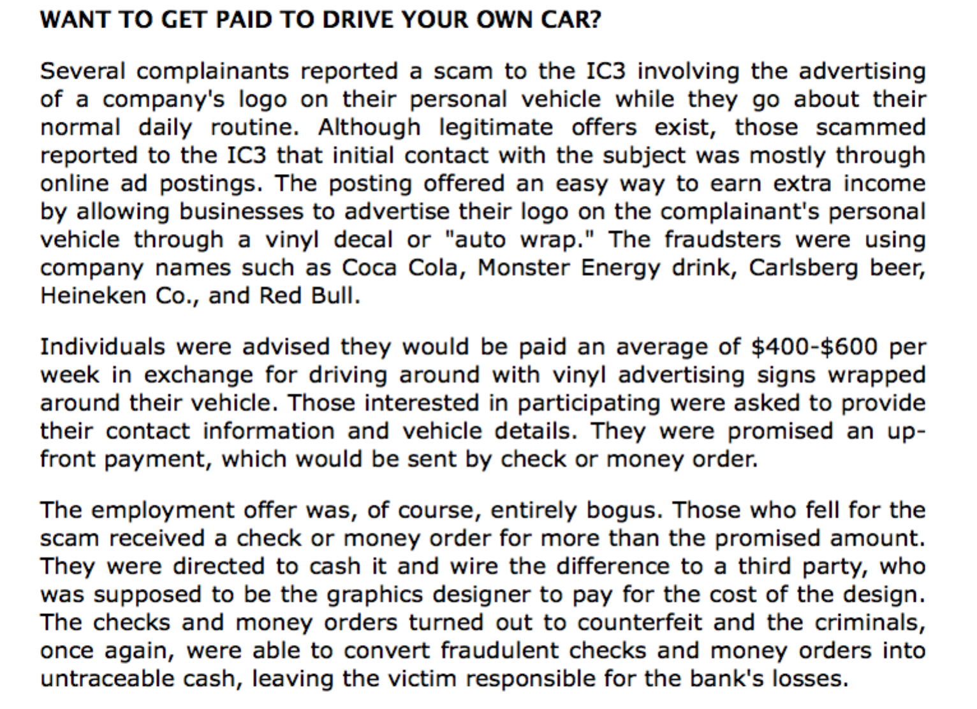
Car advertising websites for research:
http://www.wikihow.com/Turn-a-Car-Into-a-Moving-Advertisement
http://www.signs.com/blog/the-benefits-of-car-advertising/
http://www.bankrate.com/finance/auto/make-money-by-simply-driving-your-car-1.aspx
Article in Entreprehttp://www.entrepreneur.com/article/223676
Carvertise http://www.carvertise.com/gallery/
Car wraps http://graphicinstallers.com/vehicle-wraps/

Problem and Decision
What is the Elementary Social Studies Supervisor trying to do?
What problem do the teachers have?
What decision do they have to make?
Alternatives
What alternatives are they considering?

Criteria
What criteria does the supervisor want to meet?
Evaluation
Examine the data.
What are the benefits of your decision? What are some of the costs and possible consequences of your decision?

List the steps you followed to make your decision.

What other research would you like to conduct online before making a final recommendation?

Decision
What decision did you make? List reasons (evidence) for your decision.

Career Ready Practices:
1. Act as a responsible and contributing citizen and employee.
2. Apply appropriate academic and technical skills.
4. Communicate clearly, effectively and with reason.
5. Consider the environmental, social and economic impacts of decisions.
7. Employ valid and reliable research strategies.
8. Utilize critical thinking to make sense of problems and persevere in solving them.
9. Model integrity, ethical leadership and effective management.
12. Work productively in teams while using cultural/global competence.

