Decisionomics: Voting
For whom should I vote?
Based on idea by: Mrs. Beverly Ledbetter
http://printables.scholastic.com/shop/prcontent/Making-a-Good-Choice/9780545041669-009

voting can be government class. Ask at least one economics question.

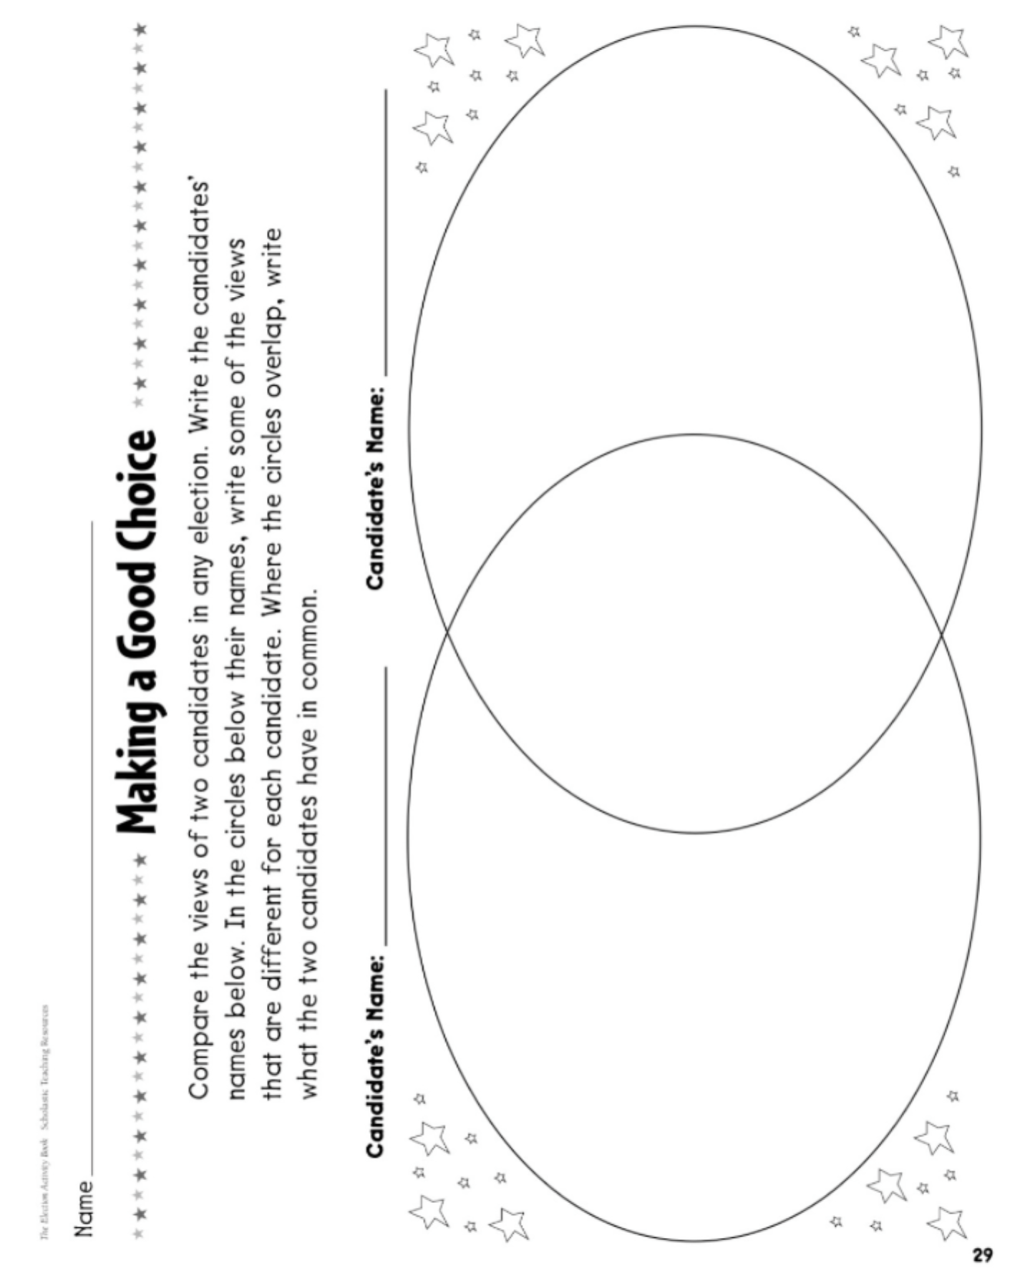
http://www.crfc.org/teaching-materials/decision-making-democracy voting and group decisin making lesson

http://www.econedlink.org/lesson/181/Mystery-Voters-Who-Don-t-Vote
The mysterery of voters who don’t vote.

http://www.econedlink.org/interactives/EconEdLink-interactive-tool-player.php?filename=em181_dragndrop_v2_save.swf&lid=181 Interactive for clues for mystery

Problem
Which candidate should you vote for?

Alternatives
What alternatives do you have?

Criteria
What criteria are important to you?

Criteria: What are important issues for me.
Alternatives: Different candidates

