 | Criteria: What are important considerations related to each alernative?
Alternatives: | Unit Cost | Carbon Offset | Demand | Political Viability
Plant trees
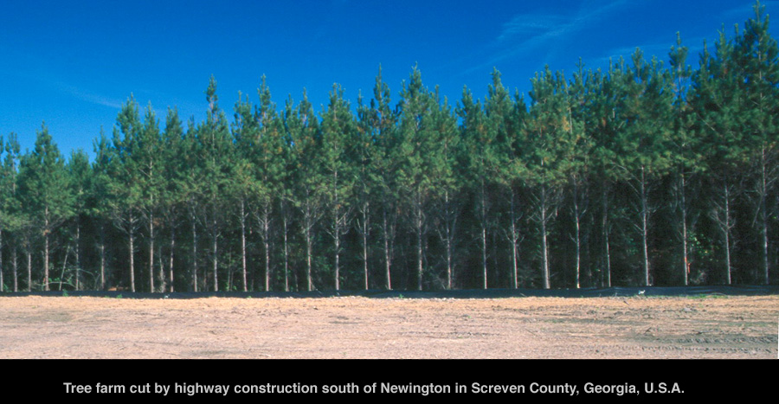
Electric Cars
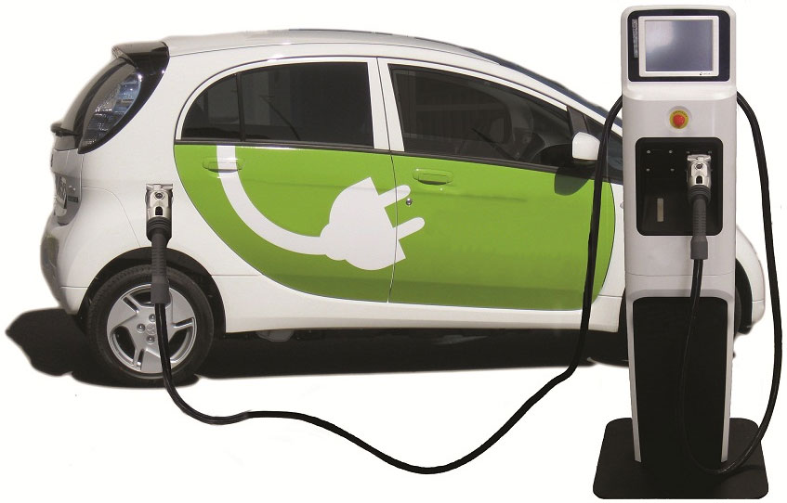
Public Transit
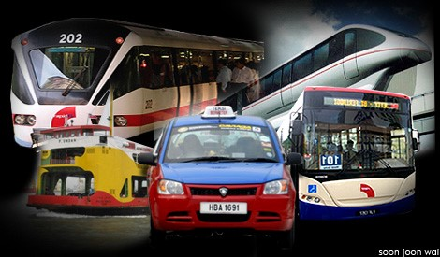
Carbon Tax
