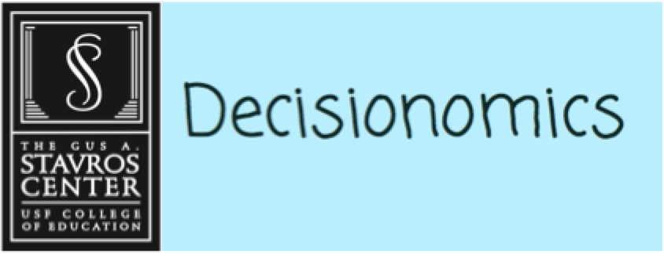
Women’s Right to Vote
Who is the greatest hero of the Suffrage Movement?

Social Studies Benchmarks:

Grade: 5

Social Studies Benchmarks:

SS.5.A.1.1 Use primary and secondary sources to understand history.

SS.5.C.2.5 Identify ways good citizens go beyond basic civic and political responsibilities to improve government and society.

SS.5.C.3.4 Describe the amendment process as defined in Article V of the Constitution and give examples.

SS.4.FL.2.5 Explain that costs are things that a decision maker gives up; benefits are things that a decision maker gains. Make an informed decision by comparing the costs and benefits of spending alternatives.

SS.4.FL.6.1 Explain that risk is the chance of loss or harm.

English/Language Arts Standards:
LAFS.5.RI.1.1 Quote accurately from a text when explaining what the text says explicitly and when drawing inferences from the text.
LAFS.5.RI.3.7 Draw on information from multiple print or digital sources, demonstrating the ability to locate an answer to a question quickly or to solve a problem efficiently.
LAFS.5.W.3.8 Recall relevant information from experiences or gather relevant information from print and digital sources; summarize or paraphrase information in notes and finished work, and provide a list of sources.
LAFS.5.SL.1.1 Engage effectively in a range of collaborative discussions (one-on-one, in groups, and teacher- led) with diverse partners on grade 5 topics and texts, building on others’ ideas and expressing their own clearly.
a. Come to discussions prepared, having read or studied required material; explicitly draw on that preparation and other information known about the topic to explore ideas under discussion.
b. Follow agreed-upon rules for discussions and carry out assigned roles.
c. Pose and respond to specific questions by making comments that contribute to the discussion and elaborate on the remarks of others.
d. Review the key ideas expressed and draw conclusions in light of information and knowledge gained from the discussions.

For this decision-making lesson, students will continue their study of the Women’s Suffrage Movement based on information provided by Internet articles and videos, to determine the most influential woman of the Movement. Using this information, students will rank their choices and explain how they reached their decisions.

Problem
Who is the most influential woman of the Women’s Suffrage Movement?

Alternatives
Susan B. Anthony, Elizabeth Cady Stanton, Alice Paul, Lucy Stone, Ida B. Wells

Criteria
Role in fighting for voting rights for women, role in fighting for other rights for women, role in fighting for rights for other groups

Decision
Which woman did you choose? How did you make that decision?

Read the letter from Women of the 21st Century and discuss the decision that the students need to make (which woman should be named the most influential woman of the Women’s Suffrage Movement). Discuss the criteria that the class included regarding how to choose the woman (role in fighting for voting rights for women, role in fighting for other rights for women, role in fighting for rights for other groups).
- Which groups of people did not have the same rights as others?
- What was the Suffrage Movement? Refer to the texts to review the specifics of this time period and rights of women, African-Americans, and children.
- Use the links below to connect the national Suffrage Movement to events in Florida. Discuss how Florida did not formally recognize the 19th Amendment until 1969 even though women were allowed to vote before that.
  - https://www.floridamemory.com/exhibits/floridahighlights/19th_amendment/
  - http://www.palmbeachpost.com/news/this-small-florida-city-let-women-vote-years-before-19th-amendment/8PsV6kxkbwSlIYvUiCBwRO/
  - http://articles.orlandosentinel.com/1996-09-01/news/9608291707_1_women-suffrage-suffrage-movement-suffrage-association
  - https://floridahumanities.org/audio_archive/womens-suffrage-in-florida/ (pod cast).
- Show the pictures of five leaders of the Women’s Suffrage Movement located at the bottom of this lesson plan. Provide students with the matrix and/or note-taking tool. Review the alternatives and criteria. Explain that they will research each of these women and determine which one was the most influential helping women get the right to vote.
- Use the following link to read about important women in the Suffrage Movement:
  - http://www.history.com/topics/womens-history/women-who-fought-for-the-vote
- Use the following links to research each woman:
- Susan B. Anthony https://www.youtube.com/watch?v=o-suAlXQhMI
- Alice Paul https://www.youtube.com/watch?v=5GDe4DkZN2A
- Elizabeth Cady Stanton https://www.youtube.com/watch?v=nCEaHGgUV-Q
- Lucy Stone https://www.youtube.com/watch?v=2hcIDGAKCjE
- Ida B. Wells https://www.youtube.com/watch?v=9DgsA3B4oVA
- After all information has been gathered, use the matrix to start a discussion on Susan B. Anthony. What notes were made related to each of the criteria? Does Susan B. Anthony meet all of the criteria? If yes, how? If not, what is missing?
  - How did she go beyond basic civic and political responsibilities to improve government and society?
  - What risks did she take?
- Repeat this process for the other women.
- In teams the students will work together to evaluate the completed matrix and make a decision regarding the woman that should be named as The Most Influential Woman of the Women’s Suffrage Movement. Students will then rank each woman from first to last.
- Students will then present their findings to the class, giving the reasons why ranked the choices as they did and the procedure of how they got to that decision. What is the opportunity cost (the next-best choice for the Most Influential Woman of the Women’s Suffrage Movement)?
  - Encourage students to discuss each step in their processes for making their choices. What did they do first? After that?
- Students write a letter to Women of the 21st Century and explain:
- how they ranked each woman
- the process they used for making their choices and
- why the woman they chose is the best choice.
A frame can also be used:
Date:
Dear Women of the 21st Century,
Our team has reviewed information on the five women that you provided and are suggesting the following for the Most Influential Woman of the Women’s Suffrage Movement. We have ranked them in order beginning with our top choice.
Top Choice:
Alternate Choice #1:
Alternate Choice #2:
Alternate Choice #3:
Alternate Choice #4 ________________________________
Alternate Choice #5 ________________________________
Our step-by-step procedure for ranking the choices in this way was:
Thank you for the opportunity to assist you with this project!
Sincerely,
Extension/ideas:
- Create a presentation for the Women of the 21 Century that outlines the woman chosen for the award.
- Have students role play the women and stage a television interview with the women as a panel of experts on suffrage.
- Read more about the Suffrage and Civil Rights at ReadWorks: https://www.readworks.org/article/Voting-Rights/8b3a3255-d5a6-4cac-b31c-7683091a25f4#!articleTab:content/contentSection:cfd232dd-39ef-401a-a946-08e0fb83154c/
Differentiation:
- Reduce alternatives and/or criteria.
  - Create a new letter from Women of the 21 Century asking students to reconsider their choices based on different alternatives/criteria
- Increase alternatives and/or criteria.
  - Same as above
- Provide note-taking tools with some of the information already filled in.

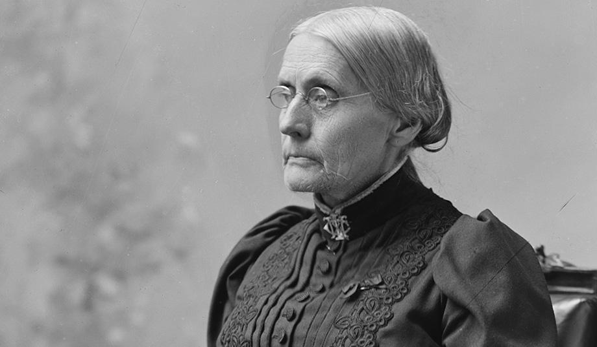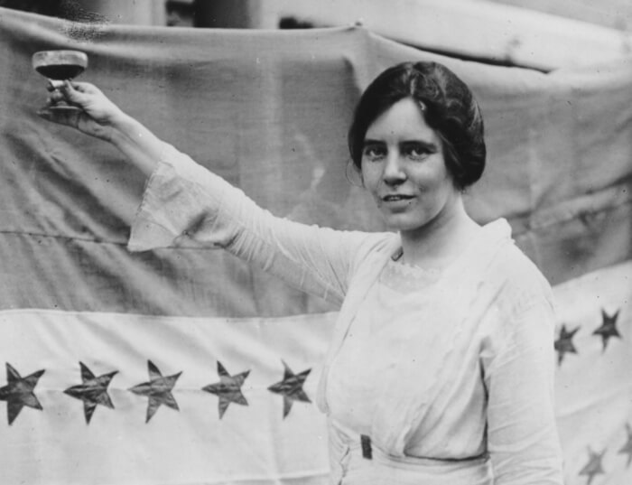
Susan B. Anthony Alice Paul

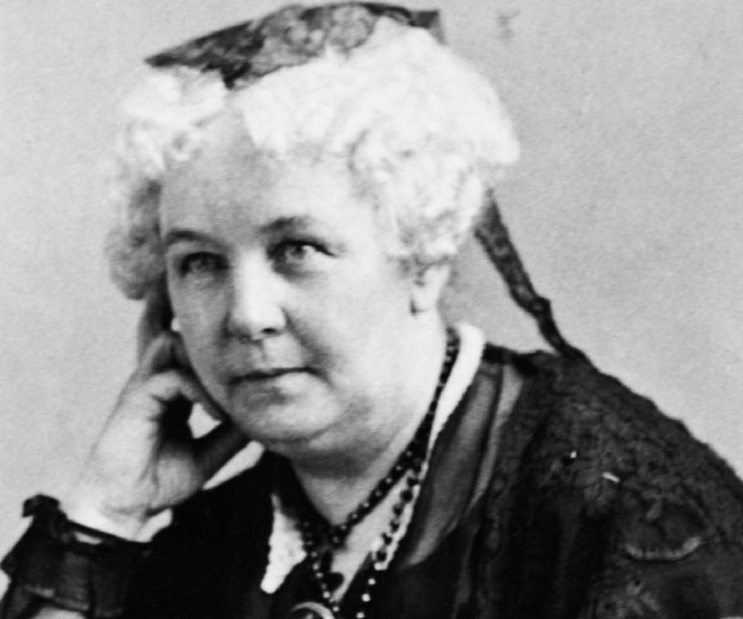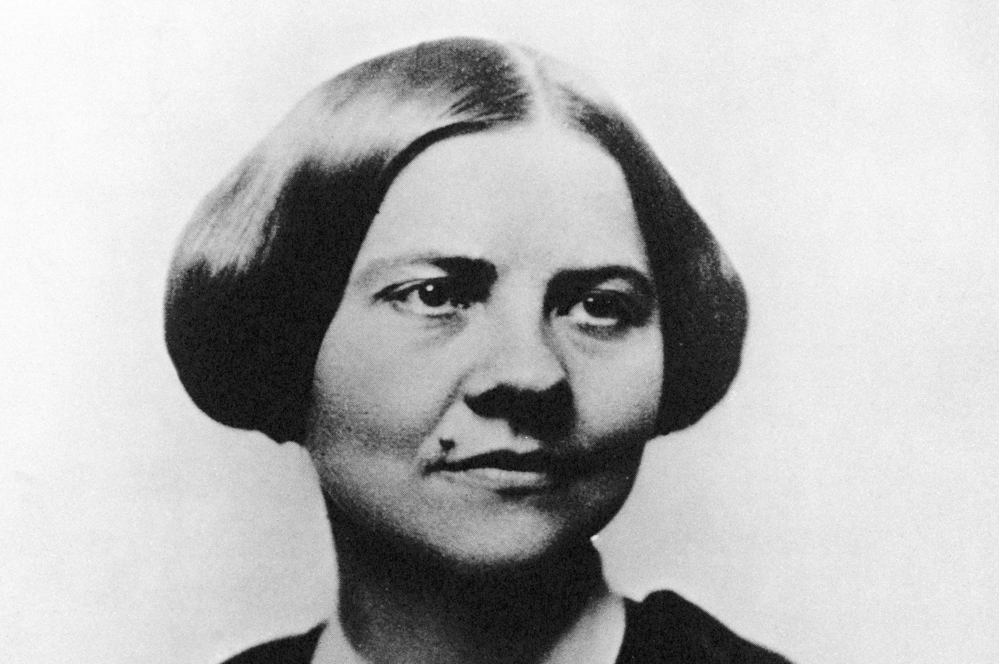
Elizabeth Cady Stanton Lucy Stone

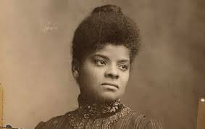
Ida B. Wells

