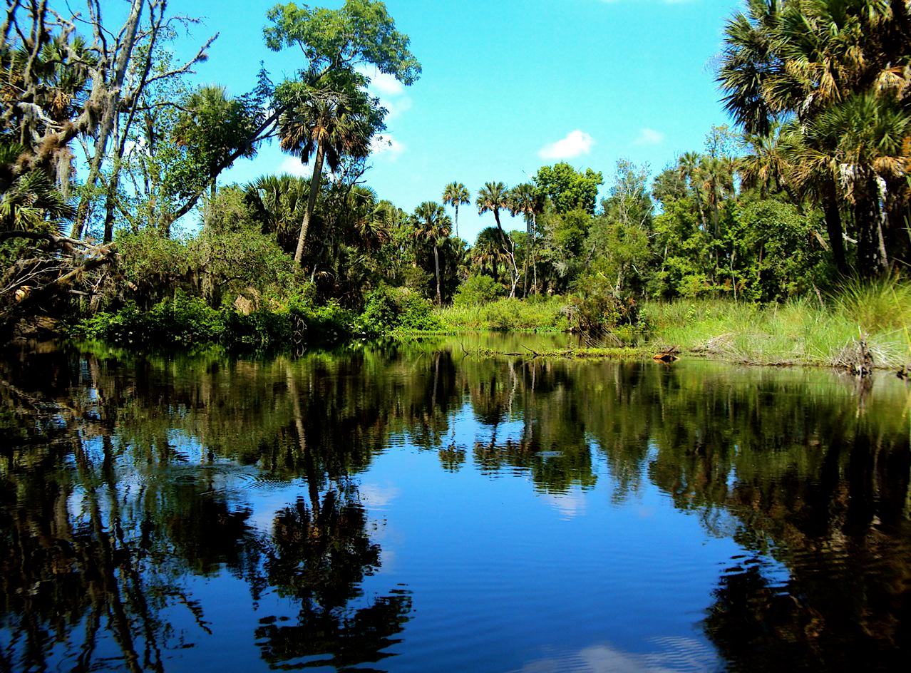

All About Nature Elementary School
863 Manatee Dr.
Big Pine, Florida 12345

Dear 5th grade students,

Our 5th grade class is going on a field trip! We have been studying the natural world and want to pick a great place to go for this very exciting one-day adventure. We want to visit a location that provides us with hands-on experiences with nature, has educational exhibits, is not too expensive, and is FUN.

We have narrowed the choices to four locations in the Tampa Bay Area: The Museum of Science and Industry (MOSI), The Florida Museum of Natural History, Camp Bayou Outdoor Learning Center, and The Florida Aquarium.

We have voted again and again, but we are in a four-way tie that cannot be broken. Could you please research each location and decide for us? Rank each potential field trip from first to fourth and explain how you came to your decision.

We cannot wait to find out where we will be going on our best-ever field trip. Thank you so much for your help.

Sincerely,

Mr. Zarid’s 5th grade class

