Field Trip Choices
Which is the best learning experience for Mr. Zarid’s class field trip?

Social Studies Benchmarks:

Grade: 5

Social Studies Benchmarks:

SS.5.E.1.2 Describe a market economy, and give examples of how the colonial and early American economy exhibited these characteristics.

Note: For this lesson, the focus is on the first part of this benchmark. In order to understand a market economy, students need to understand basic economic concepts (i.e. wants, needs, choice, resources, etc.).

Economic terms for review:
Opportunity cost - A benefit, profit, or value of something that must be given up to acquire or achieve something else; giving up one thing for another.

Scarcity – the state of being in short supply

Goods – items you buy such as food or clothing

Services – an action a person does for someone else

English/Language Arts Standards:
LAFS.5.RI.1.1 Quote accurately from a text when explaining what the text says explicitly and when drawing inferences from the text.
LAFS.5.RI.3.7 Draw on information from multiple print or digital sources, demonstrating the ability to locate an answer to a question quickly or to solve a problem efficiently.
LAFS.5.W.3.8 Recall relevant information from experiences or gather relevant information from print and digital sources; summarize or paraphrase information in notes and finished work, and provide a list of sources.
LAFS.5.SL.1.1 Engage effectively in a range of collaborative discussions (one-on-one, in groups, and teacher- led) with diverse partners on grade 5 topics and texts, building on others’ ideas and expressing their own clearly.
a. Come to discussions prepared, having read or studied required material; explicitly draw on that preparation and other information known about the topic to explore ideas under discussion.
b. Follow agreed-upon rules for discussions and carry out assigned roles.
c. Pose and respond to specific questions by making comments that contribute to the discussion and elaborate on the remarks of others.
d. Review the key ideas expressed and draw conclusions in light of information and knowledge gained from the discussions.

For this decision-making lesson, students will discuss criteria for choosing the best museum or learning center for Mr. Zarid’s class to visit based on information provided by Internet articles and video. Using this information, students will rank their choices and explain how they reached their decisions.

Problem
Which location is best for Mr. Zarid’s class field trip?

Alternatives
Four locations: Museum of Science and Industry (MOSI), Florida Museum of National History, Camp Bayou Outdoor Learning Center, The Florida Aquarium,

Criteria
What makes this field trip location a good choice?

Decision
Which museum or learning center is best for Mr. Zarid’s class? How did you make that decision?
- Read the letter from Mr. Zarid’s class and discuss the decision that the students need to make (the best museum or learning center for the Mr. Zarid’s class to visit to learn more about nature and the world around them). Discuss the criteria that the class included regarding how to choose the best field trip location (opportunity for hands-on experience with nature, educational exhibits, fun factor, cost).
- Project the pictures of four choices for the field trip: (pictures are located at the bottom of this lesson plan). Discuss any experiences that students have with these locations.
- Provide students with the note-taking tool. Review the alternatives and criteria related to the class field trip.
- Use the following links to research each location and take notes related to the criteria for choosing a museum or learning center to visit. Stop frequently during each video to discuss information and take notes:
- Museum of Science and Industry (MOSI) https://www.mosi.org
  - https://www.youtube.com/watch?v=g-6yB6uGZzE
- Florida Museum of Natural History https://www.floridamuseum.ufl.edu/
  - https://www.youtube.com/watch?v=1-2Md2MAw3A
- Camp Bayou Outdoor Learning Center http://www.campbayou.org/
  - https://www.youtube.com/watch?v=Jgi-r85KB_A
  - https://www.youtube.com/watch?v=5OSULKnkBA8
- The Florida Aquarium http://www.flaquarium.org/
  - Click on Things to Do and browse the different offerings at the aquarium
  - https://www.youtube.com/watch?v=SXznyi75Na4
- After all information has been gathered, use the matrix to start a discussion on MOSI. What notes did you take for each of the criteria? Does this location meet all of the criteria? If not, where is it lacking? Would this be a good choice for the field trip? What are the goods and services that are provided at this location?
  - Make additional notes on the matrix with specific ideas for each location related to all criteria.
- Repeat this process for the other locations.
- In teams the students will work together to evaluate the completed matrix and make a decision regarding the best museum or learning center for the class field trip. Students will then rank each location from first to last.
- Students will then present their findings to the class, giving the reasons why ranked the choices as they did and the procedure of how they got to that decision. Discuss why there can only be one best choice for the field trip (money and time for the trip are scarce resources). What is the opportunity cost (the second-best field trip location)?
  - Encourage students to discuss each step in their processes for making their choices. What did they do first? After that?
- Students write a letter to Mr. Zarid’s class reporting:
- how they ranked each location
- the process they used for making their choices and
- why the location they chose is the best one for the class field trip.
A frame can also be used:
Date:
Dear Mr. Zarid’s class,
Our team has reviewed information on the four locations that you provided and are suggesting the following for your class field trip. We have ranked the locations in order beginning with our top choice.
Top Choice for field trip:
Alternate Choice #1:
Alternate Choice #2:
Alternate Choice #3:
Our step-by-step procedure for ranking the choices in this way was:
Thank you for the opportunity to assist you with this project!
Sincerely,

Extension/ideas:
- Create a presentation for Mr. Zarid’s class that outlines the right location for their field trip.
- Look for instances of the lesson’s economic terms in other texts in Unit 1.
- Read more about using field trips to learn about the world around us at ReadWorks: https://www.readworks.org/find-content#!q:field+trip/g:21/t:0/f:0/lc:/l:[]/pt:/features:/

Differentiation:
- Reduce alternatives and/or criteria.
  - Create a new letter from Mr. Zarid’s class asking students to reconsider their choices based on different alternatives/criteria
- Increase alternatives and/or criteria.
  - Same as above
- Provide note-taking tools with some of the information already filled in.

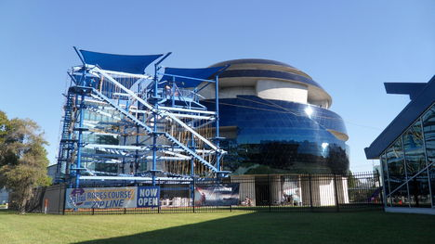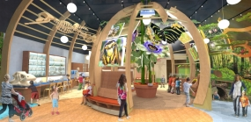
Museum of Science and Industry Florida Museum of Natural History

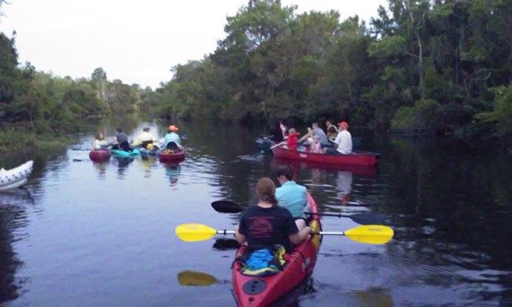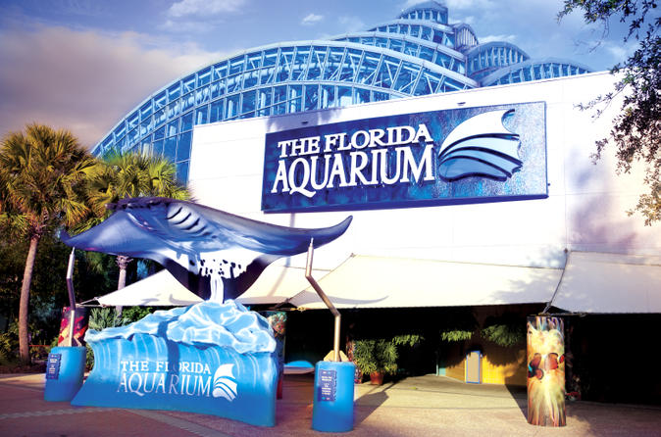
Camp Bayou Outdoor Learning Center The Florida Aquarium

