 | Criteria: What are important considerations related this field trip
Alternatives: | Opportunity for hands-on experiences with nature | Educational exhibits | Fun factor | Cost
MOSI
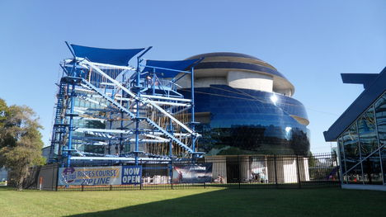
Florida Museum of National History
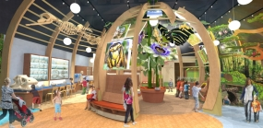
Camp Bayou Outdoor Learning Center
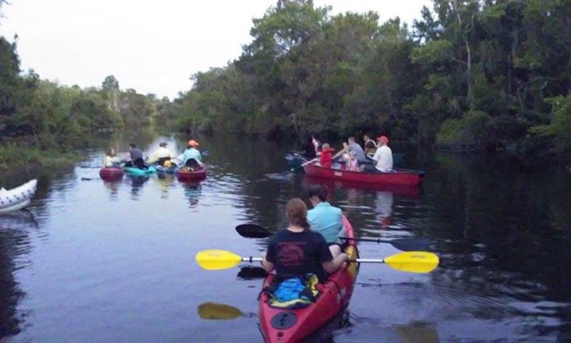
The Florida Aquarium
