 | Criteria: What makes a great entrepreneur?
Alternatives: Different Candidates | Takes an idea and makes a good product or service | Helps others | Works with a team | Changes ideas when needed
Sanjay & Shravan Kumaran
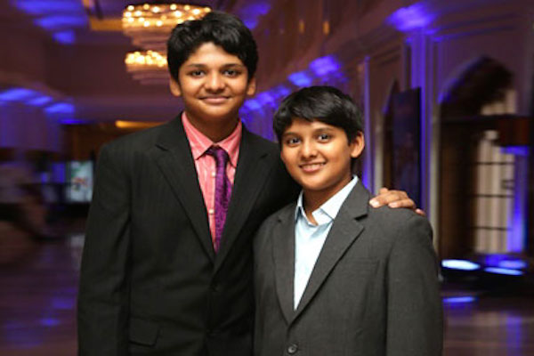
Fraser Doherty
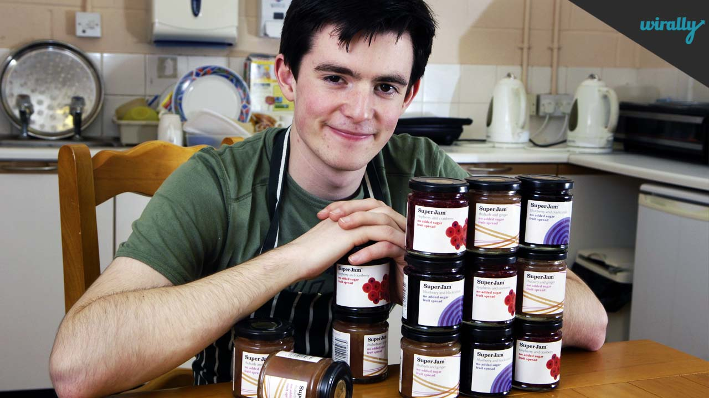
Robert Nay
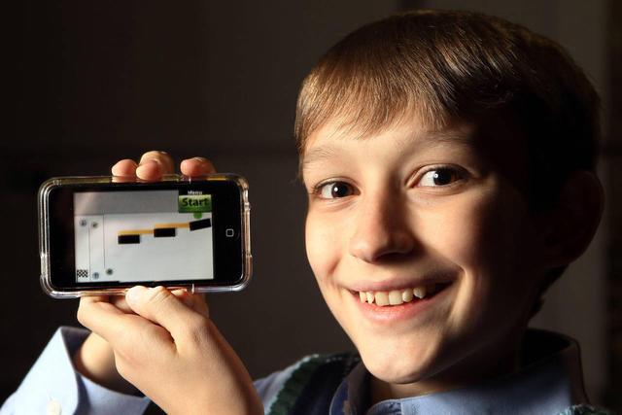
Jon Koon
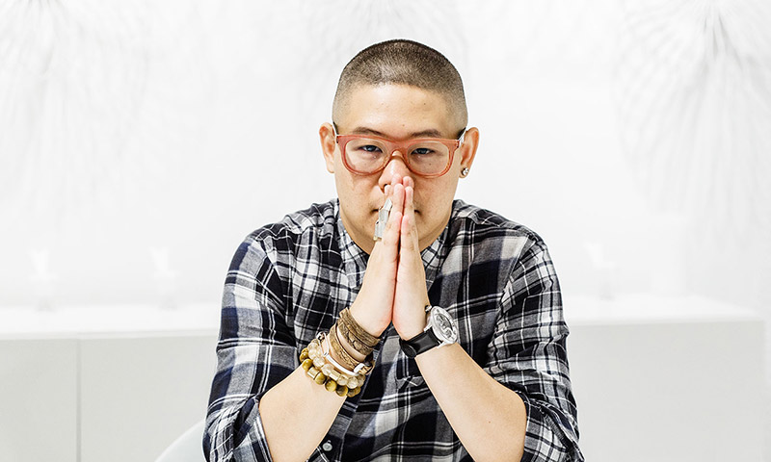
Leanna Archer
