 | Criteria: Impacts of Hurricane Irma
Alternatives: Different Locations | Ecosystem | Families | Tourism | Local economy
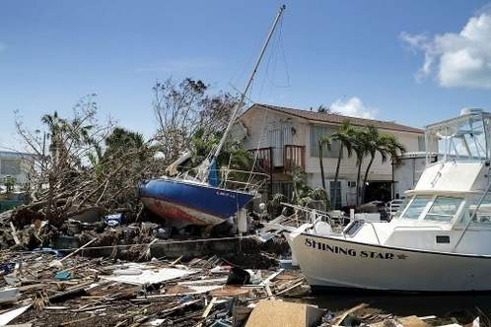

Key West
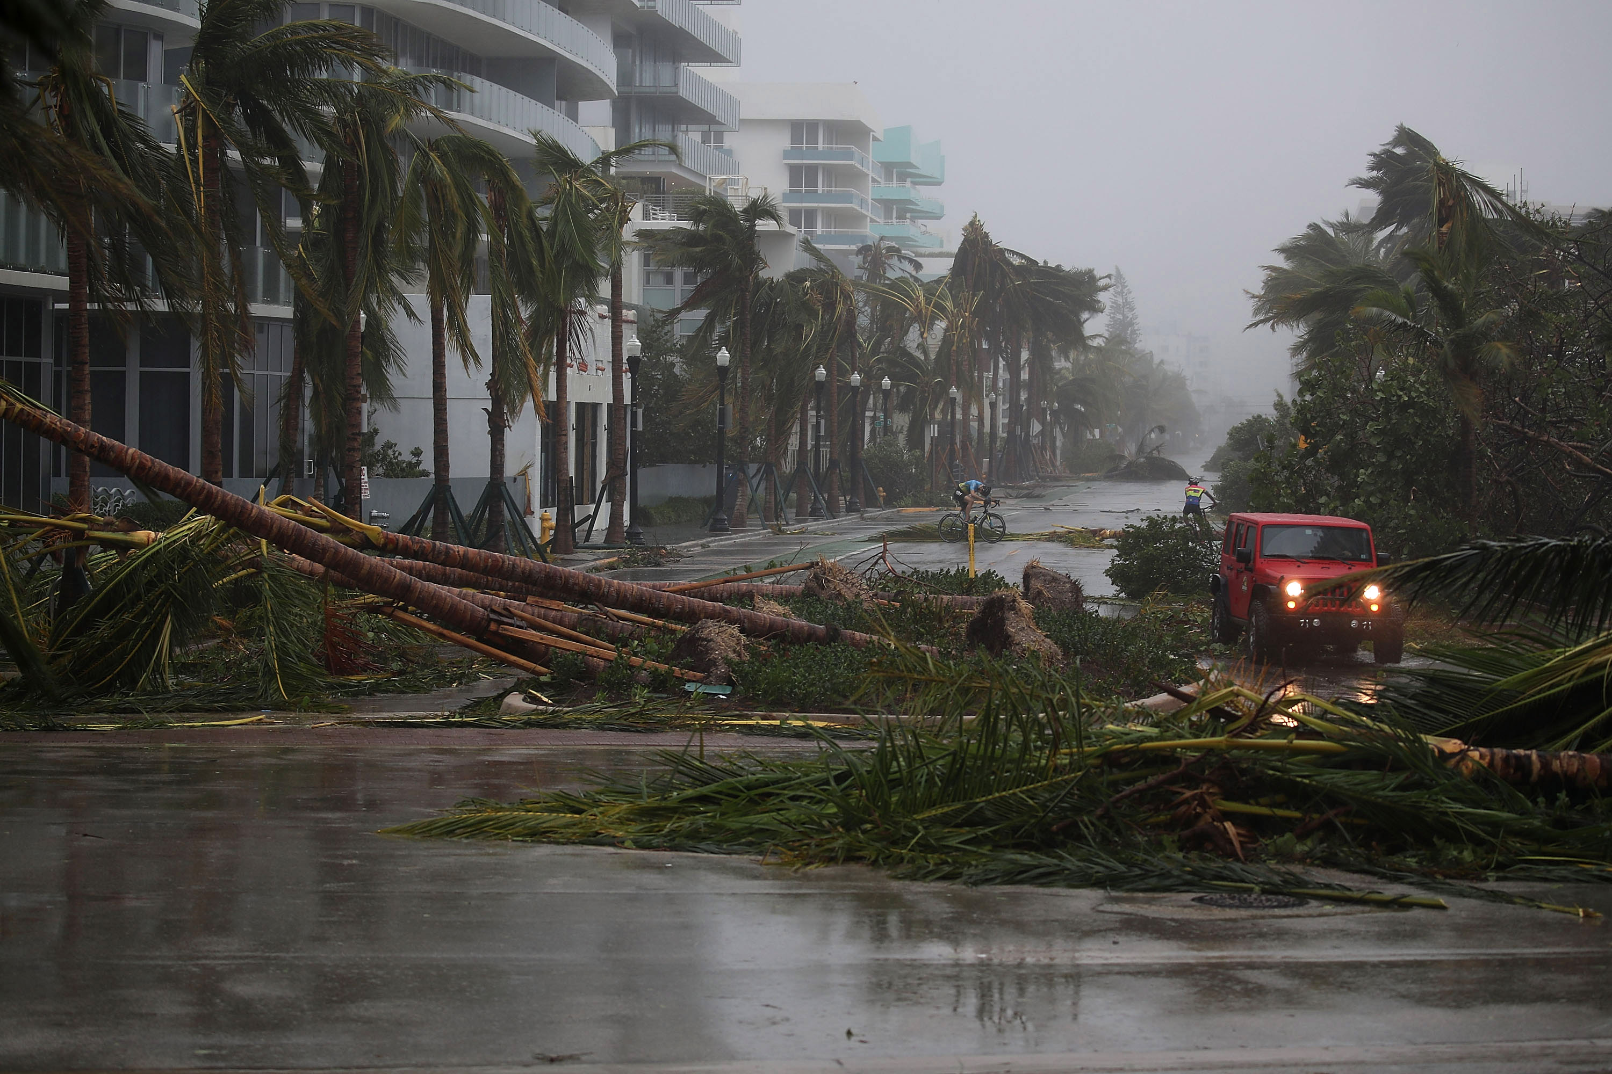

Miami
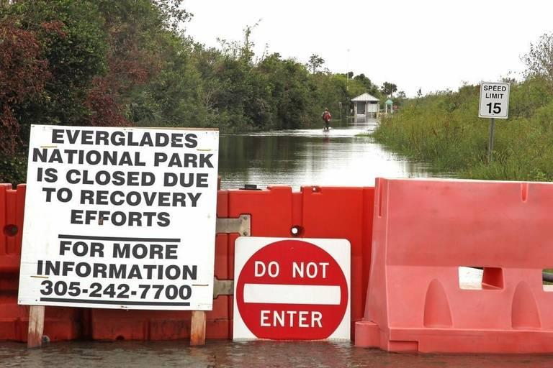

Everglades

