Criteria: What makes a great inventor?
Alternatives: Different Candidates
John Gorrie
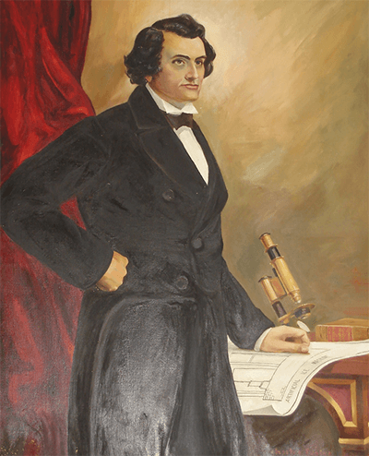
Thomas Edison
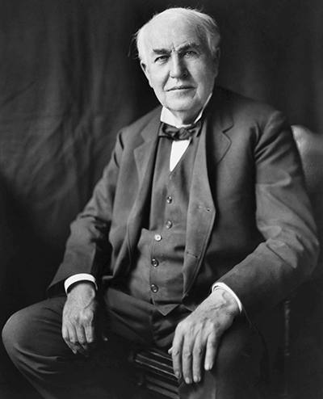
Robert Cade
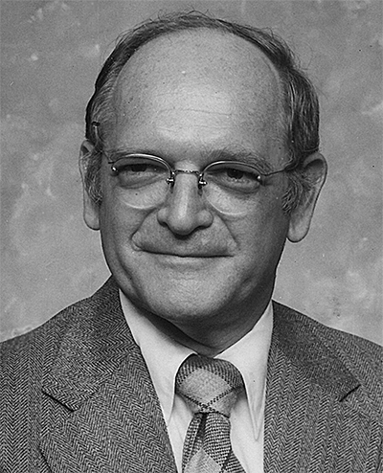
Jaqueline Quinn
Shin Tson Wu
