Who Best Represents Activism?

Social Studies Benchmarks:

Grade: 4

SS.4.C.2.2 Identify ways citizens work together to influence government and help solve community and state problems.

SS.4.C.2.3 Explain the importance of public service, voting, and volunteerism.

SS.4.FL.1.1 People have many different types of jobs from which to choose. Identify different jobs requiring people to have different skills.

English/Language Arts Standards:
LAFS.4.RI.1.1 Refer to details and examples in a text when explaining what the text says explicitly and when drawing inferences from the text.
LAFS.4.RI.3.7 Interpret information presented visually, orally, or quantitatively (e.g., in charts, graphs, diagrams, demonstrate understanding of the text (e.g., time lines, animations, or interactive elements on Web pages) and explain how the information contributes to an understanding of the text in which it appears.
LAFS.4.W.3.8 Recall relevant information from experiences or gather relevant information from print and digital sources; take notes and categorize information, and provide a list of sources
LAFS.4.SL.1.1 Engage effectively in a range of collaborative discussions (one-on-one, in groups, and teacher- led) with diverse partners on grade 4 topics and texts, building on others’ ideas and expressing their own clearly.
a. Come to discussions prepared, having read or studied required material; explicitly draw on that preparation and other information known about the topic to explore ideas under discussion.
b. Follow agreed-upon rules for discussions and carry out assigned roles.
c. Pose and respond to specific questions to clarify or follow up on information, and make comments that contribute to the discussion and link to the remarks of others.
d. Review the key ideas expressed and explain their own ideas and understanding in light of the discussion.

For this decision-making lesson, students will research four community activists and choose the one who should be promoted on an advertising campaign. Students will use web articles and videos to rank their choices and explain how they reached that decision.

Problem
Which activist should be promoted on With Liberty and Justice for All’s advertising materials?

Alternatives
Judy Bonds, W. W. Law, Craig Kielburger, Elizabeth Cady Stanton

Criteria
Identified a problem that threatened the health and/or safety of others, made an impact on his or her community, made an impact beyond his or her community, results of his or her work is still evident today

Decision
How were these activists ranked? How was that decision reached?

Read the letter from With Liberty and Justice for All. Discuss the problem (which activist should be promoted on the organization’s advertising materials), the alternatives (Judy Bonds, W. W. Law, Craig Kielburger, Elizabeth Cady Stanton) and the criteria (identified a problem that threatened the health and/or safety of others, made an impact on his or her community, made an impact beyond his or her community, results of his or her work is still evident today).

- Use the link below to begin a discussion on how any citizen can make a difference is his or her community:
  - How to Change the World – Kid President https://www.youtube.com/watch?v=4z7gDsSKUmU
  - Connect the concepts in the video to what students see in today’s world and with the work of the four candidates for Voice for Justice.
- Show pictures (on the lesson plan below) of the activists who are being considered by With Liberty and Justice for All.
- Provide students with the decision-making matrix or note-taking tool, and review the alternatives and criteria.
- Use the links below to research each activist. Stop frequently to discuss the criteria and take notes.
  - Judy Bonds
http://www.nytimes.com/2011/01/16/us/16bonds.html
https://www.youtube.com/watch?v=WifwMfgwHk4
b. W. W. Law
http://www.savannahga.gov/index.aspx?NID=1908 (biography, primary sources)
https://www.youtube.com/watch?v=yxNxp2rO4hA
c. Craig Kielburger
http://www.peaceheroes.com/CraigKielburger/craigkielburgerbio.htm
https://www.youtube.com/watch?v=D3DD5mLmwcg
d. Elizabeth Cady Stanton
https://www.nwhm.org/education-resources/biographies/elizabeth-cady-stanton
https://www.youtube.com/watch?v=nCEaHGgUV-Q
- Working in groups, students discuss the criteria for each activist. Which one meets the criteria for being named Voice for Justice? Why? Rank the choices from highest to lowest.
- Encourage students to discuss their processes for making their choices. What did they do first? After that?
- Groups write a letter to explaining how they made their choices.
Extension/ideas:
- Have each group create a presentation explaining how they made their choices.
- Research other activists who brought change to their communities.
- Learn more about the everyday people can make a difference at ReadWorks:
  - Peer Pressure Power https://www.readworks.org/article/Peer-Pressure-Power/f5939357-7009-4786-92a7-5c772683f4c6#!articleTab:content/
  - How Can You Help? https://www.readworks.org/article/How-Can-You-Help/d289530b-5c02-4f72-a685-97e3c2de9d93#!articleTab:content/
  - Harriet Tubman and the Underground Railroad https://www.readworks.org/article/Famous-African-Americans---Harriet-Tubman-and-the-Underground-Railroad/bf86d318-2804-4d41-ac76-3ef4aa7dc51b#!articleTab:content/

Differentiation:
- Reduce alternatives and/or criteria.
- Increase alternatives and/or criteria.
- Provide note-taking tools with some of the information from videos and/or web articles already filled in.

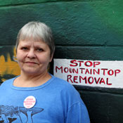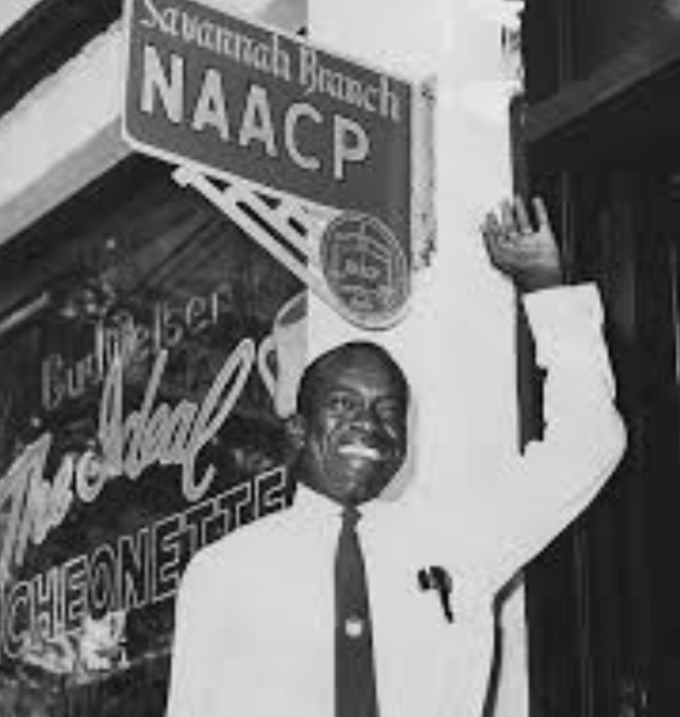
Judy Bonds W. W. Law
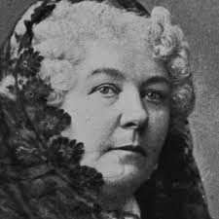
Craig Keilburger Elizabeth Cady Stanton

