 | Criteria:
Alternatives: Voices for Justice | Identified a problem that threatened the health and/or safety of others | Made an impact on his or her community | Made an impact beyond his or her community | Results of his or her work is still evident today
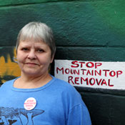
Judy Bonds
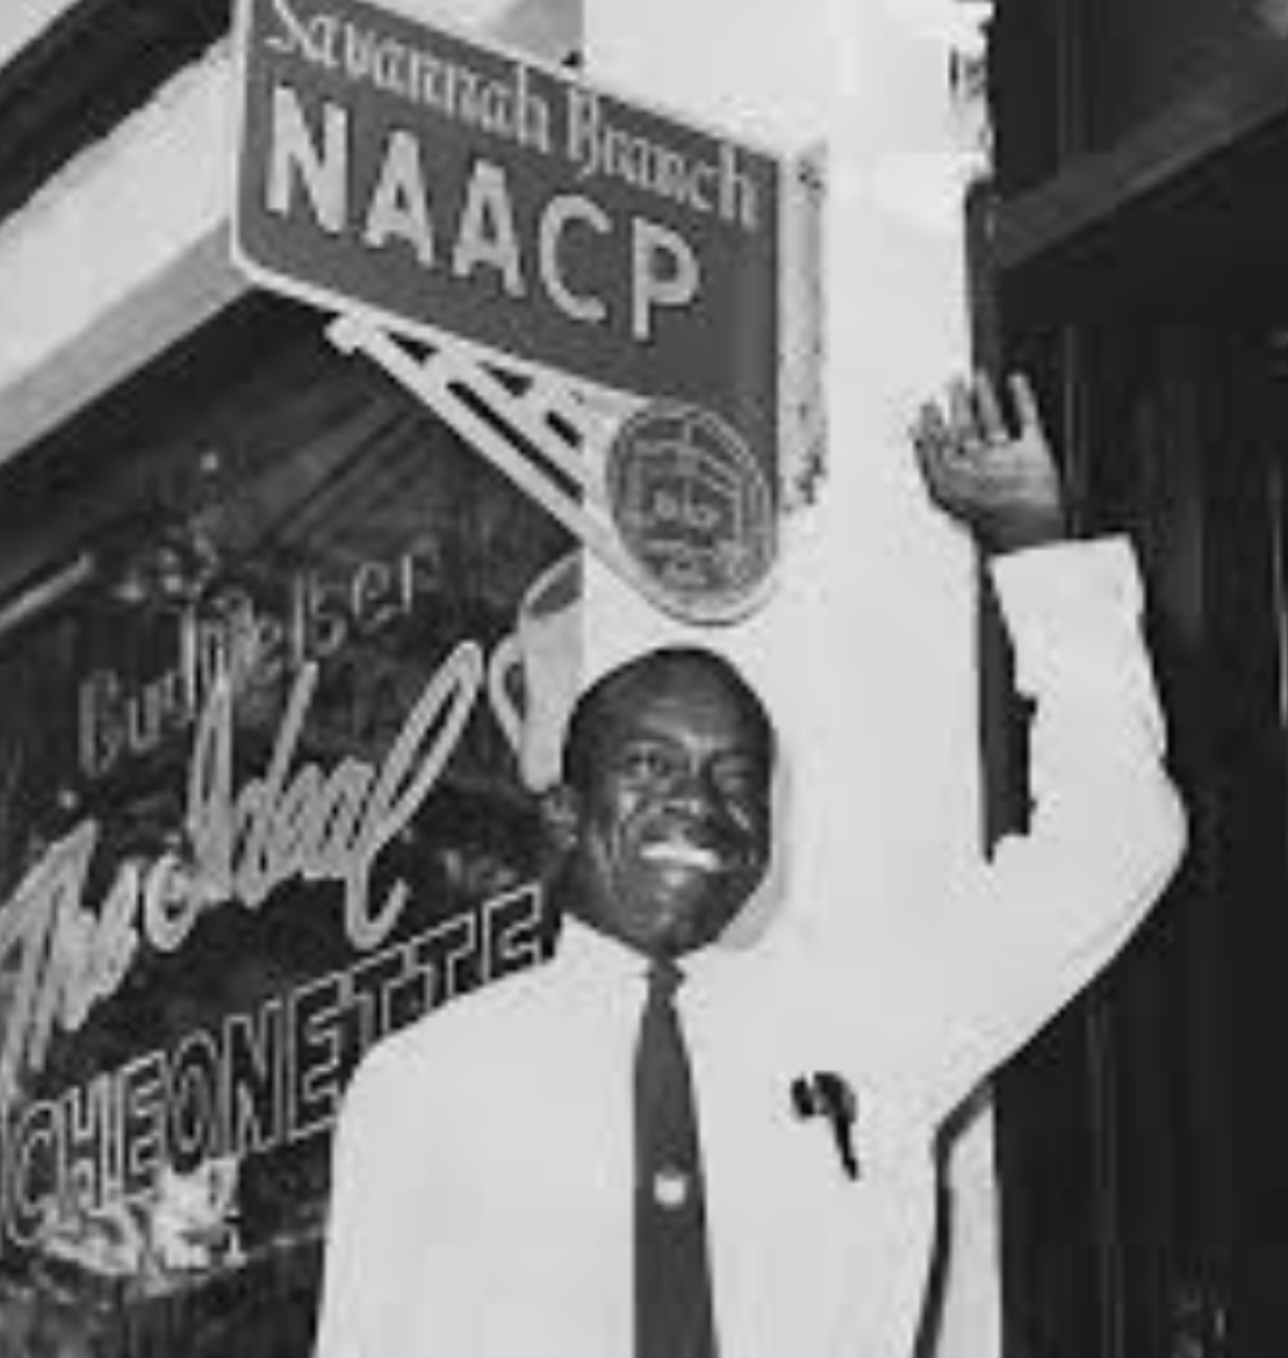
W. W. Law
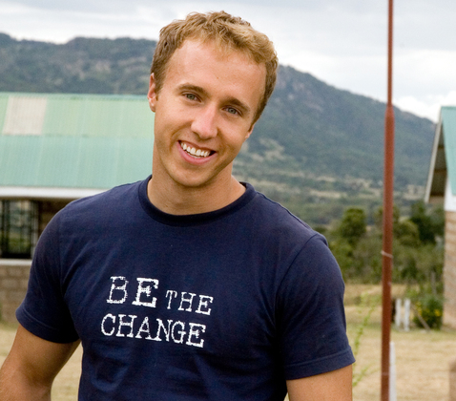
Craig Keilburger
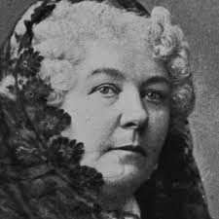
Elizabeth Cady Stanton

