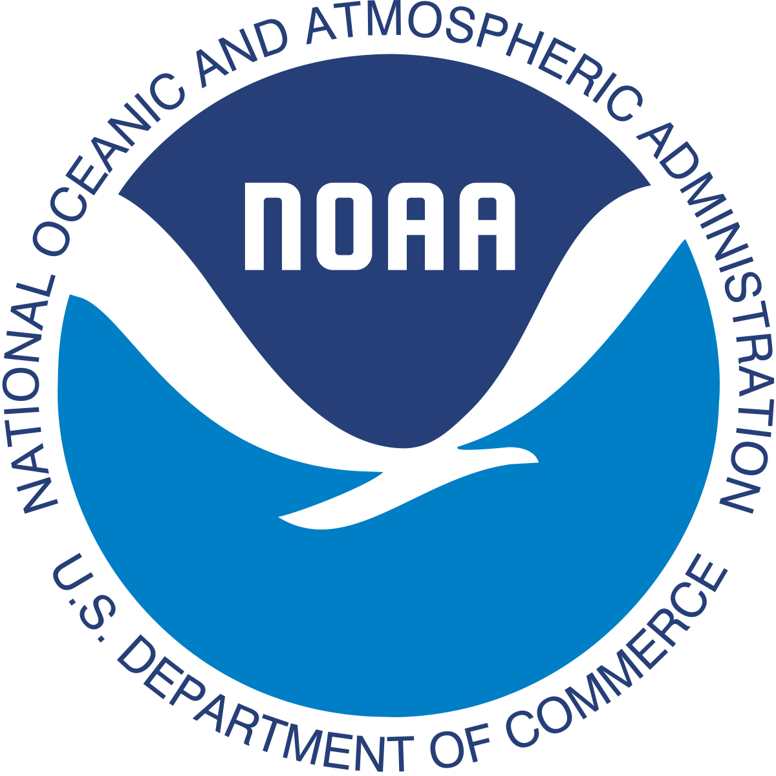

National Oceanic and Atmospheric Administration
Office of Protected Resources
NOAA Fisheries
Silver Spring, MD 20910

Dear Sea Turtle Protectors,
Sea turtles have roamed Earth's oceans and seas for millions of years. The first sea turtles were on Earth nearly 150 million years ago!
Six species of sea turtles in oceans around the United States are either threatened or in danger of extinction. We chose four species that our office would like to consider adding additional resources in ensuring their survival:
- Green Sea Turtle
- Hawksbill sea turtle
- Leatherback Sea Turtle
- Loggerhead Sea Turtle

Due to budget cuts, we have decided to direct our funding to one species this year. Having already narrowed the choices down, we ask that you to use the following criteria to direct your research of each species of sea turtle:
- To what extent is each species at risk?
- How long does each species live?
- Who are the species’ predators?
- Why is this species in trouble?
After completing your research, decide which species should receive additional support from our organization. Once you have made your decision, please write back to us and tell us how you ranked each sea turtle (first to fourth). Also explain the process you used to make each ranking.
The National Oceanic and Atmospheric Administration thanks you in advance for your time in taking on this project.

