**Ajiaco**

From Colombia, you have Ajiaco, which ingredients typically include chicken, corn, at least two kinds of potatoes, sour cream, capers, avocado, and guasca.

<https://www.worldatlas.com/webimage/countrys/samerica/co.htm>

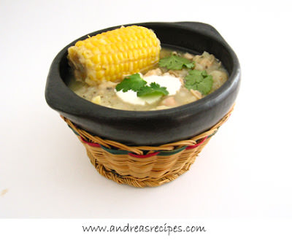

**Chlodnik**

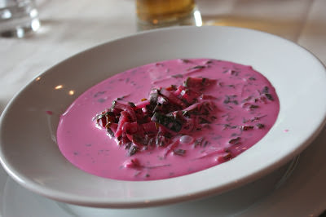

A cold variety of borsch — beet root soup traditional to some Northern European and Slavic countries made with sour cream, soured milk, kefir or yoghurt, radishes or cucumbers, garnished with dill or parsley.

<https://www.worldatlas.com/webimage/countrys/europe/pl.htm>

**Pho**

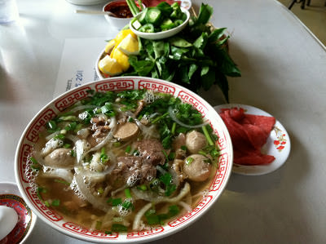

The Vietnamese beef/chicken soup cooked with scallion, welsh onion, charred ginger, wild coriander, basil, cinnamon, star anise, cloves and black cardamom.

<https://www.worldatlas.com/webimage/countrys/asia/vn.htm>

**Waterzooi**

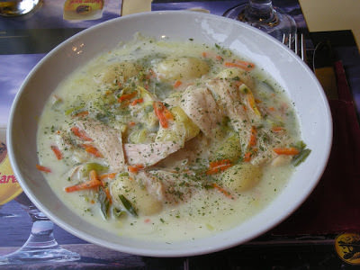

Means “watery mess’ in Dutch. Made of fish or chicken, carrots, leeks and potatoes, herbs, eggs, cream and butter.

<https://www.worldatlas.com/webimage/countrys/europe/be.htm>