Which Soup?

Social Studies Benchmarks:

Grade: 3

SS.3.E.1.3 Recognize that buyers and sellers interact to exchange goods and services through the use of trade or money.

Grade 4 Financial Literacy

SS.4.FL.2.2 Explain that people make choices about what goods and services they buy because they can’t have everything they want. This requires individuals to prioritize their wants.

SS.F.FL.2.4 Discuss that whenever people buy something, they incur an opportunity cost. Opportunity cost is the value of the next best alternative that is given up when a person makes a choice.

Economic Concepts for Review:

Buyers – People who purchase goods and services

Sellers – People who provide goods and services

Goods – Items that people buy

Services – Actions that people buy

Opportunity Cost - The next-best choice

English/Language Arts Standards:
LAFS.3.RI.1.1 Ask and answer questions to demonstrate understanding of a text, referring explicitly to the text as the basis for the answers.
LAFS.3.RI.3.7 Use information gained from illustrations (e.g., maps, photographs) and the words in a text to demonstrate understanding of the text (e.g., where, when, why, and how key events occur).
LAFS.3.W.3.8 Recall information from experiences or gather information from print and digital sources; take brief notes on sources and sort evidence into provided categories.
LAFS.3.SL.1.1 Engage effectively in a range of collaborative discussions (one-on-one, in groups, and teacher-led) with diverse partners on grade 3 topics and texts, building on others’ ideas and expressing their own clearly.
- Come to discussions prepared, having read or studied required material; explicitly draw on that preparation and other information known about the topic to explore ideas under discussion.
- Follow agreed-upon rules for discussions and carry out assigned roles.
- Pose and respond to specific questions to clarify or follow up on information, and make comments that contribute to the discussion and link to the remarks of others.
- Review the key ideas expressed and explain their own ideas and understanding in light of the discussion.

For this decision-making lesson, students will discuss criteria for choosing a new soup offering at a restaurant. Students conduct research using information from web articles, recipes, and a food glossary. Using this information, students will rank their choices and explain how they reached their decisions.

Problem
Which is the best soup choice for a new restaurant?

Alternatives
Ajiaco, Chlodnik, Pho, Waterzooi

Criteria
Is it healthy, is it easy to make, does it look delicious, is it expensive?

Decision
Which soup is best for the new restaurant? How did you make that decision?

- Read the letter from International Restaurant. What is the problem (the restaurant wants to add a soup to its menu that will attract customers). Discuss and identify buyers, sellers, goods, and services.
- Partner talk: What is your favorite soup? Discuss if these soups are healthy (probe to see if students know what ingredients are in the soups). Ask if they have eaten soup in a restaurant. How does one decide which soup to choose?
  - For a little fun, show the Soup Etiquette video at the following link: https://www.youtube.com/watch?v=APabrqapTJA
Remind students that it is important to use good manners when eating at home, at school, at restaurants, etc.
- Project the Types of Soups document found in the lesson folder. Click on the links to show the location of each country of origin for each soup. Review the criteria that International Restaurant is looking for in a new soup choice (is it healthy, is it easy to make, does it look good to eat, is it expensive). Use the matrix or note-taking tool to record information about each soup.
- Next, project the Soup Glossary. Identify the ingredients for each soup. Do the ingredients taste good? Are they healthy? Record ideas for each soup related to ingredients.
- Research recipes for each soup using the following links:
  - recipe for ajiaco https://www.healthination.com/food/healthy-ajiaco-soup
  - recipe for chlodnik http://polishhousewife.com/chlodnik-cold-polish-beet-soup/
  - recipe for pho http://www.cookinglight.com/recipes/quick-chicken-pho
  - recipe for waterzooi https://thehungrybelgian.com/2013/07/06/chicken-in-the-manner-of-ghent/
- Record additional information related to each criterion.
- After all information has been gathered, use the matrix to start a discussion on Ajiaco. What notes did you take for each of the criteria? Would this be a good choice for International Restaurant? Why or why not? Would people (buyers) want to purchase this soup (good) from the menu? Why or why not?
- Repeat this process for the other soups.
- In teams the students will work together to evaluate the completed matrix and make a decision regarding which soup would be the best choice for International Restaurant.
- Teams will then present their findings to the class, giving the reasons why ranked the choices as they did and the procedure of how they got to that decision. Prompt students to think about each step of their decision-making processes. What did they do first? After that? Point out that the soup that was ranked second is the opportunity cost (the next-best choice after the soup that was chosen).
- Students write a letter to International Restaurant reporting:
- how they ranked each soup
- the process they used for making their choices and
- why International Restaurant should choose this soup.
A frame can also be used:
Date:
Dear
Our team has reviewed information on the four types of soup you provided and is suggesting the following soup to be included in your restaurant menu. We have ranked the soups in order beginning with our top choice.
Top Choice:
Alternate Choice #1:
Alternate Choice #2:
Alternate Choice #3:
Our step-by-step procedure for ranking the choices in this way was:

Thank you for the opportunity to assist you with this project!
Sincerely,

Extension/ideas:
- Create a presentation for International Restaurant that outlines why a particular soup should be added to the menu.
- Read more about endangered species at ReadWorks:
  - Iranian Food https://www.readworks.org/article/Iranian-Food/b370b915-bd82-4e4c-b7ec-4a009bccc394#!articleTab:content/
  - Students’ Health and Schools (text set) https://www.readworks.org/article/Students-Health-and-Schools/49be133d-1cbe-483a-9d19-0069d49a1655#!articleTab:content/contentSection:effe0d92-f480-4e06-a694-d64768fa55e5/
- Research other international soups. Create a class recipe book.
- Team up with other classes to make each soup recipe to determine taste and easy in making.
- If your school has a garden, use ingredients to make soup.

Differentiation:
- Reduce alternatives and/or criteria.
  - Create a new letter from International Restaurant asking students to reconsider their choices based on different alternatives/criteria
- Increase alternatives and/or criteria.
  - Same as above
- Provide note-taking tools with some of the information already filled in.

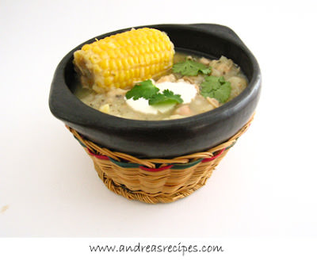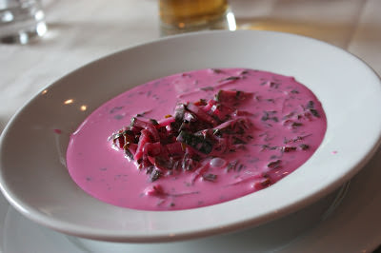
ajiaco chlodnik

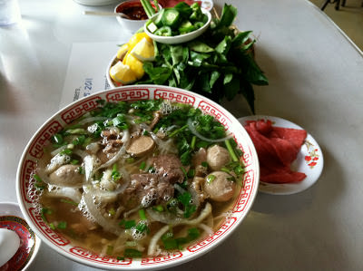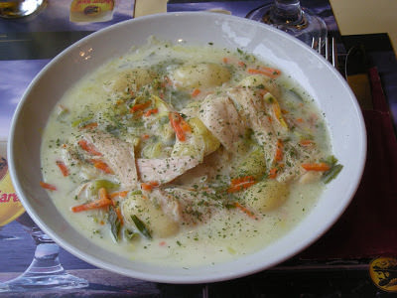
pho waterzooii

