Soup Glossary

Borsch | 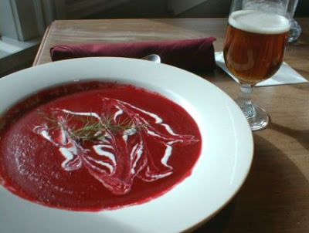 | strong red colored vegetable soup from eastern Europe that includes beet roots
Capers | 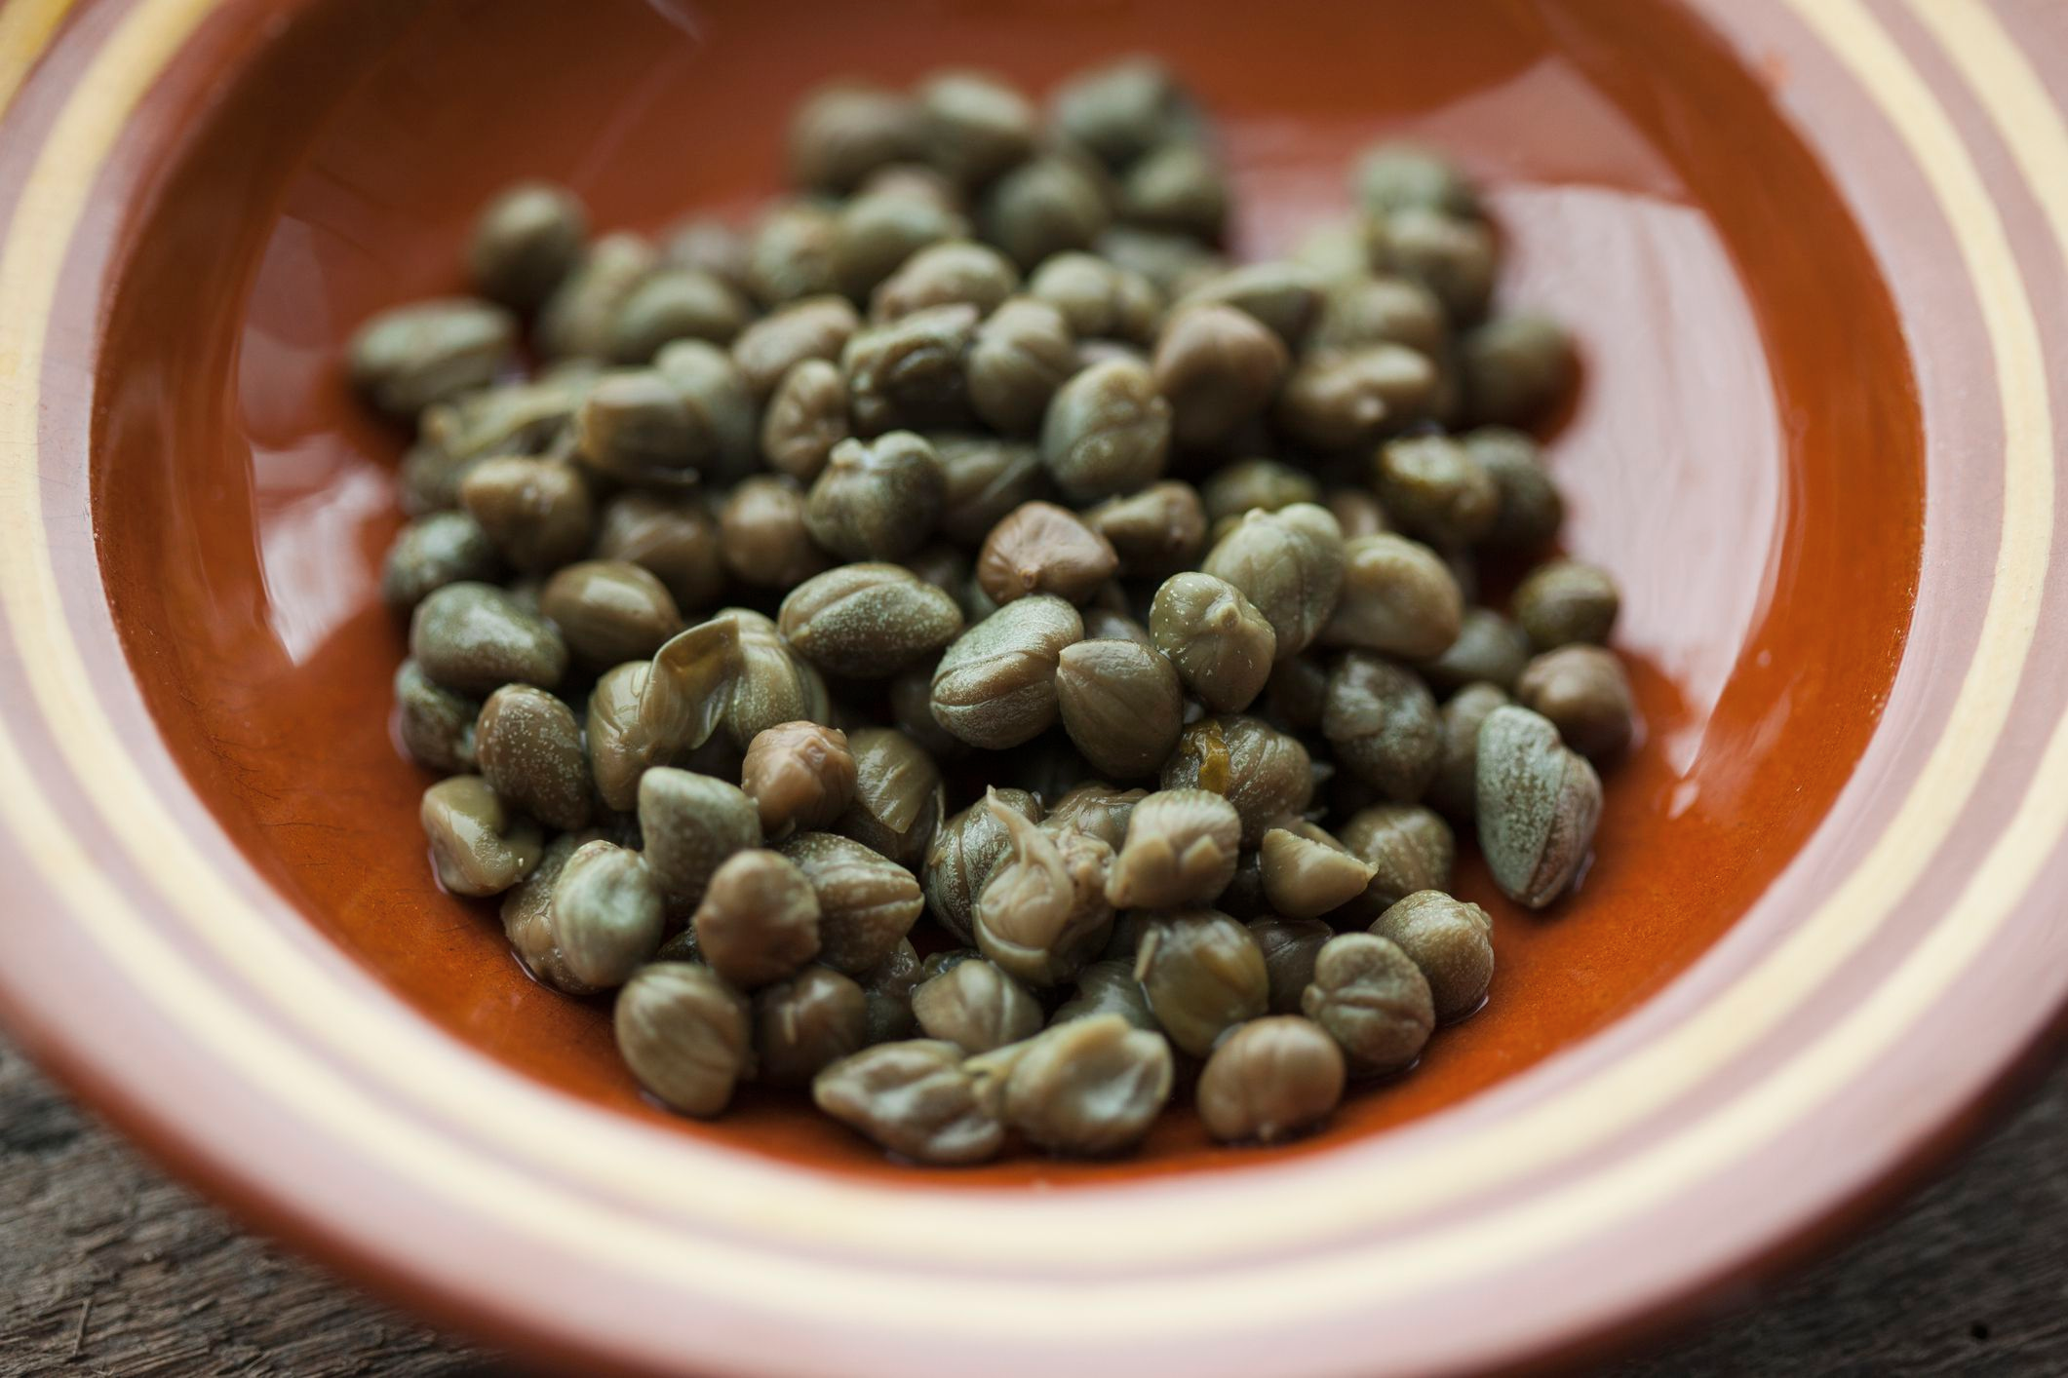 | pickled flower buds packed in salt
Charred Ginger | 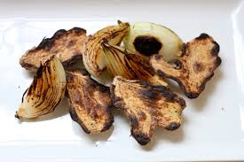 | root spice burned over an open flame
Cinnamon | 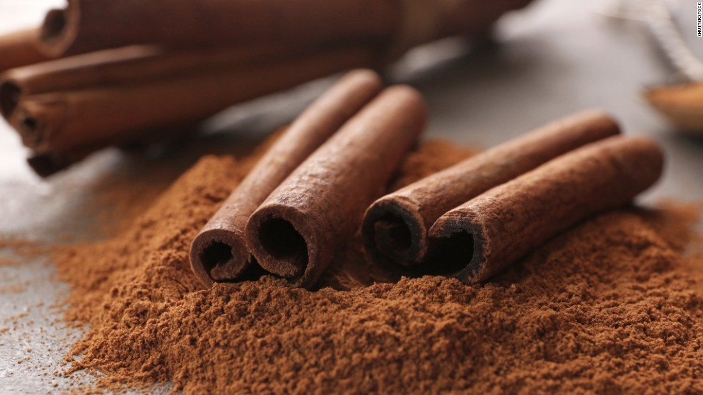 | spice obtained from the inner bark of several different trees
Cream |  | the thick white or pale yellow fatty liquid that rises to the top when milk is left to stand
Cloves | 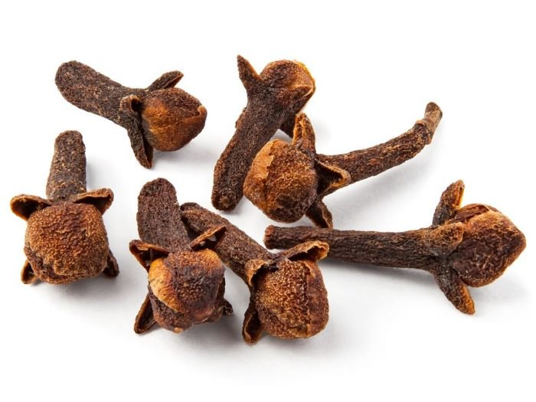 | the dried flower bud of a tropical tree, used as an aromatic spice
Dill | 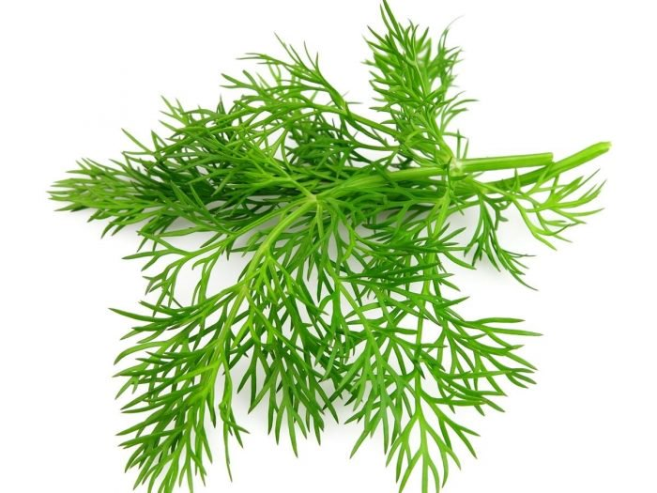 | an herb of the parsley family, with fine blue-green leaves and yellow flowers
Guasca | 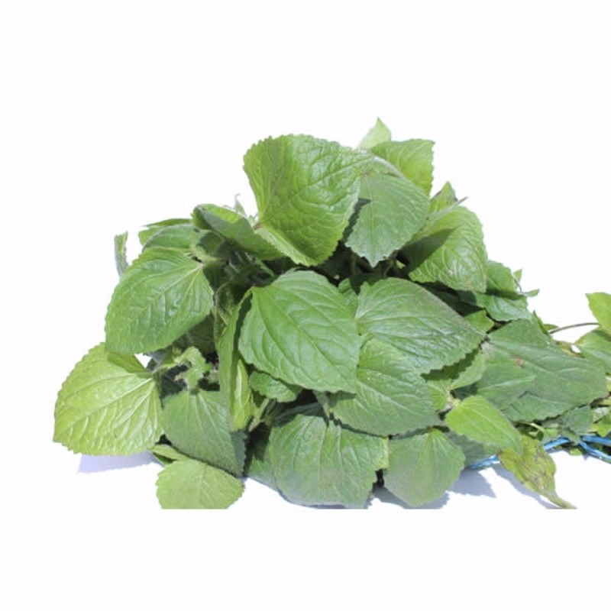 | an herb plant in the daisy family
Kefir | 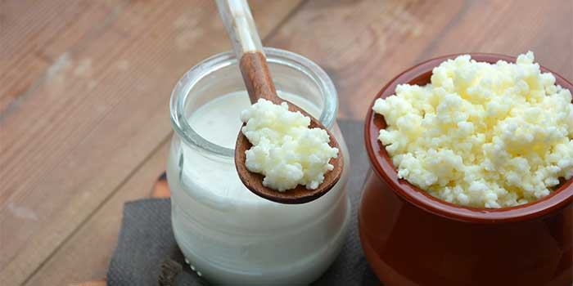 | a sour-tasting drink make from cow's milk fermented with certain bacteria  high fat content
Leeks | 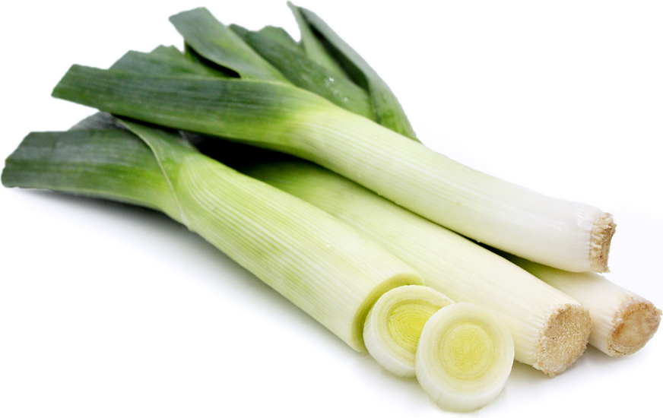 | a plant related to the onion
Parsley | 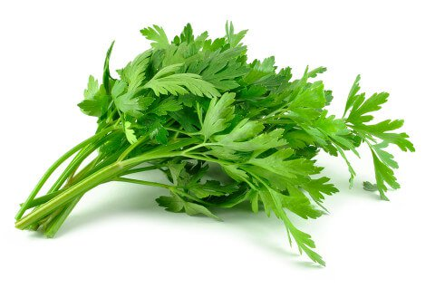 | aromatic leaves that are either crinkly or flat and used as an herb to flavor food
Radish | 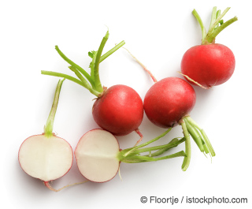 | a spicy-tasting edible root
Scallion | 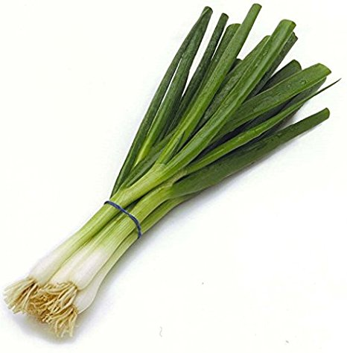 | a long-necked onion with a small bulb
Star Anise | 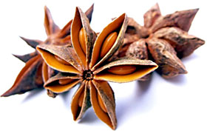 | a small star-shaped fruit with one seed in each arm
Sour Cream |  | cream that has been deliberately fermented by the addition of certain bacteria  high fat content
Welsh Onion | 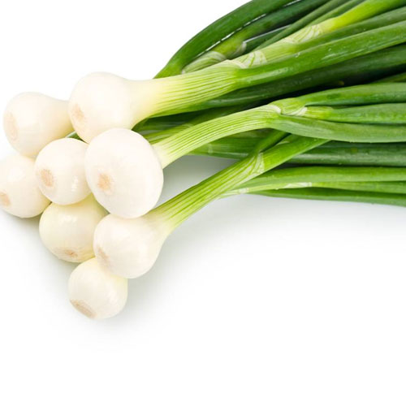 | a bunched onion, similar to a scallion
Wild Coriander | 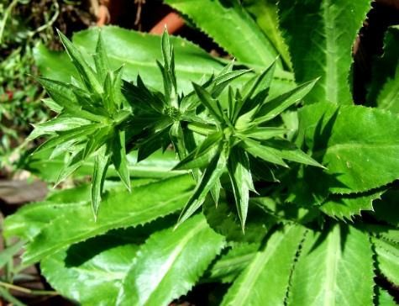 | a food herb, similar to parsley
Yoghurt |  | a semisolid sourish food prepared from milk fermented by added bacteria  high fat content

