 | Criteria:
Alternatives: Types of soup | Healthy | Easy to make | Looks good to eat | How expensive? (ranked from $ to $$$$
Ajiaco  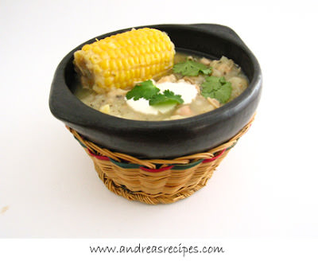 |  |  |  | $
Chlodnik  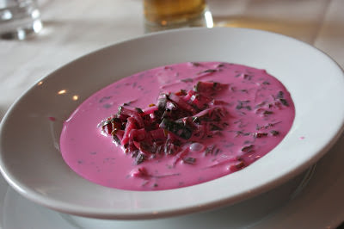 |  |  |  | $$
Pho  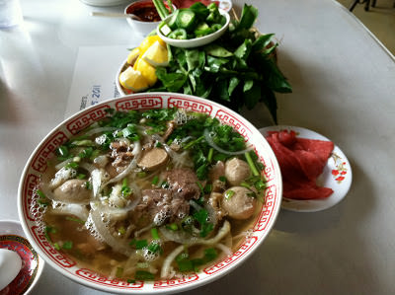 |  |  |  | $
Waterzooi          

