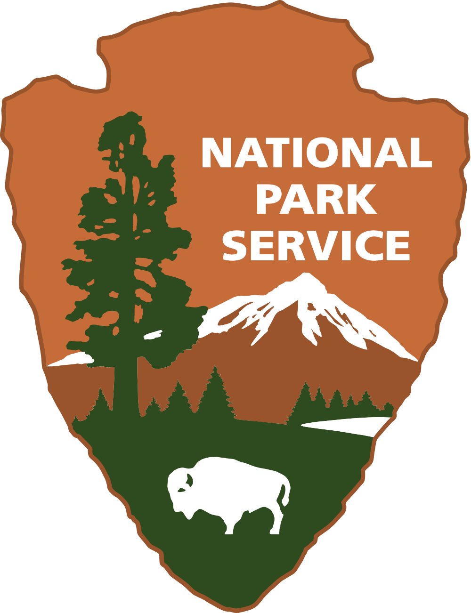

Dear Students,

Greetings from the National Park Service! Our organization manages all United States national parks. We often have families contact us to get information about visiting our parks across the country. This is where we need your help.

The Smith family wants to visit one National Park that has great natural or man-made landmarks as well as other areas of interest nearby. We have narrowed the list of states to four, but we need you to research each state and determine which one would provide the most interesting and educational trip for the family. Mr. and Mrs. Smith, along with their three children (ages 10, 7, and 5) would also like to know how you would rank each state from best choice to last choice.

Once you have made your decision, please write me back and let me know how you ranked each state and what influenced your decision. Thank you in advance for your time and talents on this task.

Sincerely,

