Vacation Choices
Which is the best National Park vacation for the Smith family?

Adapted from CPALMS Resource ID#: 49205

Social Studies Benchmarks:

Grade: 3

SS.3.E.1.1 Give examples of how scarcity results in trade.

SS.3.E.1.3 Recognize that buyers and sellers interact to exchange goods and services through the use of trade or money.

SS.3.A.1.1 Analyze primary and secondary sources.

SS.3.A.1.2 Utilize technology resources to gather information from primary and secondary sources.

SS.3.G.2.5 Identify natural and man-made landmarks in the United States, Canada, Mexico, and the Caribbean.

Economic Concepts for Review:

Scarcity – Not having enough of a resource to meet the wants and needs of consumers

Buyers – People who purchase goods and services

Sellers – People who provide goods and services

Goods – Items that people buy

Services – Actions that people buy

Trade – The action of buying goods and services, often using items other than money

English/Language Arts Standards:
LAFS.3.RI.1.1 Ask and answer questions to demonstrate understanding of a text, referring explicitly to the text as the basis for the answers.
LAFS.3.RI.3.7 Use information gained from illustrations (e.g., maps, photographs) and the words in a text to demonstrate understanding of the text (e.g., where, when, why, and how key events occur).
LAFS.3.W.3.8 Recall information from experiences or gather information from print and digital sources; take brief notes on sources and sort evidence into provided categories.
LAFS.3.SL.1.1 Engage effectively in a range of collaborative discussions (one-on-one, in groups, and teacher-led) with diverse partners on grade 4 topics and texts, building on others’ ideas and expressing their own clearly.
- Come to discussions prepared, having read or studied required material; explicitly draw on that preparation and other information known about the topic to explore ideas under discussion.
- Follow agreed-upon rules for discussions and carry out assigned roles.
- Pose and respond to specific questions to clarify or follow up on information, and make comments that contribute to the discussion and link to the remarks of others.
- Review the key ideas expressed and explain their own ideas and understanding in light of the discussion.

For this decision-making lesson, students will discuss criteria for choosing the best National Park for a family to visit based on information provided by The National Park Service, web articles, and videos. Using this information, students will rank their choices and explain how they reached their decisions.

Problem
Which National Park is best for the Smith’s family vacation?

Alternatives
Four National Parks: Acadia, Yellowstone, Yosemite, or Great Smokey Mountains

Criteria
What park characteristics meet the needs of the Smith family?

Decision
Which National Park is best for the Smith family? How did you make that decision?

- Read the letter from The National Park Service and discuss the decision that the company wants the students to make (the best National Park for the Smith family’s vacation).
- Explore The National Park Service’s website at https://www.nps.gov/index.htm
- Scroll down and click on Learn and Explore.
- Under Learn More, click on About Us, Discover History, and other links to provide a historical context for The National Park Service.
- Project the pictures of four National Parks: Acadia, Yellowstone, Great Smokey Mountains, and Yosemite (pictures are located at the bottom of this lesson plan).
- Provide students with the decision-making matrix. Review the alternatives and criteria related to the National Parks.
- Use the following links to research each park and take notes on the note-taking tool related to the criteria for choosing a park to visit:
National Parks by state:
https://en.wikipedia.org/wiki/List_of_national_parks_of_the_United_States

Best National Parks to visit:
https://www.npca.org/articles/1480-the-10-most-visited-parks-and-less-visited-side-trips?gclid=CLqt3fPh9NMCFd6PswodxDIETA#sm.00001piiighnp2fruq6wls43vmkws

View the You Tube videos (stop frequently during each video to discuss information and take notes:
- Yosemite National Park: https://www.youtube.com/watch?v=dmK5-3ZhXX8
- Acadia National Park: https://www.youtube.com/watch?v=MQTA8HU07zc
- Yellowstone National Park: https://www.youtube.com/watch?v=AKoFN9brF_Y
- Great Smokey Mountains National Park: https://www.youtube.com/watch?v=poyWuEA6HT0
- After all information has been gathered, use the matrix to start a discussion on Acadia National Park. What notes did you take for each of the criteria? Does this park meet all of the criteria? If not, where is it lacking? Would this be a good choice for the Smith family? Make notes on the matrix for each of the criteria.
- Repeat this process for the other parks.
- In teams the students will work together to evaluate the completed matrix and make a decision regarding the best National Park for the Smith family to visit. Students will then rank each park from first to last.
- Students will then present their findings to the class, giving the reasons why ranked the choices as they did and the procedure of how they got to that decision. Prompt students to think about each step of their decision-making processes. What did they do first? After that?
- Students write a letter to Ranger Brochure reporting:
- how they ranked each park choice
- the process they used for making their choices and
- why the park they chose meets the needs of the Smith family.
A frame can also be used:
Date:

Dear Ranger Brochure,
Our team has reviewed information on the four National Parks that you provided and are suggesting the following park for the Smith’s family vacation. We have ranked the types of energy in order beginning with our top choice.
Top Choice of Park:
Alternate Choice #1:
Alternate Choice #2:
Alternate Choice #3:
Our step-by-step procedure for ranking the choices in this way was:

Thank you for the opportunity to assist you with this project!
Sincerely,
Extension/ideas:
- Create a presentation for the Smith family that outlines the right National Park for their vacation.
- Read more about National Parks at ReadWorks: https://www.readworks.org/find-content#!q:national+park/g:17,19/t:0/f:0/lc:/l:[]/pt:/features:/

Differentiation:
- Reduce alternatives and/or criteria.
  - Create a new letter from Ranger Brochure asking students to reconsider their choices based on different alternatives/criteria
- Increase alternatives and/or criteria.
  - Same as above
- Provide note-taking tools with some of the information already filled in.

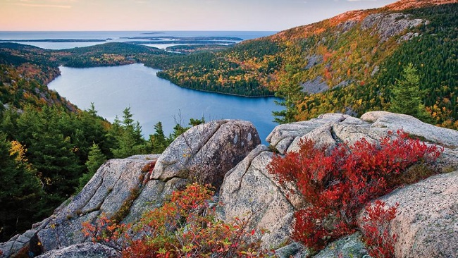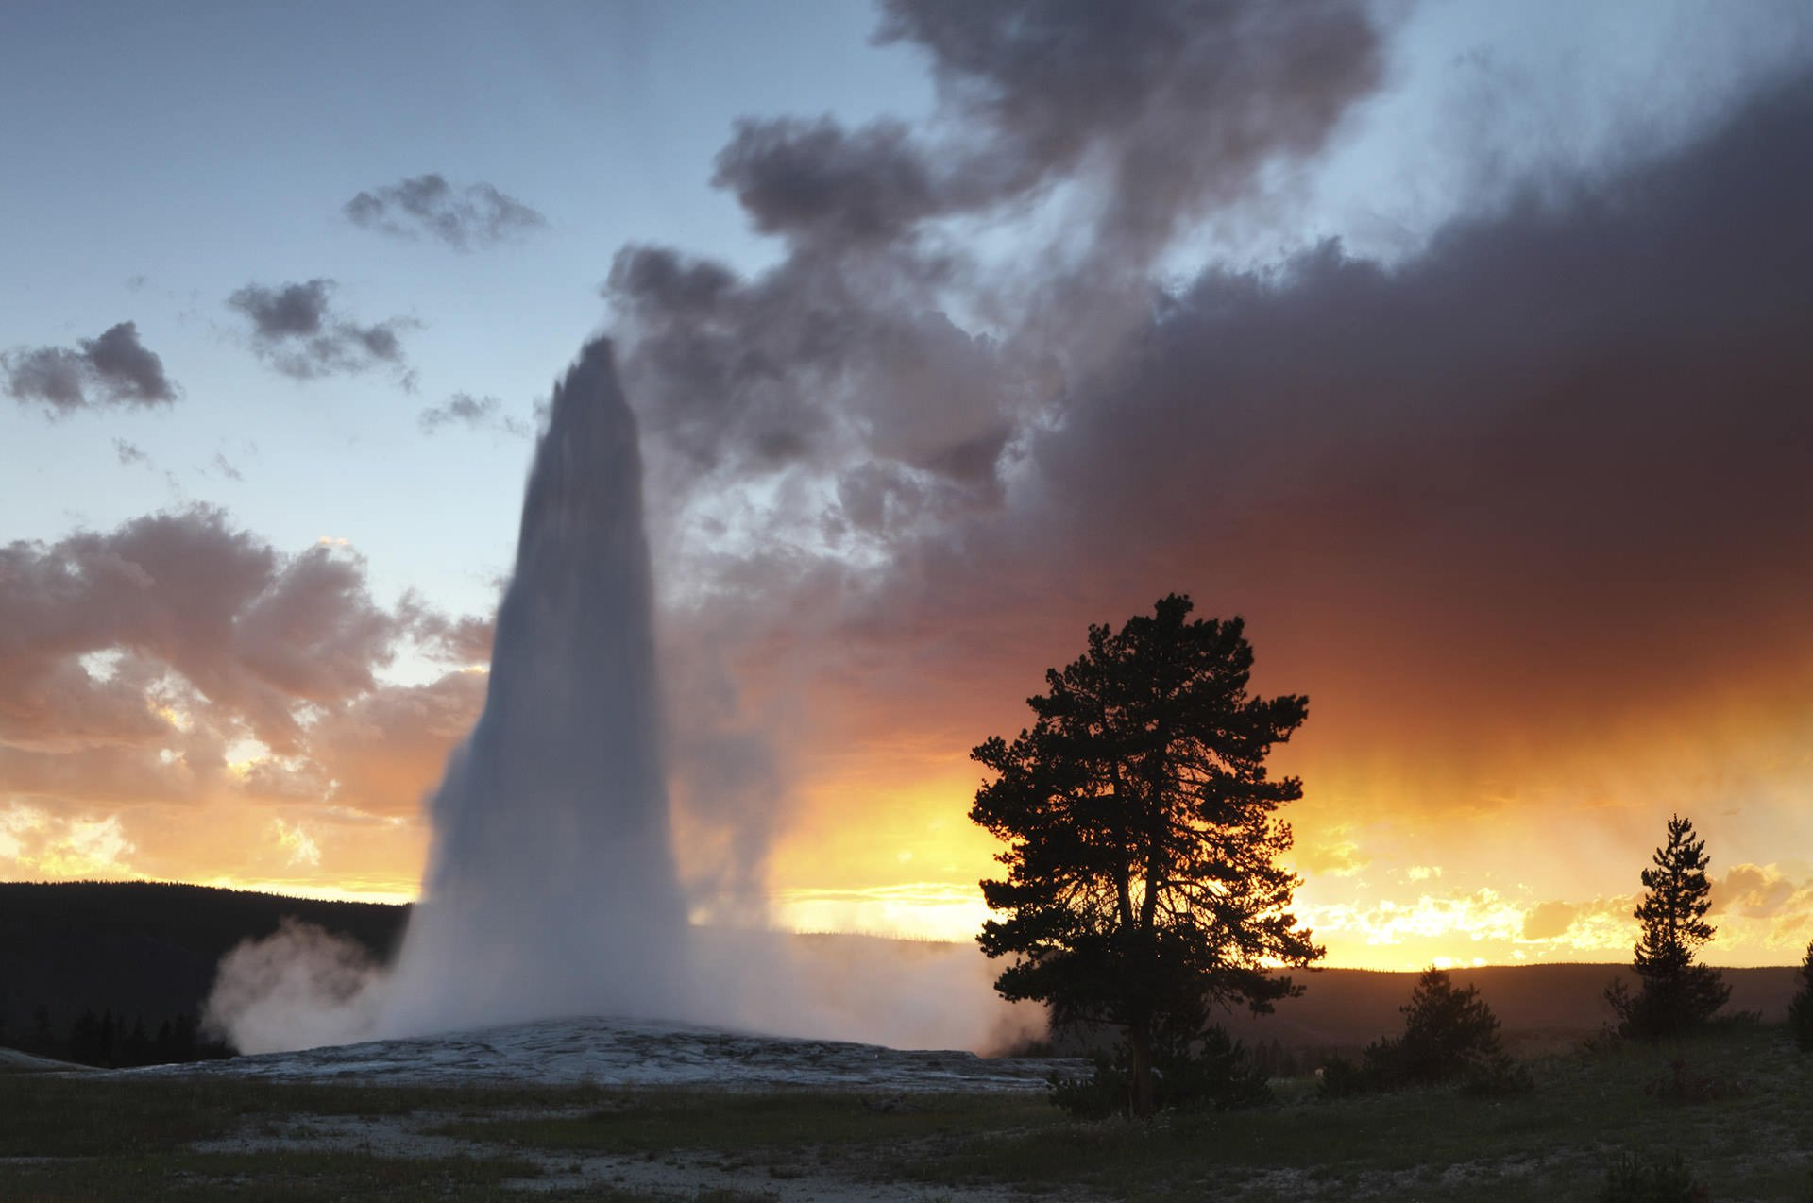
Acadia National Park Yellowstone National Park

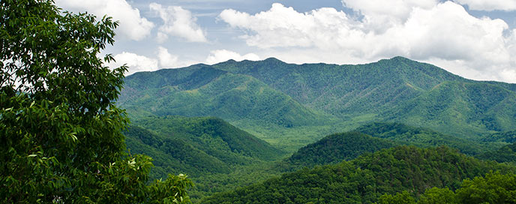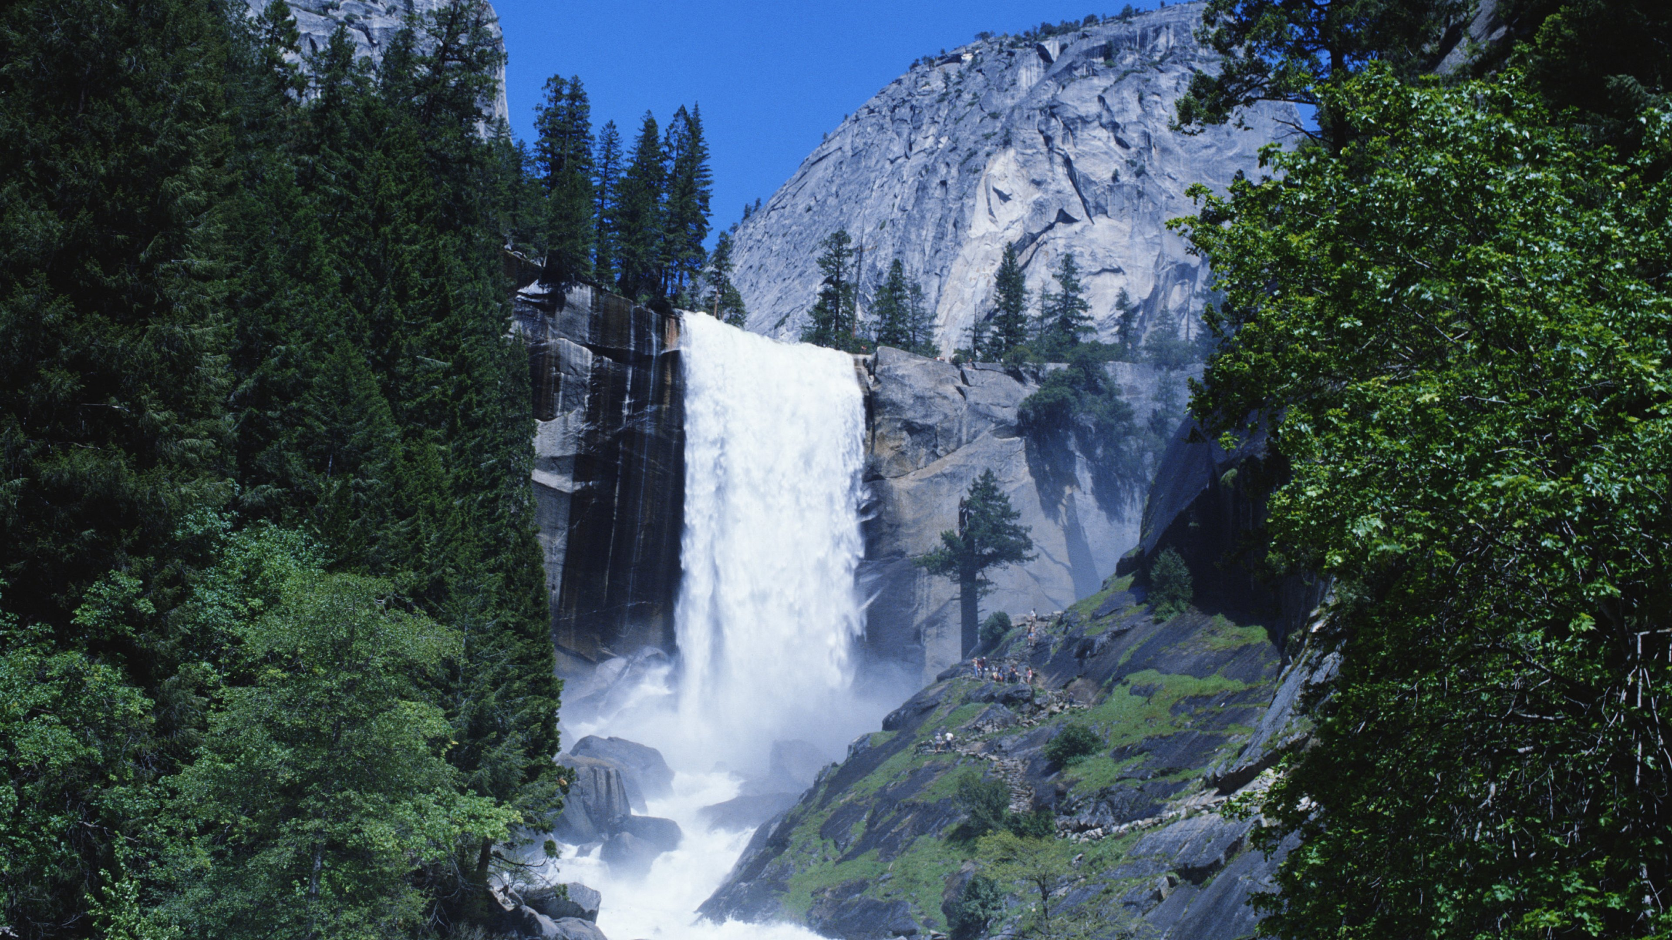
Great Smokey Mountains National Park Yosemite National Park

