 | Criteria: What makes a National Park worth visiting?
Alternatives: Different National Parks | What natural or man-made landmarks are in the park? | What kinds of educational opportunities does the park provide? | What is the cost of visiting the park? | What else might the family do near the park?
Acadia National Park
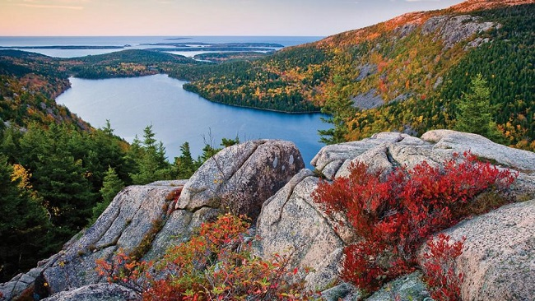
Yellowstone National Park
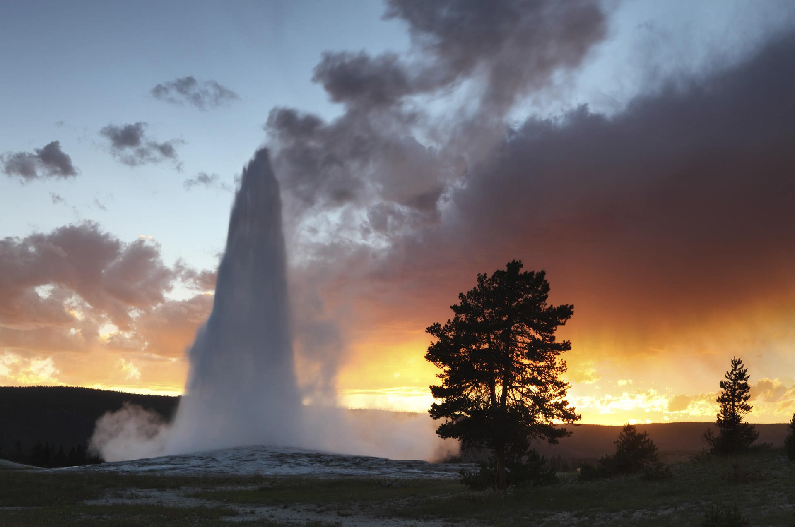
Great Smokey Mountain National Park
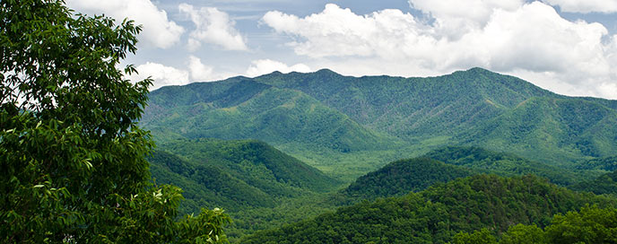
Yosemite National Park
