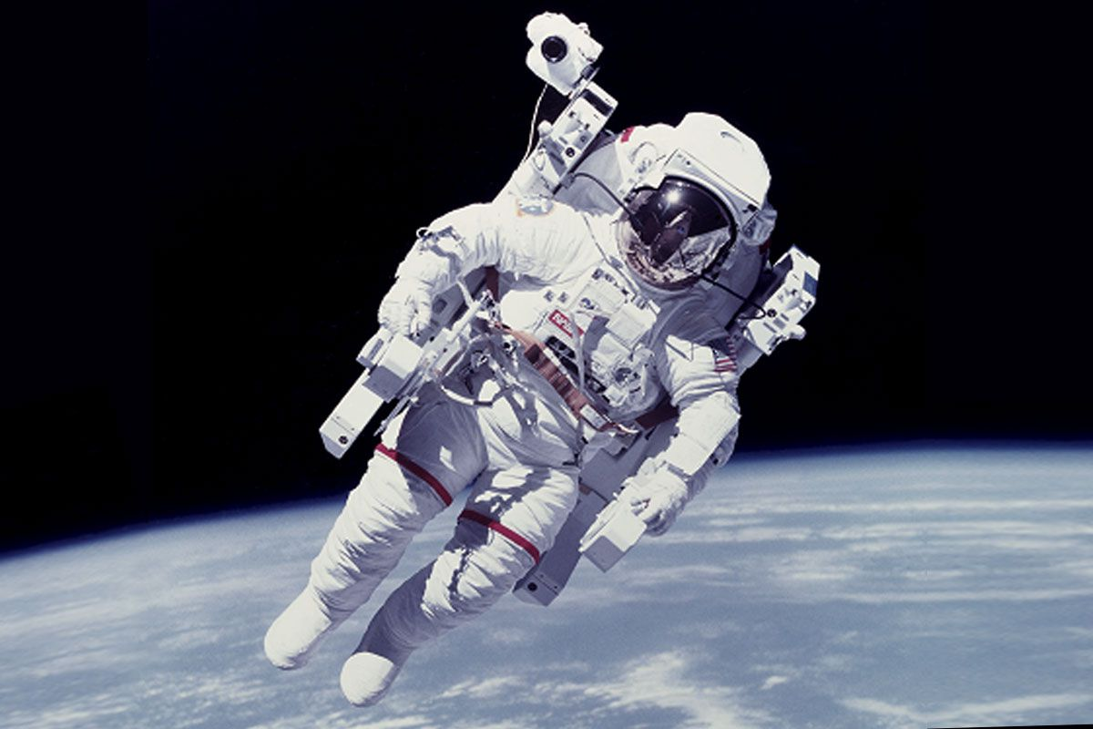
Future Astronauts of America

Dear students,
Future Astronauts of America is an organization that supports young men and women who are interested in a career as an astronaut. We value the history of space travel and would like to bestow our first annual Greatest American Astronaut Award to a well-deserving former astronaut.
We chose five astronauts who greatly impacted the field of space exploration:
- Alan Shepard, Jr.
- John Glenn, Jr.
- Neil Armstrong
- James Lovell, Jr.
- Dr. Sally Ride
We will base our final decision on how well each astronaut showed the following characteristics:
- Service to community and country before becoming and astronaut
- Service to NASA as an astronaut
- Service to community and country after leaving NASA
After completing your research, please decide which of these five individuals should be our very first Greatest American Astronaut. Once you have made your decision, please write back to us and tell us how you ranked each person from first to fifth. Also explain the process you used to make each ranking.
Thank you so much for your work in this worthy project,

Future Astronauts of America

