Who is the Greatest American Astronaut of All Time?

Social Studies Benchmarks:

Grade: 3

SS.3.A.1.2 Utilize technology resources to gather information from primary and secondary sources.

SS.3.C.2.1 Identify group and individual actions of citizens that demonstrate civility, cooperation, volunteerism, and other civic virtues.

Grade 4 Financial Literacy

SS.4.FL.1.1 People have many different types of jobs from which to choose. Identify different jobs requiring people to have different skills.

English/Language Arts Standards:
LAFS.3.RI.1.1 Ask and answer questions to demonstrate understanding of a text, referring explicitly to the text as the basis for the answers.
LAFS.3.RI.3.7 Use information gained from illustrations (e.g., maps, photographs) and the words in a text to demonstrate understanding of the text (e.g., where, when, why, and how key events occur).
LAFS.3.W.3.8 Recall information from experiences or gather information from print and digital sources; take brief notes on sources and sort evidence into provided categories.
LAFS.3.SL.1.1 Engage effectively in a range of collaborative discussions (one-on-one, in groups, and teacher-led) with diverse partners on grade 3 topics and texts, building on others’ ideas and expressing their own clearly.
- Come to discussions prepared, having read or studied required material; explicitly draw on that preparation and other information known about the topic to explore ideas under discussion.
- Follow agreed-upon rules for discussions and carry out assigned roles.
- Pose and respond to specific questions to clarify or follow up on information, and make comments that contribute to the discussion and link to the remarks of others.
- Review the key ideas expressed and explain their own ideas and understanding in light of the discussion.

For this decision-making lesson, students will discuss criteria for choosing the greatest American astronaut of all time. Students conduct research using information from web articles and videos. Using this information, students will rank their choices and explain how they reached their decisions.

Problem
Who should be named the Greatest American Astronaut of All Time?

Alternatives
Alan Shepard, Jr., John Glenn, Jr., Neil Armstrong, James Lovell, Jr., Dr. Sally Ride

Criteria
Service to community and country before becoming and astronaut, service to NASA as an astronaut, service to community and country after leaving NASA

Decision
Which astronaut did you choose? How did you make that decision?

- Read the letter from Future Astronauts of America. What is the problem (They are looking for the astronaut that should be named the greatest American astronaut of all time).
- Project the pictures of the five astronauts (at the end of this lesson plan).
  - Research each astronaut at the Universe Today site: https://www.universetoday.com/45089/famous-astronauts/
  - Note: This link may need to be copied and pasted into your browser.
c. Use the matrix or note-taking tool to take notes on each astronaut.
- Research each astronaut at the following links:
  - Alan Shepard, Jr.
https://www.youtube.com/watch?v=043DakKoEr4
  - John Glen, Jr.
https://www.youtube.com/watch?v=jQty14PvMaM
  - Neil Armstrong
https://www.youtube.com/watch?v=BS87_h-P02M
  - James Lovell, Jr.
https://www.youtube.com/watch?v=IdwrQRrMRyI
  - Dr. Sally Ride
https://www.youtube.com/watch?v=RD6vzRd0rhY
  - Stop frequently during the videos to discuss criteria, make notes
  - Record additional information related to each criterion.
- After all information has been gathered, use the matrix to start a discussion on Alan Shepard. What notes did you take for each of the criteria? Would he be a good choice for greatest astronaut? Why or why not?
- Repeat this process for the other astronauts.
- In teams the students will work together to evaluate the completed matrix and make a decision regarding which astronaut would be the best choice.
- Teams will then present their findings to the class, giving the reasons why ranked the choices as they did and the procedure of how they got to that decision. Prompt students to think about each step of their decision-making processes. What did they do first? After that? Point out that the astronaut that was ranked second is the opportunity cost (the next-best choice after the astronaut that was chosen).
- Students write a letter to Future Astronauts of America reporting:
- how they ranked each astronaut
- the process they used for making their choices and
- why they should choose this astronaut.
A frame can also be used:
Date:
Dear
Our team has reviewed information on the five astronauts you provided and is suggesting the following astronaut to be name Greatest American Astronaut of All Time. We have ranked them in order beginning with our top choice.
Top Choice:
Alternate Choice #1:
Alternate Choice #2:
Alternate Choice #3:
Alternate Choice #4 ________________________________
Our step-by-step procedure for ranking the choices in this way was:

Thank you for the opportunity to assist you with this project!
Sincerely,
Extension/ideas:
- Create a presentation for Future Astronauts of America that outlines why the top choice should receive the award.
- Create presentations highlighting each astronaut based on research.
- Read more about space travel at ReadWorks:
  - Exploring Space (article-a-day set) https://www.readworks.org/article/Exploring-Space/6972caa2-c290-4f8b-b2f6-525d609773da#!articleTab:content/contentSection:8415aa28-cbee-4c2c-b9f7-dbbc28eca882/
- Research other astronauts, both American and those from other countries. Should one of these have been included in the original research? Why
Differentiation:
- Reduce alternatives and/or criteria.
  - Create a new letter from Future Astronauts of America asking students to reconsider their choices based on different alternatives/criteria
  - Include astronauts from other countries and recommend the award be changed to Greatest Astronauts from Around the World.
- Increase alternatives and/or criteria.
  - Same as above
- Provide note-taking tools with some of the information already filled in.

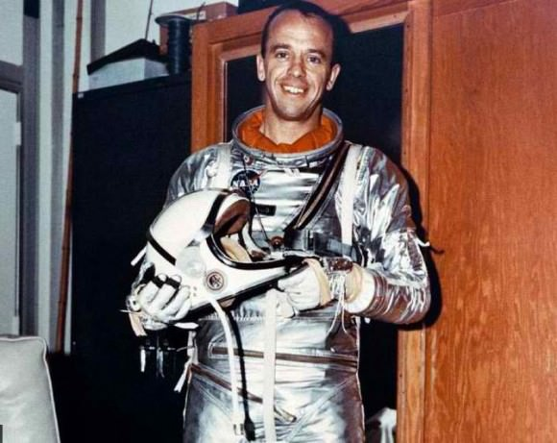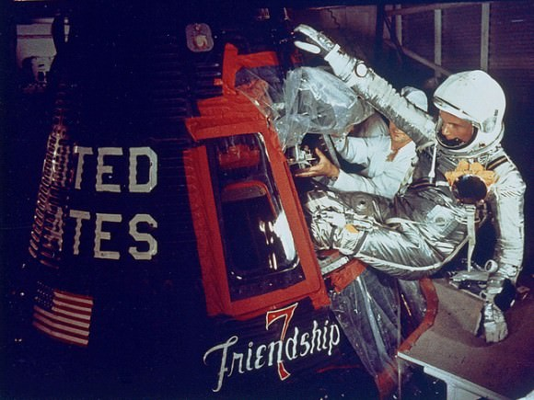
Alan Shepard, Jr. John Glenn, Jr.

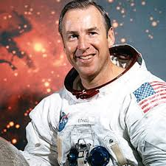
Neil Armstrong James Lovell, Jr.

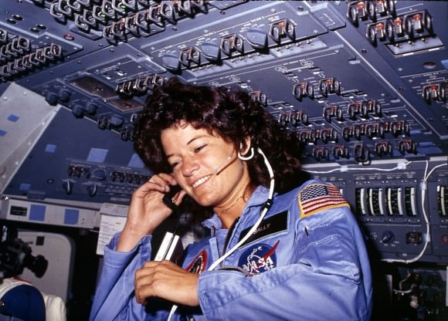
Dr. Sally Ride

