Alternatives: | service to community and country before becoming and astronaut | service to NASA as an astronaut, | service to community and country after leaving NASA
Alan Shepard, Jr.
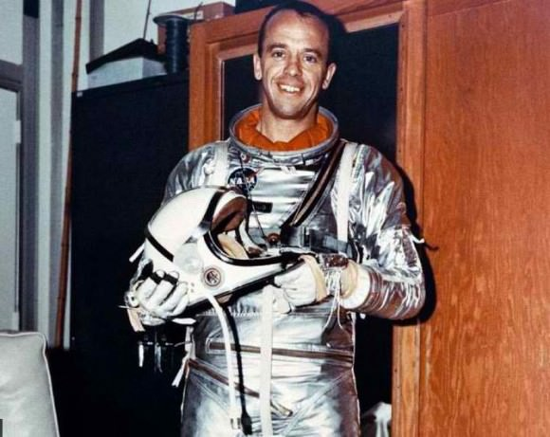
John Glenn, Jr.
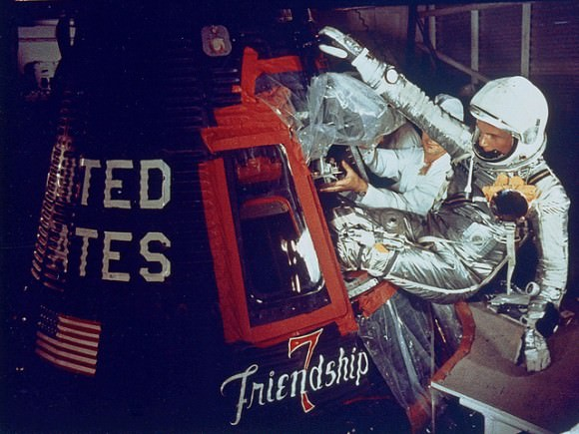
Neil Armstrong
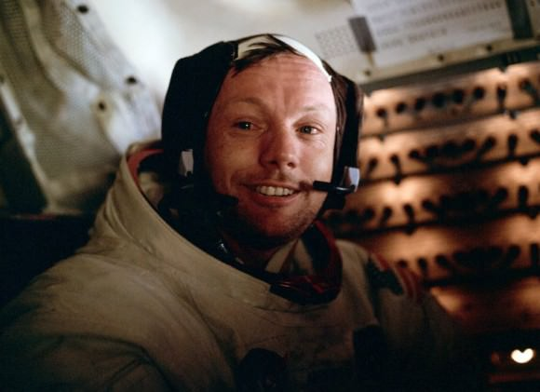
James Lovell, Jr.
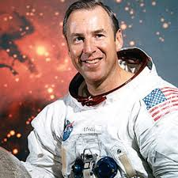
Dr. Sally Ride
