Where Should We Go?

Grade: 2

Social Studies Benchmarks:

SS.2.E.1.1 Recognize that people make choices because of limited resources.

SS.2.E.1.2 Recognize that people supply goods and services based on consumer demands.

SS.2.G.1.1 Use different types of maps (political, physical, and thematic) to identify map elements.

Economic Concepts for Review:

Limited Resources – Resources for which there is a finite, or limited, supply

Goods – things that people buy (food, clothing, school supplies, etc.)

Services – actions that people buy (hair cut, lawn care, care repair, etc.)

Consumer – a person who buys a good or service

English/Language Arts Standards:
LAFS.2.RI.1.1 Ask and answer such questions as who, what, where, when, why, and how to demonstrate understanding of key details in a text.
LAFS.2.RI.3.7 Explain how specific images (e.g., a diagram showing how a machine works) contribute to and clarify a text
LAFS.2.W.3.8 Recall information from experiences or gather information from provided sources to answer a question.
LAFS.2.SL.1.1 Participate in collaborative conversations with diverse partners about grade 2 topics and texts with peers and adults in small and larger groups.
a. Follow agreed-upon rules for discussions (e.g., gaining the floor in respectful ways, listening to others with care, speaking one at a time about the topics and texts under discussion).
b. Build on others’ talk in conversations by linking their comments to the remarks of others.
c. Ask for clarification and further explanation as needed about the topics and texts under discussion.

For this decision-making lesson, students will discuss criteria for choosing the best place for a family vacation using web articles and videos relating to interesting places to visit. Using this information, students will rank their choices and explain how they reached their decisions.

Problem
What should be Family Friendly Travel Agency’s trip of the month?

Alternatives
Alaska, Monteverde Rainforest, African Savanna, Rocky Mountain National Park

Criteria
Interesting sites, good choice for kids, travel time, cost

Decision
Rank the locations based on your research. Which location would you choose? How did you arrive at this decision?

- Read the letter from Family-Friendly Travel Agency. Identify the problem (which trip should be advertised as the Family Trip of the Month).
  - Discuss decision-making. People have to make choices based on limited resources. What are the limited resources (travel locations, time, money).
  - Identify the alternatives (travel locations) and the criteria for choosing the best location to advertise as the trip of the month.
  - Ask students how they will select location (they will research different locations and use information from the advertisement to choose the best trip of the month).
  - Discuss each of the criteria. Explain that there are four important categories related to choosing a location that will help students make their decisions.
- Provide maps to students (or use the following links) so they can locate each destination.
  - Alaska https://www.worldatlas.com/na/us/ak/a-where-is-alaska.html
  - Monteverde, Costa Rica https://www.worldatlas.com/na/cr/where-is-costa-rica.html
  - African Savanna, Namibia https://www.nationalgeographic.com/environment/habitats/grassland-map/#/6366.jpg
https://www.findlatitudeandlongitude.com/?loc=african+Savanna#.Wlkdf6uxNNI
  - Smokey Mountain National Park
https://kids.britannica.com/kids/article/Great-Smoky-Mountains- National-Park/346132
- Estimate which place would have the longest travel time from Florida.
  - Google “How long does it take to get from Florida to ___________?” Enter the travel time onto the matrix.
  - Discuss travel time to each location. How much is travel time a factor in choosing a location?
- Provide the matrix or note-taking tool to use while researching each place.
- Use the information from the links below for additional research for each location:
  - Alaska
    - https://www.youtube.com/watch?v=nEUhX852WxU (video)
    - http://www.travelwithkids.tv/destinations/alaska/
      - Model recording information on the matrix. Watch the video on Alaska, stopping frequently to discuss how the criteria connects to this location. Enter the information onto the matrix.
      - Go to the Travel With Kids site to learn about fun things for kids to do in Alaska. Review the site and fill in the matrix related to the criteria.
      - Continue this process for each location.
  - Monteverde, Costa Rica
    - https://www.youtube.com/watch?v=Y4lBSbHJePMhttps://www.youtube.com/watch?v=oP7NfsF60-I (video)
    - https://travelforkids.com/Funtodo/Costa_Rica/costarica_monteverde.htm
  - African Savanna, Namibia
    - https://www.youtube.com/watch?v=Pj7cRxjCXoU (video)
    - https://fullsuitcase.com/safari-with-kids-info/
  - Rocky Mountain National Park
    - https://www.youtube.com/watch?v=VC0Pf3sE6hQ (video)
    - https://www.familyvacationcritic.com/rocky-mountain-national-park-family-vacation/dat/

- Students work in groups to discuss the criteria and rank their choices from highest to lowest.
- Share results. Have students explain the steps they took to make their decisions. What did they do first? Next?
- Students write a letter to Family Friendly Travel Agency explaining how they made their choices. A frame can also be used:
Dear ______________,

Here is how we ranked each trip location from first to fourth as our choice for Trip of the Month:

#1 ____________________
#2 ____________________
#3 ____________________
#4 ____________________

We think ________________ should be the Trip of the Month. We based our decision on the following criteria: __________________________________, __________________,______________________, and ______________________.
_______________________ is the best choice because ______________________
___________________________________________________________________.

Thank you,

Extension Activities/Ideas:
- Read more about endangered animals in ReadWorks
  - Exploring Continents (Article a Day Text Set) https://www.readworks.org/article/Exploring-Continents/e4dabdaa-3c50-4f68-9db3-944876ce5fdf#!articleTab:content/contentSection:6272d40e-7424-4e53-a179-ebaf3b12e7aa/
- Create brochures that promote the Trip of the Month.

Differentiation:
- Reduce alternatives and/or criteria.
  - Create a new letter from Family Friendly Travel Agency asking students to reconsider their choices based on different alternatives/criteria
- Increase alternatives and/or criteria.
  - Same as above
- Provide note-taking tools with some of the information already filled in.

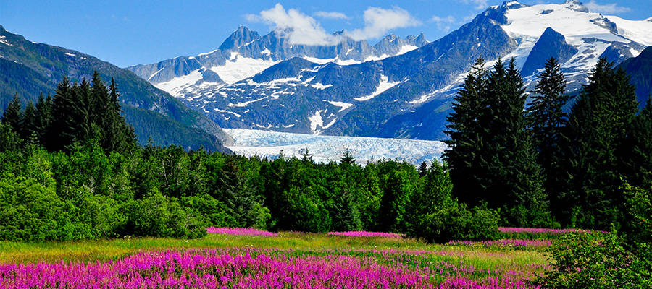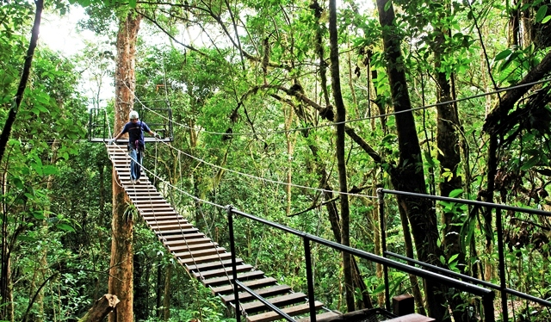
Alaska Monteverde

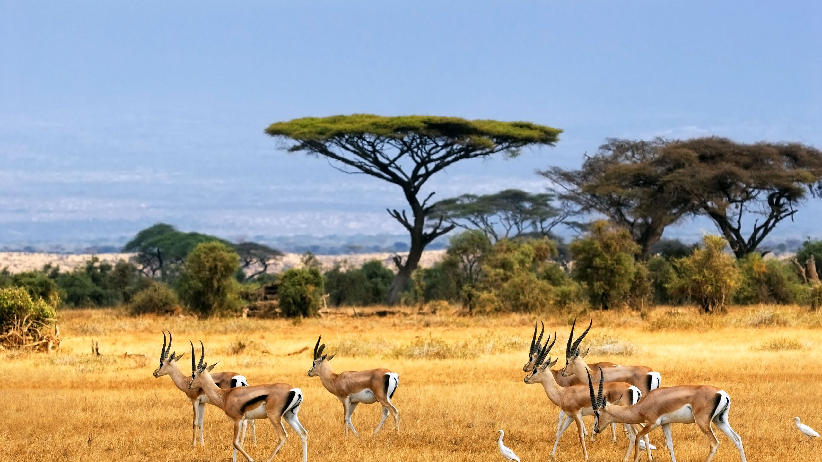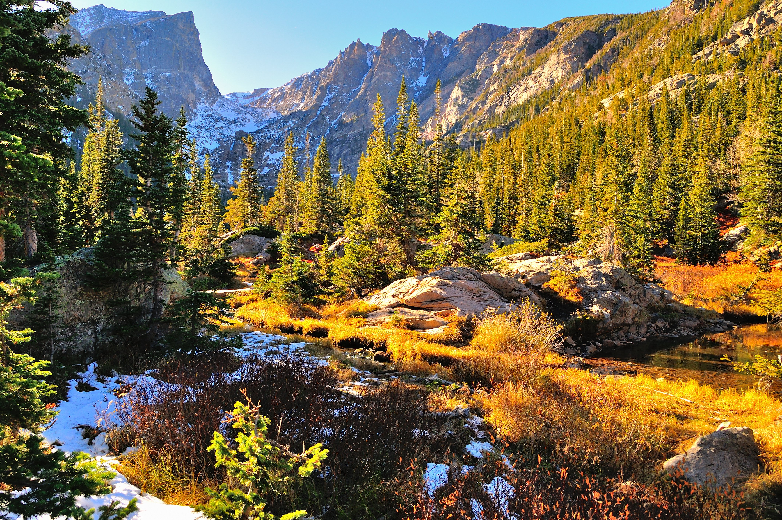
African Savanna Smokey Mountain National Park

