Criteria: What are important character traits for a president?
Alternatives: Different Candidates
Paul
Bessie
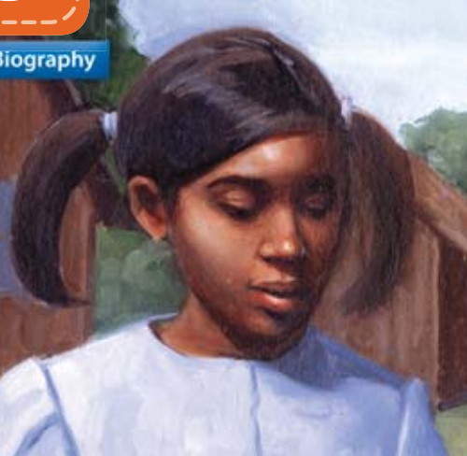

Lizzie
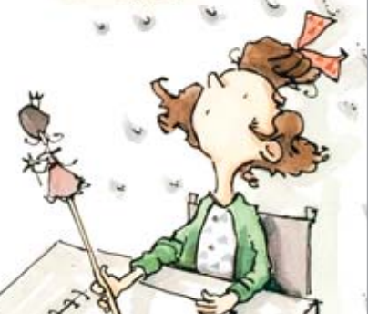
Cesar
