National Honey Association
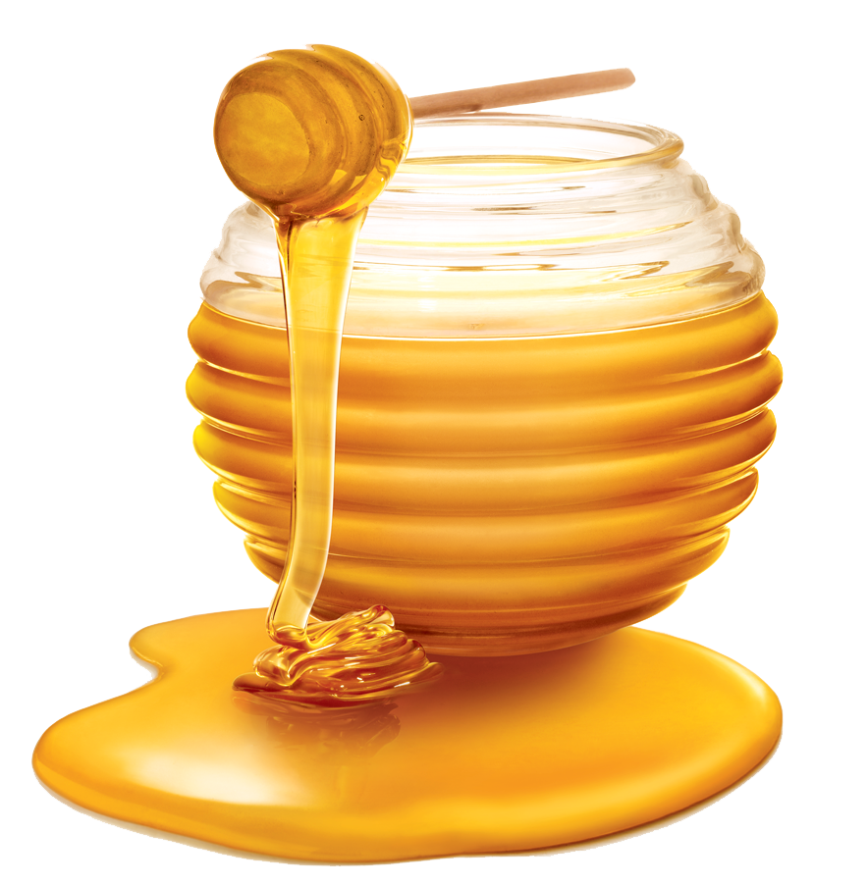
Honey is a sweet deal!!

We need Florida honey! The National Honey Association is sponsoring this year’s National Honey Tasting Championship in Washington, DC. Each state is invited to enter one type of honey that is considered #1 in taste, health benefits, availability, and cost. Florida’s honey will compete with honey from across the United States in an effort to become the National Honey Associations Best Honey for 2018!

Members of the Florida Honey Association submitted four candidates for entry into our contest:

Gallberry Honey
Orange Blossom Honey
Tupelo Honey
Wildflower Honey

We need research teams to determine which honey best represents Florida. Teams should rank the four types of honey from first to fourth. Once you have made your decision, write to us and let us know how you made that decision.

We hope you are up to this sweet assignment!

