 | Criteria:
Alternatives: | Health benefits | Location/availability | Taste | Cost
Gallberry Honey  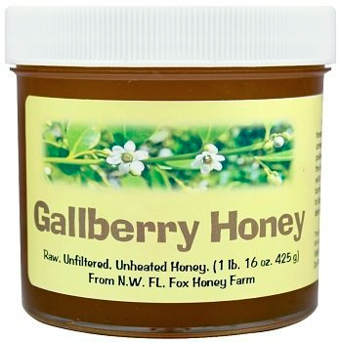 |  |  |  | $11.49 per pound
Orange Blossom Honey  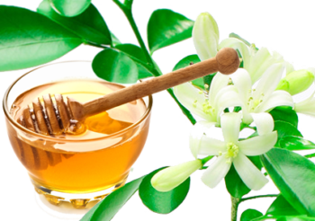 |  |  |  | $15.95 per pound
Tupelo Honey  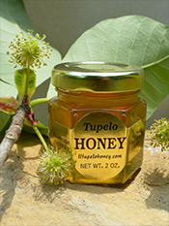 |  |  |  | $22.99 per pound
Wildflower Honey  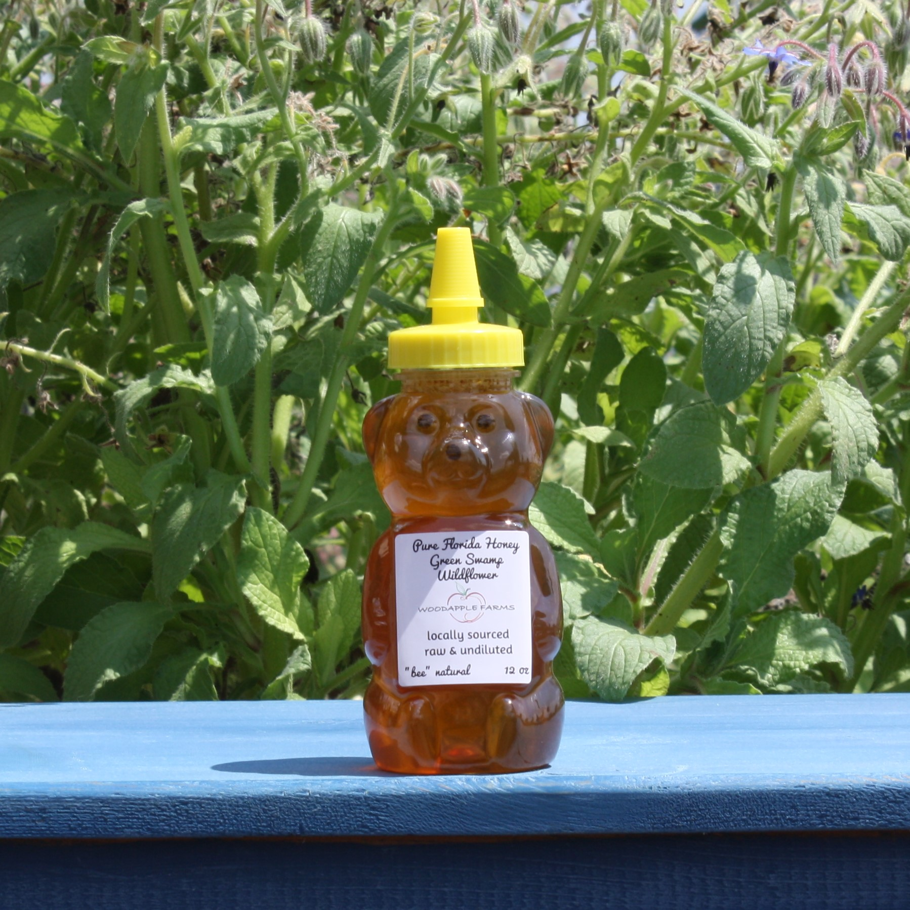 |  |  |  | $10.10 per pound

