 | Criteria:
Alternatives: | Where does it live? | What is the main Cause of Endangerment? | Is it helpful to Environment? | Do any organizations already help?
Gray Bat
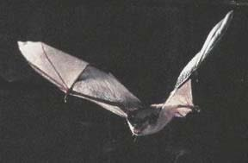
American Alligator
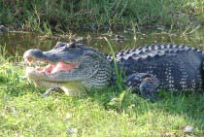
West Indian Manatee
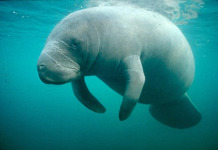
Florida Panther
