Alternatives: Scenic Train Trips
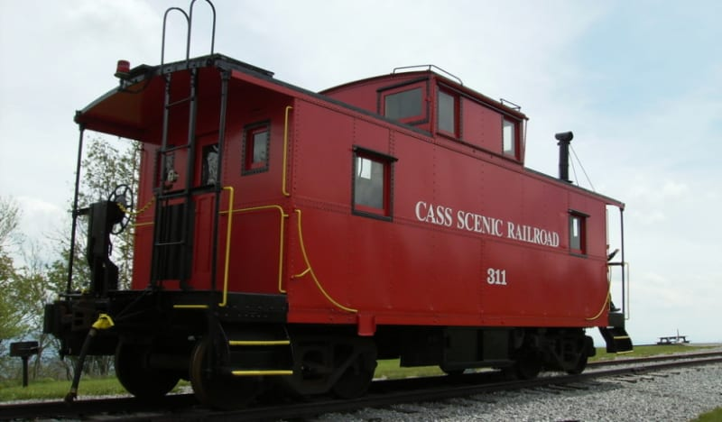
Cass Scenic Railroad
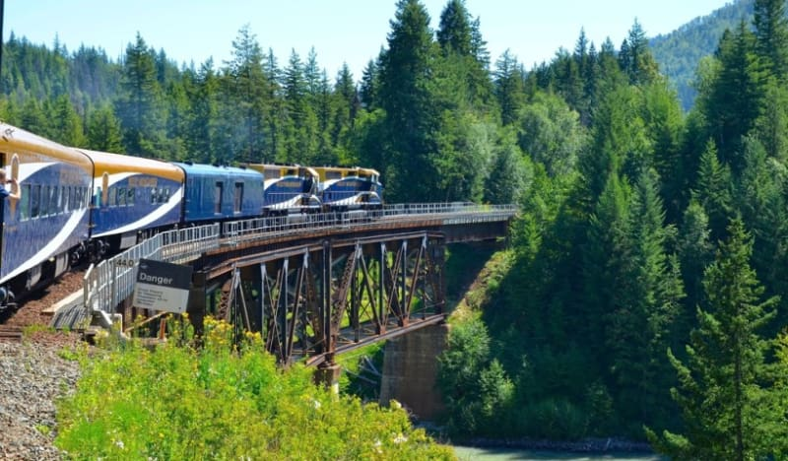
Rocky Mountaineer
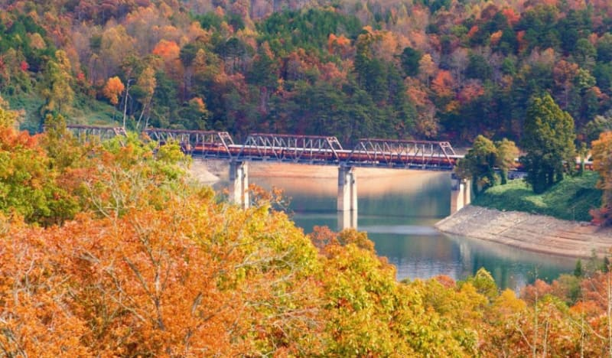
Great Smokey Mountain Railroad
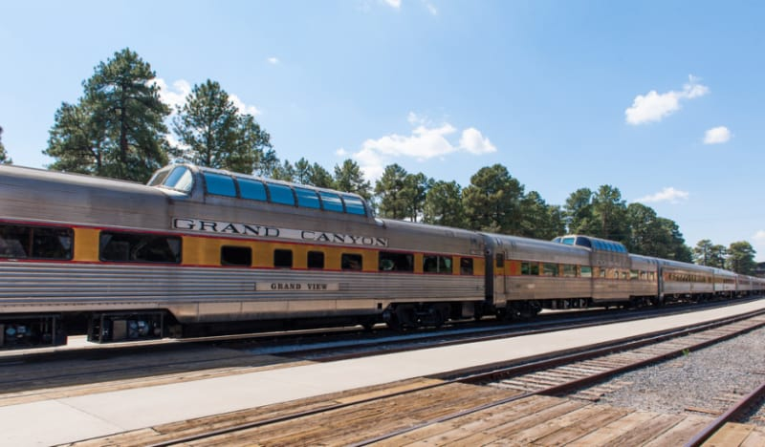
Grand Canyon Railway

