Scenic Railways Association
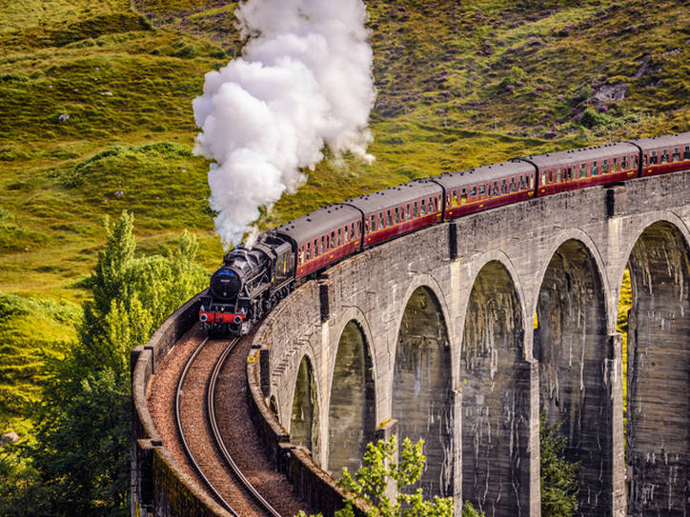
Your Dream Destination is Only a Train Ride Away

Greetings!

The Scenic Railway Association is offering discount tickets for several popular train trips. We want to choose one more train trip for this discount price offer. We have narrowed the choices down to four popular trips:

- Grand Canyon Railway
- Cass Scenic Railroad
- Great Smokey Mountain Railroad
- Rocky Mountaineer

Members of our association are looking for train trips that offer the following:

- Beautiful locations
- On-board amenities (food, entertainment, viewing windows)
- Education about the history of the area
- The opportunity to study nature and wildlife

Please research each of these train trips and advise us on the one that you find to be the best choice. Rank your choices from first to fourth, and let us know how you made your decisions.

Thank you for helping to make a train trip affordable,

Your friends at the Scenic Railway Association

