 | Criteria:
Alternatives: Scenic Train Trips | Beautiful locations | onboard amenities (food, entertainment, viewing windows) | education about the history of the area | opportunity to study nature and wildlife
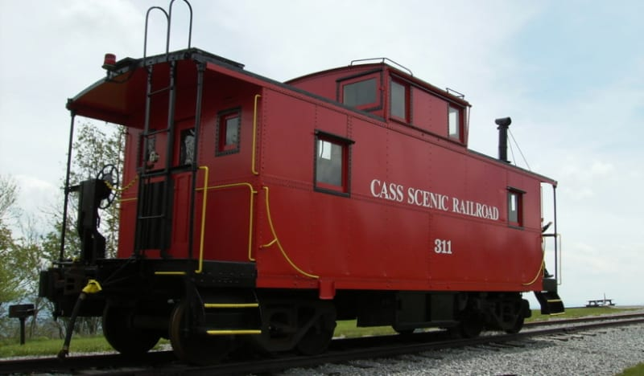
Cass Scenic Railroad
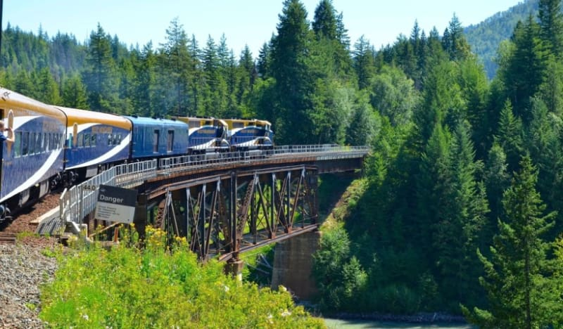
Rocky Mountaineer
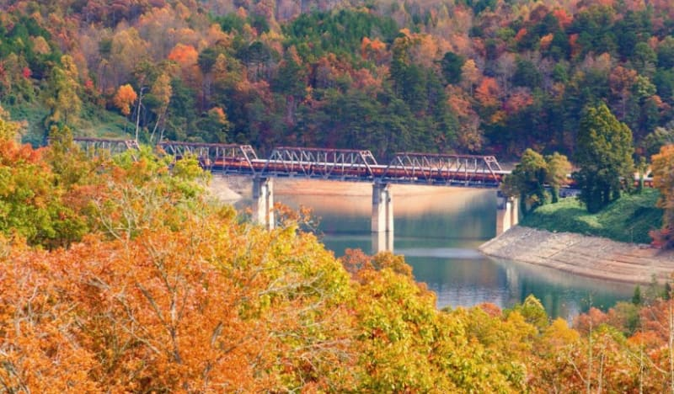
Great Smokey Mountain Railroad
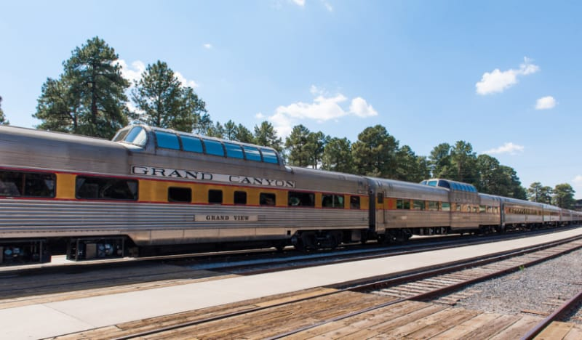
Grand Canyon Railway

