Which Scenic Train Ride Should We Take?

Grade: 1

Social Studies Benchmarks:

SS.1.E.1.2 Define opportunity costs as giving up one thing for another.

SS.1.E.1.4 Distinguish people as buyers, sellers, and producers of goods and services.

SS.1.E.1.6 Identify that people need to make choices because of scarce resources.
SS.G.1.
Economic concepts for review:
Opportunity cost – The second best choice
Buyers – People who buy goods or services
Sellers – People who sell goods or services
Producers – People who create and supply goods or services
Scarcity – Not enough goods or services to meet the demands of consumers

English/Language Arts Standards:
LAFS.1.RI.1.1 Ask and answer questions about key details in a text.
LAFS.1.RI.3.7 Use illustrations and details in a text to describe its key details.
LAFS.1.W.3.8 With guidance and support from adults, recall information from experiences or gather information from provided sources to answer a question.
LAFS.1.SL.1.1 Participate in collaborative conversations with diverse partners about grade 1 topics and texts with peers and adults in small and larger groups.
a. Follow agreed-upon rules for discussions (e.g., listening to others with care, speaking one at a time about the topics and texts under discussion).
b. Build on others’ talk in conversations by responding to the comments of others through multiple exchanges.
c. Ask questions to clear up any confusion about the topics and texts under discussion.

For this decision-making lesson, students will discuss criteria for choosing a train trip using research sites and videos. Using this information, students will rank their choices and explain how they reached those decisions.

Problem
Which train trip would be the best to take?

Alternatives
Grand Canyon Railway, Cass Scenic Railroad, Great Smokey Mountain Railroad, Rocky Mountaineer

Criteria
Beautiful locations, onboard amenities (food, entertainment, viewing windows), education about the history of the area, opportunity to study nature and wildlife

Decision
Which train trip is the best choice? How did you make that decision?

- Read the letter from the Scenic Railway Association to the students. Help students determine the problem (a train trip is to be chosen for a discount price).
  - Discuss train travel and determine students’ familiarity with trains. Why is a train an interesting transportation choice?
  - Discuss scarcity. How does scarcity relate to making choices? What choice do the students need to make? What are the scarce resources (railroads/railways)
- Review the choices from the Scenic Railway Association. Project the pictures of the different trains (below).
Using the letter, identify criteria that the Scenic Railway Association included related to their wants and needs in choosing a train trip (beautiful locations, onboard amenities (food, entertainment, viewing windows), education about the history of the area, opportunity to study nature and wildlife
- ). Explain that people have to make choices since they cannot have everything they want. They have to decide what is most important to them. What they have to give up is the opportunity cost. The insect that is the second best choice is the opportunity cost.
- Visit the 10 top train trips in the United States site to review scenic train trips: http://www.escapehere.com/destination/the-10-best-scenic-train-trips-in-north-america/?utm_medium=cpc&utm_source=google&utm_campaign=EH_GGL_US_DESK-SearchETA&utm_content=g_c_211482385596&cus_widget=kwd-299420436944&utm_term=best%20train%20trips%20in%20usa&cus_teaser=&gclid=EAIaIQobChMIt5LQ3sfB2AIV1rXACh3GowZbEAAYASAAEgJ95PD_BwE
  - Use the matrix or note-taking tool to take notes on what makes each train trip a good choice.
- Use the following links and the matrix or note-taking tool to research each train trip:
  - Cass Scenic Railroad https://www.youtube.com/watch?v=mgAWXiKen44
  - Rocky Mountaineer https://www.youtube.com/watch?v=PyLxv79UbuI
  - Great Smokey Mountains Railroad https://www.youtube.com/watch?v=7tOs0YNA7cc
  - Grand Canyon Railway https://www.youtube.com/watch?v=TsNfqf30yHQ
    - Stop videos throughout viewing to make notes, discuss criteria, etc.
- Using the matrix, review the alternatives and criteria related to the four train trips.
- Students can add to their notes using details from these sites onto the matrix.
- Discuss Grand Cass Scenic Railroad. What are good reasons to choose this trip? What are some reasons that this might not be the best choice?
- Repeat this process for the other three choices.
- Students work in groups to discuss the criteria and rank their choices from highest to lowest.
- Share results. Discuss opportunity cost (the next best choice that was given up). Make the connection between their second choice as the opportunity cost.
- Ask students to talk about the processes of making their best choices. What did they do first? After that?
- Students write a letter to the Scenic Railway Association explaining how they made their choices. A frame can also be used:

Dear ______________,

Here is how we ranked each choice of train trip:

#1 ____________________
#2 ____________________
#3 ____________________
#4 ____________________

We think the railroad trip you should choose is ________________. We based our decision on the following criteria: ___________________________________,
________________________________________________________________,
and _____________________________________________________________.
The thing we like the most about ___________________ is _______________.

Thank you,

Extension/ideas:
- After groups rank their choices, suggest other criteria that could change their decisions:
- Have students work with their groups to make a presentation to showcase their choice for the train trip.
- Read more about trains at ReadWords
  - Travel in America (paired texts) https://www.readworks.org/article/Travel-in-America/9a87c067-5a75-49b7-91ab-6e3c4ff0f45d#!articleTab:content/contentSection:337114f2-f8f6-4734-a3f3-0f3abe35fa89/
  - Building a Railroad to Cross the Country https://www.readworks.org/article/Building-a-Railroad-to-Cross-the-Country/337114f2-f8f6-4734-a3f3-0f3abe35fa89#!articleTab:content/
- Design a flyer to advertise the train trip.
- Make a model of the train. Write to explain the amenities that this train offers.

Differentiation:
- Reduce alternatives and/or criteria.
- Increase alternatives and/or criteria.
- Increase the number of pictures related to the alternatives and/or criteria.

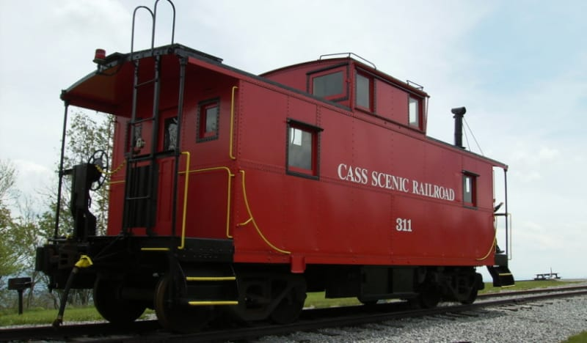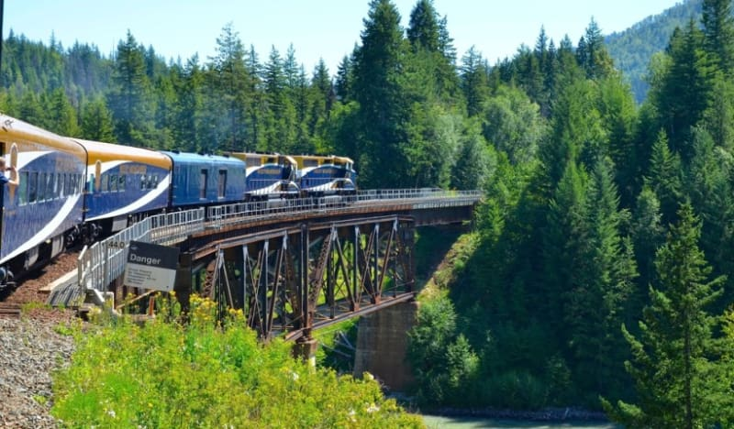
Cass Scenic Railroad Rocky Mountaineer

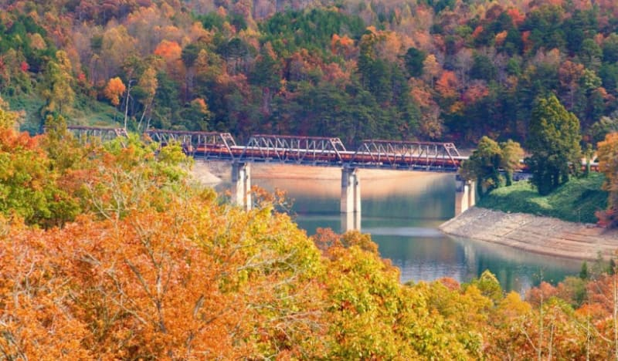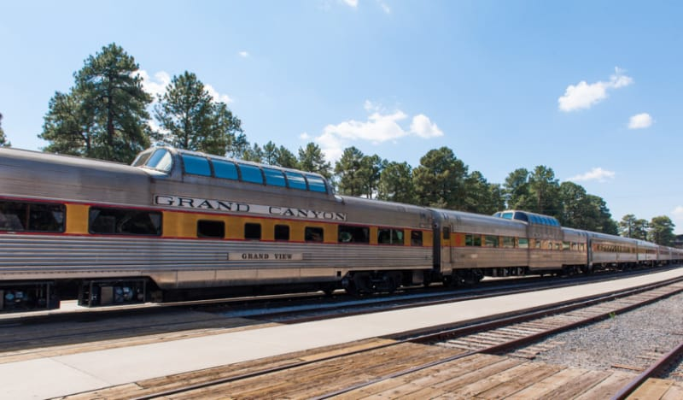
Great Smokey Mountain Railroad Grand Canyon Railway

