What Pet Should I Get?

Adapted from CPALMS Resource ID#: 51184

Grade: 1

Social Studies Benchmarks:

SS.1.E.1.2 Define opportunity costs as giving up one thing for another.

SS.1.E.1.4 Distinguish people as buyers, sellers, and producers of goods and services.

SS.1.E.1.6 Identify that people need to make choices because of scarce resources.

Economic concepts for review:
Opportunity cost – The second best choice
Buyers – People who buy goods or services
Sellers – People who sell goods or services
Producers – People who create and supply goods or services
Scarcity – Not enough goods or services to meet the demands of consumers

Science Benchmarks:
SC.1.L.17.1 Through observation, recognize that all plants and animals, including humans, need the basic necessities of air, water, food, and space.

English/Language Arts Standards:
LAFS.1.RI.1.1 Ask and answer questions about key details in a text.
LAFS.1.RI.3.7 Use illustrations and details in a text to describe its key details.
LAFS.1.W.3.8 With guidance and support from adults, recall information from experiences or gather information from provided sources to answer a question.
LAFS.1.SL.1.1 Participate in collaborative conversations with diverse partners about grade 1 topics and texts with peers and adults in small and larger groups.
a. Follow agreed-upon rules for discussions (e.g., listening to others with care, speaking one at a time about the topics and texts under discussion).
b. Build on others’ talk in conversations by responding to the comments of others through multiple exchanges.
c. Ask questions to clear up any confusion about the topics and texts under discussion.

For this decision-making lesson, students will discuss criteria for choosing the right type of dog for Arthur and his family using websites and videos. Using this information, students will rank their choices and explain how they reached those decisions.

Problem
What dog should Arthur choose?

Alternatives
What are the different types of dogs?

Criteria
What are the most important qualities Arthur’s family wants in a dog?

Decision
Should Arthur’s family get a Chihuahua, a Labrador Retriever, a Bulldog or a Pug? How did you make that decision?

Note: This lesson is based on Arthur’s Pet Business. Click the link below to access the story: (https://www.youtube.com/watch?v=Y1lSCAAipbc ).

- After reading or viewing the book, read the letter from Arthur to the students. Help students determine Arthur’s problem (he has to choose the right type of dog for his family).
  - Introduce the idea of what goes into taking care of animals. What are goods and services that pet owners need (food, leash, veterinarian, etc.)?
  - Discuss scarcity. How does scarcity relate to making choices? What are the scarce resources (money, types of dogs)
  - Ask students about buyers and sellers. Who are the buyers? Who might be the sellers?
- Review the choices that the family has. Project the pictures of the different types of dogs (below).
- Using the letter, identify criteria that the family included related to their wants and needs in choosing a dog (size, friendliness, etc.). Explain that people have to make choices since they cannot have everything they want. They have to decide what is most important to them. What they have to give up is the opportunity cost.
- Use the following links and the note-taking tool to research each type of dog:
http://dogtime.com/dog-breeds/chihuahua#/slide/1
https://www.youtube.com/watch?v=dHX2xul3WEk (Chihuahua)
http://dogtime.com/dog-breeds/labrador-retriever#/slide/1
https://www.youtube.com/watch?v=0cj81wHmfXc (Labrador)
http://dogtime.com/dog-breeds/bulldog#/slide/1
https://www.youtube.com/watch?v=yYwAJrAdUbY (Bulldog)
http://dogtime.com/dog-breeds/pug#/slide/1
https://www.youtube.com/watch?v=8Kkrmubsgf8 (Pug)
- Stop videos throughout viewing to make notes, discuss traits of breeds, etc.
- Provide students with the decision-making matrix. Review the alternatives and criteria related to the four dogs.
- Students can add to their notes using details from these sites onto the matrix.
- Students can choose additional criteria to add to the matrix (eg. How much to they eat, how often should they go to the vet, etc.)
- Discuss the Chihuahua. What are good reasons to choose a Chihuahua? What are some reasons that this might not be best for Arthur and his family? Refer back to the texts and notes to review information about Chihuahuas.
- Repeat this process for the other three dog choices.
- Students work in groups to discuss the criteria and rank their choices from highest to lowest.
- Share results. Discuss opportunity cost (the next best choice that was given up). Make the connection between their second choice as the opportunity cost.
- Ask students to talk about the processes of making their best choices. What did they do first? After that?
- Students write a letter to Arthur explaining how they made their choices. A frame can also be used:

Dear ______________,

Here is how we ranked each choice for Arthur’s family’s dog:

#1 ____________________
#2 ____________________
#3 ____________________
#4 ____________________

We think Arthur and his family should buy a ________________. We based our decision on the following criteria: ___________________________________,
________________________________________________________________,
and _____________________________________________________________.
The thing we like the most about a ___________________ is _______________.

Thank you,

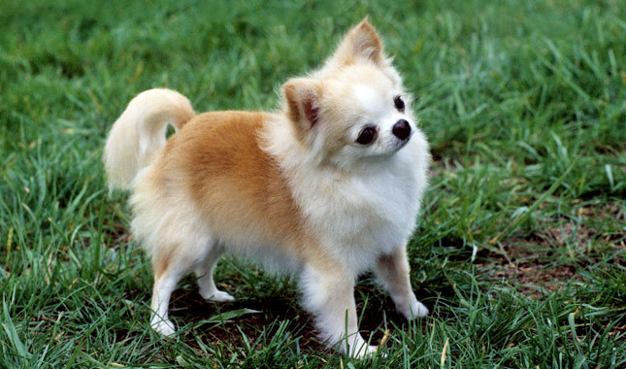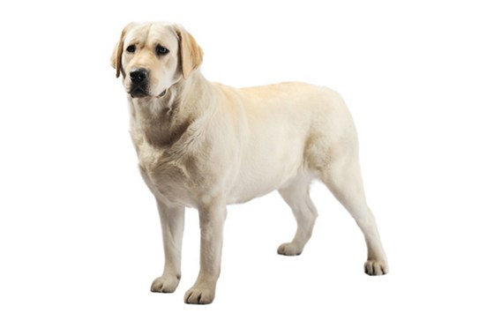
http://www.vetstreet.com/dogs/chihuahua https://www.purina.com/dogs/dog-breeds/labrador-retriever
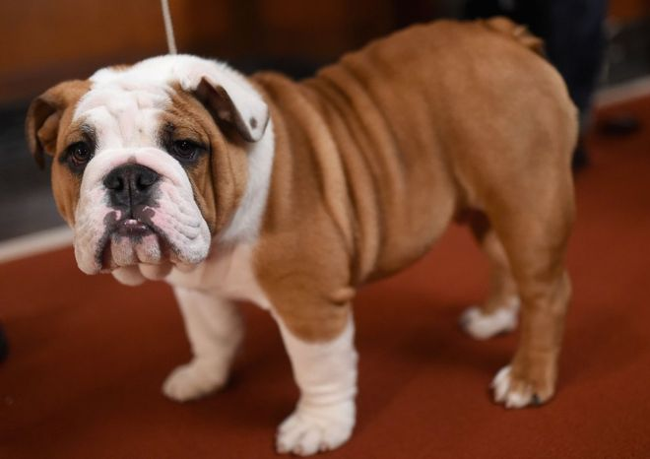
http://www.bbc.com/news/science-environment-36916431 http://dogtime.com/dog-breeds/pug#/slide/1
Extension/ideas:
- After groups rank their choices, suggest other criteria that could change their decisions:
- Have students work with their groups to make a presentation to show which dog is best for Arthur’s family and how they came to their decisions.
- Read the ReadWorks text, Many Kinds of Dogs https://www.readworks.org/article/Many-Kinds-of-Dogs/3a9cc052-3cda-46fb-8455-ad163f688e8b#!articleTab:content/
  - Would one of these dogs be a better choice for Arthur’s family?

Differentiation:
- Reduce alternatives and/or criteria.
- Increase alternatives and/or criteria.
- Increase the number of pictures related to the alternatives and/or criteria.

