 | Criteria: What are important qualities in choosing a dog?
Alternatives: Types of Dogs | Size | Friendliness | Barking
Chihuahua
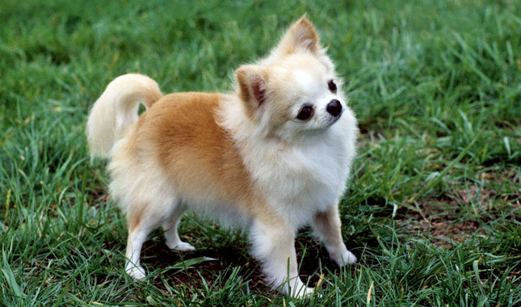
Labrador Retriever
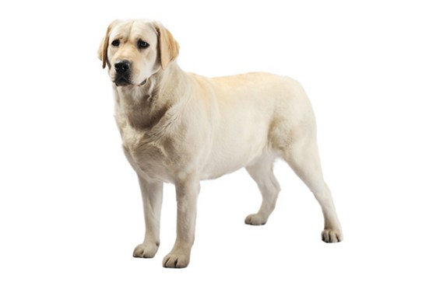
Bulldog
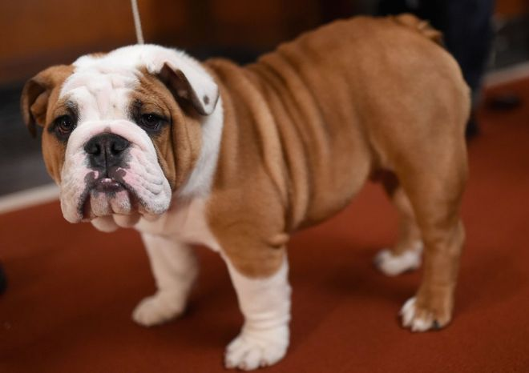
Pug
