 | Criteria: What are important qualities in choosing a dog?
Alternatives: Types of Dogs | Size | Friendliness | Barking
Chihuahua  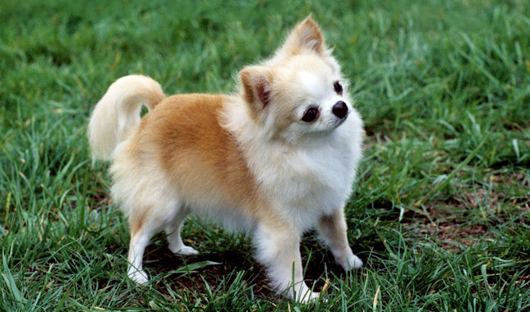 | Very small (< 10 inches, < 15 pounds) | Moderately protective | Likes to bark
Labrador Retriever  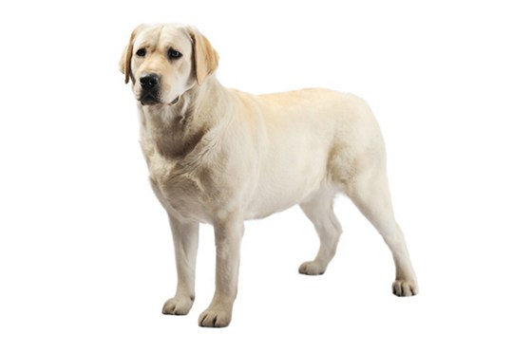 | Large (22-27 inches, 50-115 pounds) | Loves everyone | Average barking
Bulldog  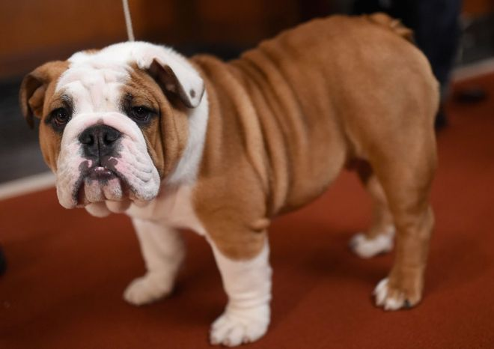 | Medium (12- 24 inches, 30- 55 pounds) | Loves everyone | Not much barking
Pug  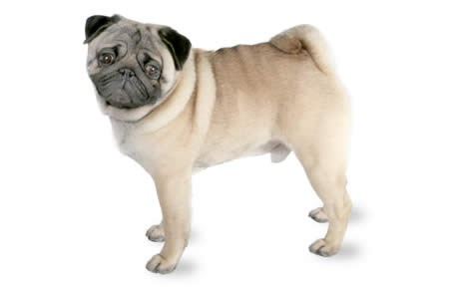 | Small (9-15 inches, 15-35 pounds) | Fairly friendly with strangers | Not much barking

