What Should Be Florida’s State Insect?

Grade: 1

Social Studies Benchmarks:

SS.1.E.1.2 Define opportunity costs as giving up one thing for another.

SS.1.E.1.4 Distinguish people as buyers, sellers, and producers of goods and services.

SS.1.E.1.6 Identify that people need to make choices because of scarce resources.

Economic concepts for review:
Opportunity cost – The second best choice
Buyers – People who buy goods or services
Sellers – People who sell goods or services
Producers – People who create and supply goods or services
Scarcity – Not enough goods or services to meet the demands of consumers

Science Benchmarks:
SC.1.L.17.1 Through observation, recognize that all plants and animals, including humans, need the basic necessities of air, water, food, and space.

English/Language Arts Standards:
LAFS.1.RI.1.1 Ask and answer questions about key details in a text.
LAFS.1.RI.3.7 Use illustrations and details in a text to describe its key details.
LAFS.1.W.3.8 With guidance and support from adults, recall information from experiences or gather information from provided sources to answer a question.
LAFS.1.SL.1.1 Participate in collaborative conversations with diverse partners about grade 1 topics and texts with peers and adults in small and larger groups.
a. Follow agreed-upon rules for discussions (e.g., listening to others with care, speaking one at a time about the topics and texts under discussion).
b. Build on others’ talk in conversations by responding to the comments of others through multiple exchanges.
c. Ask questions to clear up any confusion about the topics and texts under discussion.

For this decision-making lesson, students will discuss criteria for choosing the an insect they think should become Florida’s State Insect using internet research sites. Using this information, students will rank their choices and explain how they reached those decisions.

Problem
What insect should represent Florida as its State Insect?

Alternatives
Honeybee, ladybug, milkweed assassin bug, hover fly?

Criteria
Good for the environment, attractive, has special abilities, safe around humans

Decision
Should Florida’s insect be a honeybee, a lady bug, a milkweed assassin bug, or a hover fly? How did you make that decision?

- Read the letter from the Florida Insect Society to the students. Help students determine the problem (an insect is to be chosen to be Florida’s State Insect).
  - Discuss scarcity. How does scarcity relate to making choices? What choice do the students need to make? What are the scarce resources (types of insects)
- Review the choices that the family has. Project the pictures of the different types of insects (below).
- Using the letter, identify criteria that the Florida Insect Society included related to their wants and needs in choosing a state insect. Explain that people have to make choices since they cannot have everything they want. They have to decide what is most important to them. What they have to give up is the opportunity cost. The insect that is the second best choice is the opportunity cost.
- Visit the MyFlorida site to review all of the state symbols at http://dos.myflorida.com/florida-facts/florida-state-symbols/
  - Click on the links to look at a variety of state symbols. Note that Florida has a state butterfly but not a state insect.
  - Discuss that certain insects can be bad for the environment but that some insects are good, or beneficial. Go to the Lawn Master site to research how each of the insects being considered to be the Florida State Insect can be beneficial to our neighborhood environments. http://www.lawnmasterpensacola.com/blog/not-all-bugs-are-bad-which-creatures-help-or-hurt-your-lawn
  - Use the matrix or note-taking tool to take notes on how each insect is good for our environment.
- Use the following links and the matrix or note-taking tool to research each type of insect:
  - Honeybee
    - https://kids.nationalgeographic.com/animals/honeybee/#honeybee-pink-flower.jpg
    - https://www.terminix.com/pest-control/bees/behavior/do-honeybees-sting/
  - Lady bug
    - https://kids.nationalgeographic.com/animals/ladybug/#ladybug-daisy.jpg
    - http://infinitespider.com/ladybugs-bite-surprising-answer/
  - Milkweed Assassin Bug
    - http://www.growingproduce.com/vegetables/beneficial-of-the-month-milkweed-assassin-bug/
    - https://www.whatsthatbug.com/2011/02/01/milkweed-assassin-bug-nymph-4/
  - Hoverfly
    - http://entomology.ifas.ufl.edu/creatures/beneficial/hover_fly.htm
    - http://krystalangel-thebeautyofnature.blogspot.com/2010/08/hoverflies-do-not-sting-and-7-other.html
- Stop videos throughout viewing to make notes, discuss criteria, etc.
- Using the matrix, review the alternatives and criteria related to the four insects.
- Students can add to their notes using details from these sites onto the matrix.
- Discuss the honeybee. What are good reasons to choose the honeybee? What are some reasons that this might not be the best choice?
- Repeat this process for the other three insect choices.
- Students work in groups to discuss the criteria and rank their choices from highest to lowest.
- Share results. Discuss opportunity cost (the next best choice that was given up). Make the connection between their second choice as the opportunity cost.
- Ask students to talk about the processes of making their best choices. What did they do first? After that?
- Students write a letter to The Florida Insect Society explaining how they made their choices. A frame can also be used:

Dear ______________,

Here is how we ranked each choice Florida’s State Insect:

#1 ____________________
#2 ____________________
#3 ____________________
#4 ____________________

We think the Florida State Insect should be ________________. We based our decision on the following criteria: ___________________________________,
________________________________________________________________,
and _____________________________________________________________.
The thing we like the most about the ___________________ is _______________.

Thank you,

Extension/ideas:
- After groups rank their choices, suggest other criteria that could change their decisions:
- Have students work with their groups to make a presentation to showcase their choice for Florida State Insect
- Read the ReadWorks text,
  - Bugs (Article a Day Text Set)
  - https://www.readworks.org/article/Bugs/df9a5029-de63-435d-b6d5-fd53ce4d97f4#!articleTab:content/contentSection:7ddca158-2404-4a8c-978f-ad823ecf0a93/
- Write a letter to state legislators and/or Florida’s governor and explain that Florida should have a state insect. Name the insect you chose as the Florida State insect and explain the process you used.

Differentiation:
- Reduce alternatives and/or criteria.
- Increase alternatives and/or criteria.
- Increase the number of pictures related to the alternatives and/or criteria.

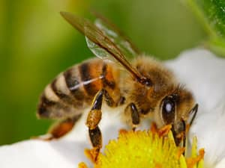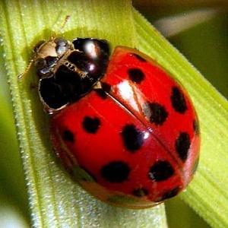
Honeybee Ladybug

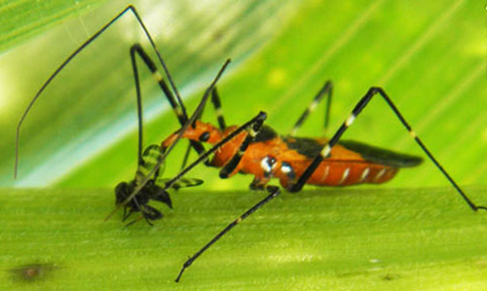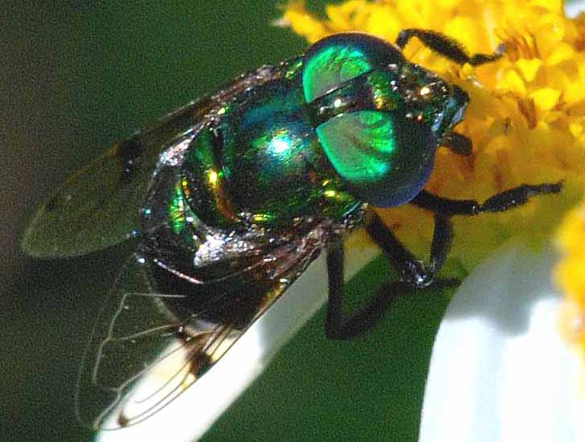
Milkweed Assassin Bug Hoverfly

