 | Criteria:
Alternatives: Types of insects | Good for the environment | Attractive | Has special abilities | Safe around humans
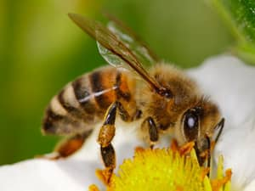
Honey Bee
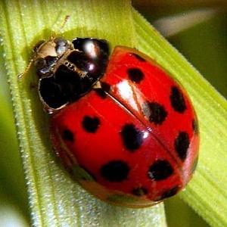
Ladybug
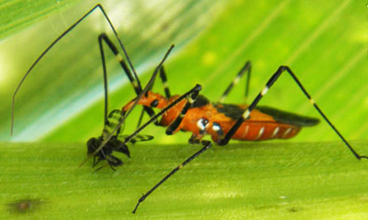
Milkweed Assassin Bug
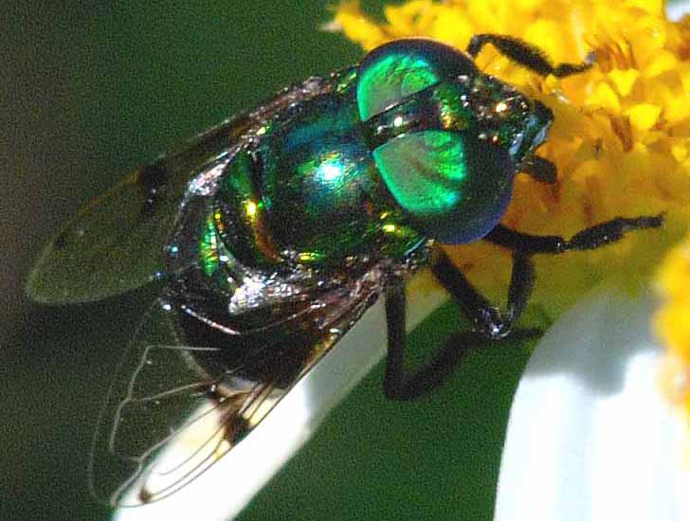
Hover Fly

