Buying a House
Which house should they buy?

Adapted from CPALMS Resource ID#: 48413

Grade: 1

Social Studies Benchmarks:

SS.1.E.1.2 Define opportunity costs as giving up one thing for another.

SS.1.E.1.4 Distinguish people as buyers, sellers, and producers of goods and services.

SS.1.E.1.6 Identify that people need to make choices because of scarce resources.
SS.1.G.1.6 Describe how location, weather, and physical environment affect the way people live in our community.
Science Benchmarks:
SC.1.E.6.2 Describe the need for water and how to be safe around water (This benchmark is related to the houseboat alternative).

English/Language Arts Standards:
LAFS.1.RI.1.1 Ask and answer questions about key details in a text.
LAFS.1.RI.3.7 Use illustrations and details in a text to describe its key details.
LAFS.1.W.3.8 With guidance and support from adults, recall information from experiences or gather information from provided sources to answer a question.
LAFS.1.SL.1.1 Participate in collaborative conversations with diverse partners about grade 1 topics and texts with peers and adults in small and larger groups.
a. Follow agreed-upon rules for discussions (e.g., listening to others with care, speaking one at a time about the topics and texts under discussion).
b. Build on others’ talk in conversations by responding to the comments of others through multiple exchanges.
c. Ask questions to clear up any confusion about the topics and texts under discussion.

For this decision-making lesson, students will discuss criteria for choosing the right house for a family moving to Florida based on information provided from a real estate firm Internet sites, and videos. Using this information, students will rank their choices and explain how they reached those decisions.

Problem
What house should Andy’s family buy?

Alternatives
What are the different types of houses on the market?

Criteria
What are the most important qualities wanted in a house?

Decision
Should Andy’s family buy a tiny house, a yurt, a tree house, or a houseboat? How did you make that decision?

- Read the letter from Sunshine Real Estate to the students. Help students determine Andy’s problem (he is moving to Florida and wants advise regarding the type of house that his parents should buy).
  - Discuss scarcity. How does scarcity relate to making choices? What are the scarce resources (money, the family has a limited budget, houses, the real estate firm has only identified 4 houses)
  - Ask students whether the family is buying a house or selling a house. Identify the family as buyers. Who are selling the houses? The owners of the houses are selling them. They are using a real estate company to help sell the houses.
- Review the choices that the family has. Project the pictures of a tiny house, a yurt, a tree house, and a houseboat (below).
- Using the letter, identify criteria that the family included related to their wants and needs in buying a house (eg. bedrooms, bathrooms, budget). Explain that people have to make choices since they cannot have everything they want. They have to decide what is most important to them. What they have to give up is the opportunity cost.
- Use the following links for more research on each type of house:
http://www.lifehack.org/314070/9-benefits-living-tiny-house
https://www.youtube.com/watch?v=Hfgj_am_KUY (tiny house)
http://home.howstuffworks.com/yurt4.htm
https://www.youtube.com/watch?v=VuuIgQEMOlw (yurt)
https://www.motherearthnews.com/nature-and-environment/treehouse-living-custom-options
https://www.youtube.com/watch?v=FXdj58DpY5M (tree house)
https://joanneguidoccio.com/2016/05/27/top-10-advantages-of-living-in-a-houseboat/
https://www.youtube.com/watch?v=PRQm2F5Oaf8 (houseboat)
Students can add to their notes using details from these sites.
- Provide students with the decision-making matrix. Review the alternatives and criteria related to the four house choices.
- Discuss the tiny house. What are good reasons to buy a tiny house? What are some reasons that this might not be best for Andy and his family? Refer back to the texts and notes to review information about tiny houses.
- Repeat this process for the other three house choices.
- Students work in groups to discuss the criteria and rank their choices from highest to lowest.
- Share results. Discuss opportunity cost (the next best choice that was given up). Make the connection between their second choice as the opportunity cost.
- Students write a letter to the real estate agent explaining how they made their choices. A frame can also be used:
Dear ______________,

Here is how we ranked each choice for Andy’s family’s house:

#1 ____________________
#2 ____________________
#3 ____________________
#4 ____________________

We think Andy and his family should buy a ________________. We based our decision on the following criteria: ___________________________________,
________________________________________________________________,
and _____________________________________________________________.
The thing we like the most about a ___________________ is _______________.

Thank you,

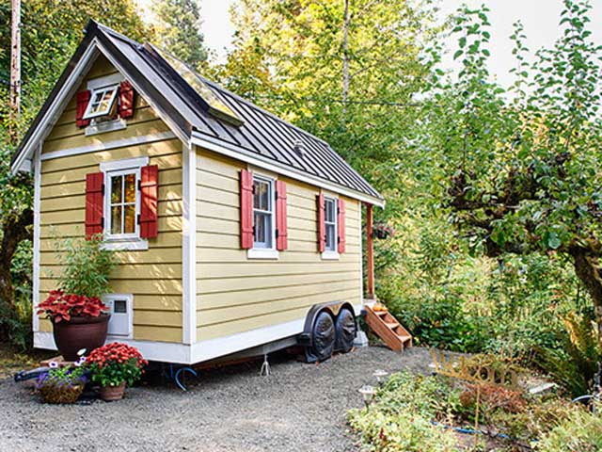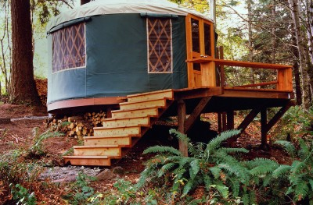
http://www.countryliving.com/home-design/g1887/tiny-house/ http://www.yurts.com/gallery/

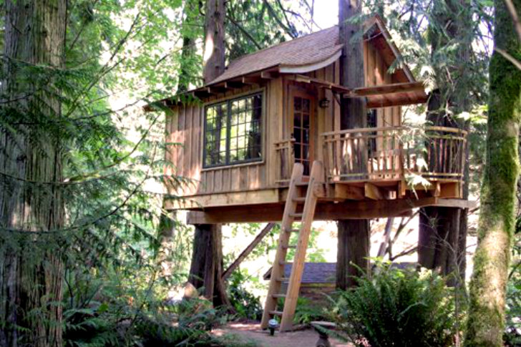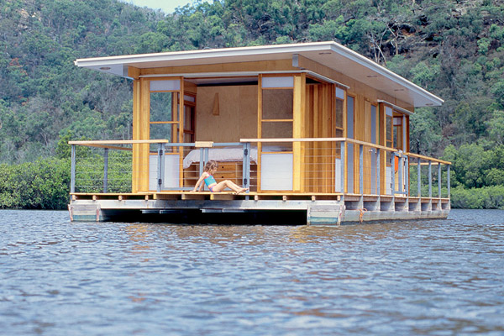
http://inhabitat.com/gorgeous-robins-nest-treehouse-hotel-immerses-you-in-nature/ http://www.goodshomedesign.com/arkiboat-cozy-house-boat/
Extension/ideas:
- After groups rank their choices, suggest other criteria that could change their decisions:
  - Buying a home that moves
  - Having an extra bedroom
  - 4 people in the family instead of 3
- Have students work with their groups to make a presentation to show which house is best for Andy’s family and how they came to their decisions.
- Write a letter to Andy to welcome him to Florida. Describe his new house and the thinks you like best about it.

Differentiation:
- Reduce alternatives and/or criteria.
- Increase alternatives and/or criteria.
- Increase the number of pictures related to the alternatives and/or criteria.

